Foundations of Data Management

INF- 551 Spring 2020

**Keyword-Driven Exploration of Relational Data Using Firebase**

Final Project Report

Sairam Kamal Raj Tejaswini Prakash Kulkarni

Contents

Current status and timelines of the Project: 3

Datasets used: 3

Steps carried out in order to achieve the above-mentioned status: 3

Screenshots of the Completed components: 5

UI: 34

Challenges encountered: 35

Summary Report:  35

# 

# Project Goal:

As part of the INF551 – Foundations of Data Management course and with an inclination towards learning how to use cloud-based real-time database, we worked on performing keyword exploration of real-time data using Firebase. As part of the process, we researched over 50+ databases from several online repositories like Kaggle, Google Data Search, MySQL databases and sample databases from Microsoft and selected 3 databases.

We selected 3 CSV datasets (apart from the world dataset provided by the course faculty) from Kaggle based on our team’s interest and real-time requirement and satisfying course’s constraints that each dataset should have atleast 3 tables inter-related with each other through foreign-key relationships.

We downloaded the dataset from Kaggle, imported them into MySQL database and then loaded them onto Firebase. Further, we developed an inverted index on each search term and designed and built Web UI interface to explore the data using key relationship esearch.

The 2 selected databases are:

1. SF Bay Area Bike Share database - enables quick, easy, and affordable bike trips around the San Francisco Bay Area and

2. Questions from Cross Validated Stack Exchange database - Full text of questions and answers from [Cross Validated](http://stats.stackexchange.com/), the statistics and machine learning Q&A site from the Stack Exchange network.

These databases satisfice the project requirements of having 3 related tables with over 100+ records in each table.

# Group Members and Responsibilities:

Our group consists of 2 Computer Science Master’s students namely Sairam Kamal Raj (M.S in Computer Science Data Science) and Tejaswini Kulkarni (M.S in Computer Science).

Even though our actual responsibilities on the project differed from our initial anticipated responsibility. We shared equal responsibility on the project and while I worked on the Back End aspects including the databases and loading data onto the Firebase. My teammate worked on developing the front end user interface and performed the demo of the final project.

Our initial responsibilities were:

1. Converting CSV files to MySQL databases – Owner: Sairam and Fellow Student: Tejaswini.

2. Clean the data in the tables – Owner: Tejaswini and Fellow Student: Sairam.

3. Importing MySQL database to Firebase and developing Inverted index – Owner: Sairam and Fellow Student: Tejaswini.

4. Testing data retrieval from Firebase DB based on keywords (initial testing would probably be done using SQL queries) – Owner: Tejaswini and Fellow Student: Sairam.

5. Developing App UI interface using JavaScript and Faceted Search JavaScript Library – Owner: Sairam and Fellow Student: Tejaswini.

6. Testing look and feel of UI interface – Owner: Tejaswini and Fellow Student: Sairam.

7. Connecting UI with database in Firebase – Owner: Sairam and Fellow Student: Tejaswini.

8. Testing data retrieval from Firebase DB based on key words entered through UI – Owner: Tejaswini and Fellow Student: Sairam.

9. Designing and developing project proposals, mid-term reports, milestone tracking, performance analysis on query processing and exploration process, Demo in last week of class and handing over deliverables to INF551 faculty team – Co-Owned by Sairam and Tejaswini.

10. Initial presentations will be handled by Sairam since the other team member is a DEN student and hence supported by On-Campus student for initial presentations (As confirmed by professor).

Changes in the responsibilities were as follows:

1. Converting CSV files to MySQL databases – Owner: Sairam and Fellow Student: Tejaswini.

2. Clean the data in the tables – Owner: Sairam and Fellow Student: Tejaswini.

3. Importing MySQL database to Firebase and developing Inverted index – Owner: Sairam and Fellow Student: Tejaswini.

4. Testing data retrieval from Firebase DB based on keywords (initial testing would probably be done using SQL queries) – Owner: Sairam and Fellow Student: Tejaswini.

5. Developing App UI interface using JavaScript and Faceted Search JavaScript Library – Owner: Tejaswini and Fellow Student: Sairam.

6. Testing look and feel of UI interface – Owner: Tejaswini and Fellow Student: Sairam.

7. Connecting UI with database in Firebase – Owner: Tejaswini and Fellow Student: Sairam.

8. Testing data retrieval from Firebase DB based on key words entered through UI – Owner: Tejaswini and Fellow Student: Sairam.

9. Designing and developing project proposals, mid-term reports, milestone tracking, performance analysis on query processing and exploration process, Demo in last week of class and handing over deliverables to INF551 faculty team – Co-Owned by Sairam and Tejaswini.

10. Initial presentation of the project - handled by Sairam since the other team member is a DEN student and hence supported by On-Campus student for initial presentations (As confirmed by professor).

# Prior Research for the Project:

We performed extensive research of over 50+ databases from several online repositories like Kaggle, Google Data Search, MySQL databases and sample databases from Microsoft and selected 3 databases that satisfies the course project requirement of having 3 tables in each dataset and over 100+ records in each table.

While, I performed research on steps and processes of loading huge databases onto Firebase and how to overcome memory issues. My teammate performed research on steps to connect Web UI with Firebase and performing foreign-key searches across tables present in the database.

# Database and UI requirements of the project:

1. The project should have at least three databases: 2 chosen by us and 1 provided by teaching faculty. Each database should have at least 3 tables and at least two foreign key relationships.
2. Each table in a database should have over 100+ records.
3. The program should not download the entire database into the browser and app and implement the search and navigation using the “local” data. Instead, it should send requests to Firebase server to retrieve only the data necessary to complete the search or navigation.

# Datasets Used:

The 2 selected databases are:

1. SF Bay Area Bike Share database - enables quick, easy, and affordable bike trips around the San Francisco Bay Area and

2. Questions from Cross Validated Stack Exchange database - Full text of questions and answers from [Cross Validated](http://stats.stackexchange.com/), the statistics and machine learning Q&A site from the Stack Exchange network.

**Links for these databases are:**

SF Bay Area Bike Share DB:

[https://www.kaggle.com/benhamner/sf-bay-area-bike-share](https://www.kaggle.com/benhamner/sf-bay-area-bike-share%20)

Questions from Cross Validated Stack Exchange DB:

<https://www.kaggle.com/stackoverflow/statsquestions>

**Brief Description of the datasets:**

**Dataset 1 – SF Bay Area Bike Share Database.**

The SF Bay Area Bike Share DB enables quick, easy and affordable bike trips around the San Francisco Bay Area. This transformed version of Bay Area Bike Share data has 4 tables:

Station table - containing data that represents a station where users can pick up or return bikes.

Status table - containing details about the number of bikes and docks available for given station and minute.

Trips table - containing data about individual bike trip.

Additionally, Weather table – containing data pertaining to the weather condition on specific days for certain zip codes.

**Motivation for selecting the database:**

According to the study performed by Inrix, San Francisco was ranked as the 5th worst city in the world and 3rd worst in the nation when it came to traffic congestion in 2017 following Los Angeles (1st place), Moscow (2nd), New York City (3rd) and Sao Paulo Brazil (4th).

It was difficult for us to imagine a situation where post-graduation we would be working in a city where folks in spend roughly 12% of their driving time in dealing traffic congestion and 79 peak hours stuck in congestion.

With no more land to build out, strategy to handle traffic becomes laser-focused and the challenge is to use existing infrastructure more efficiently. Hence, bike share is a good alternative to combat traffic congestion.

**Tables and Relationships:**

1. Table “Station” has primary key: id (used to uniquely identify each station).

2. Table “Status” has Primary Keys: “station_id” and “time”. It uses “station_id” as Foreign Key to refer to table “station”.

3. Table “Trip” has Primary Key: “id” and refers to table “station” using Foreign Key “start_station_id” and “end_station_id”.

4. Table “Weather” has Primary Key: “date” and “zip_code” and refers to table “Status” using zipcode.

Screenshots of the Dataset:

“Station” table:

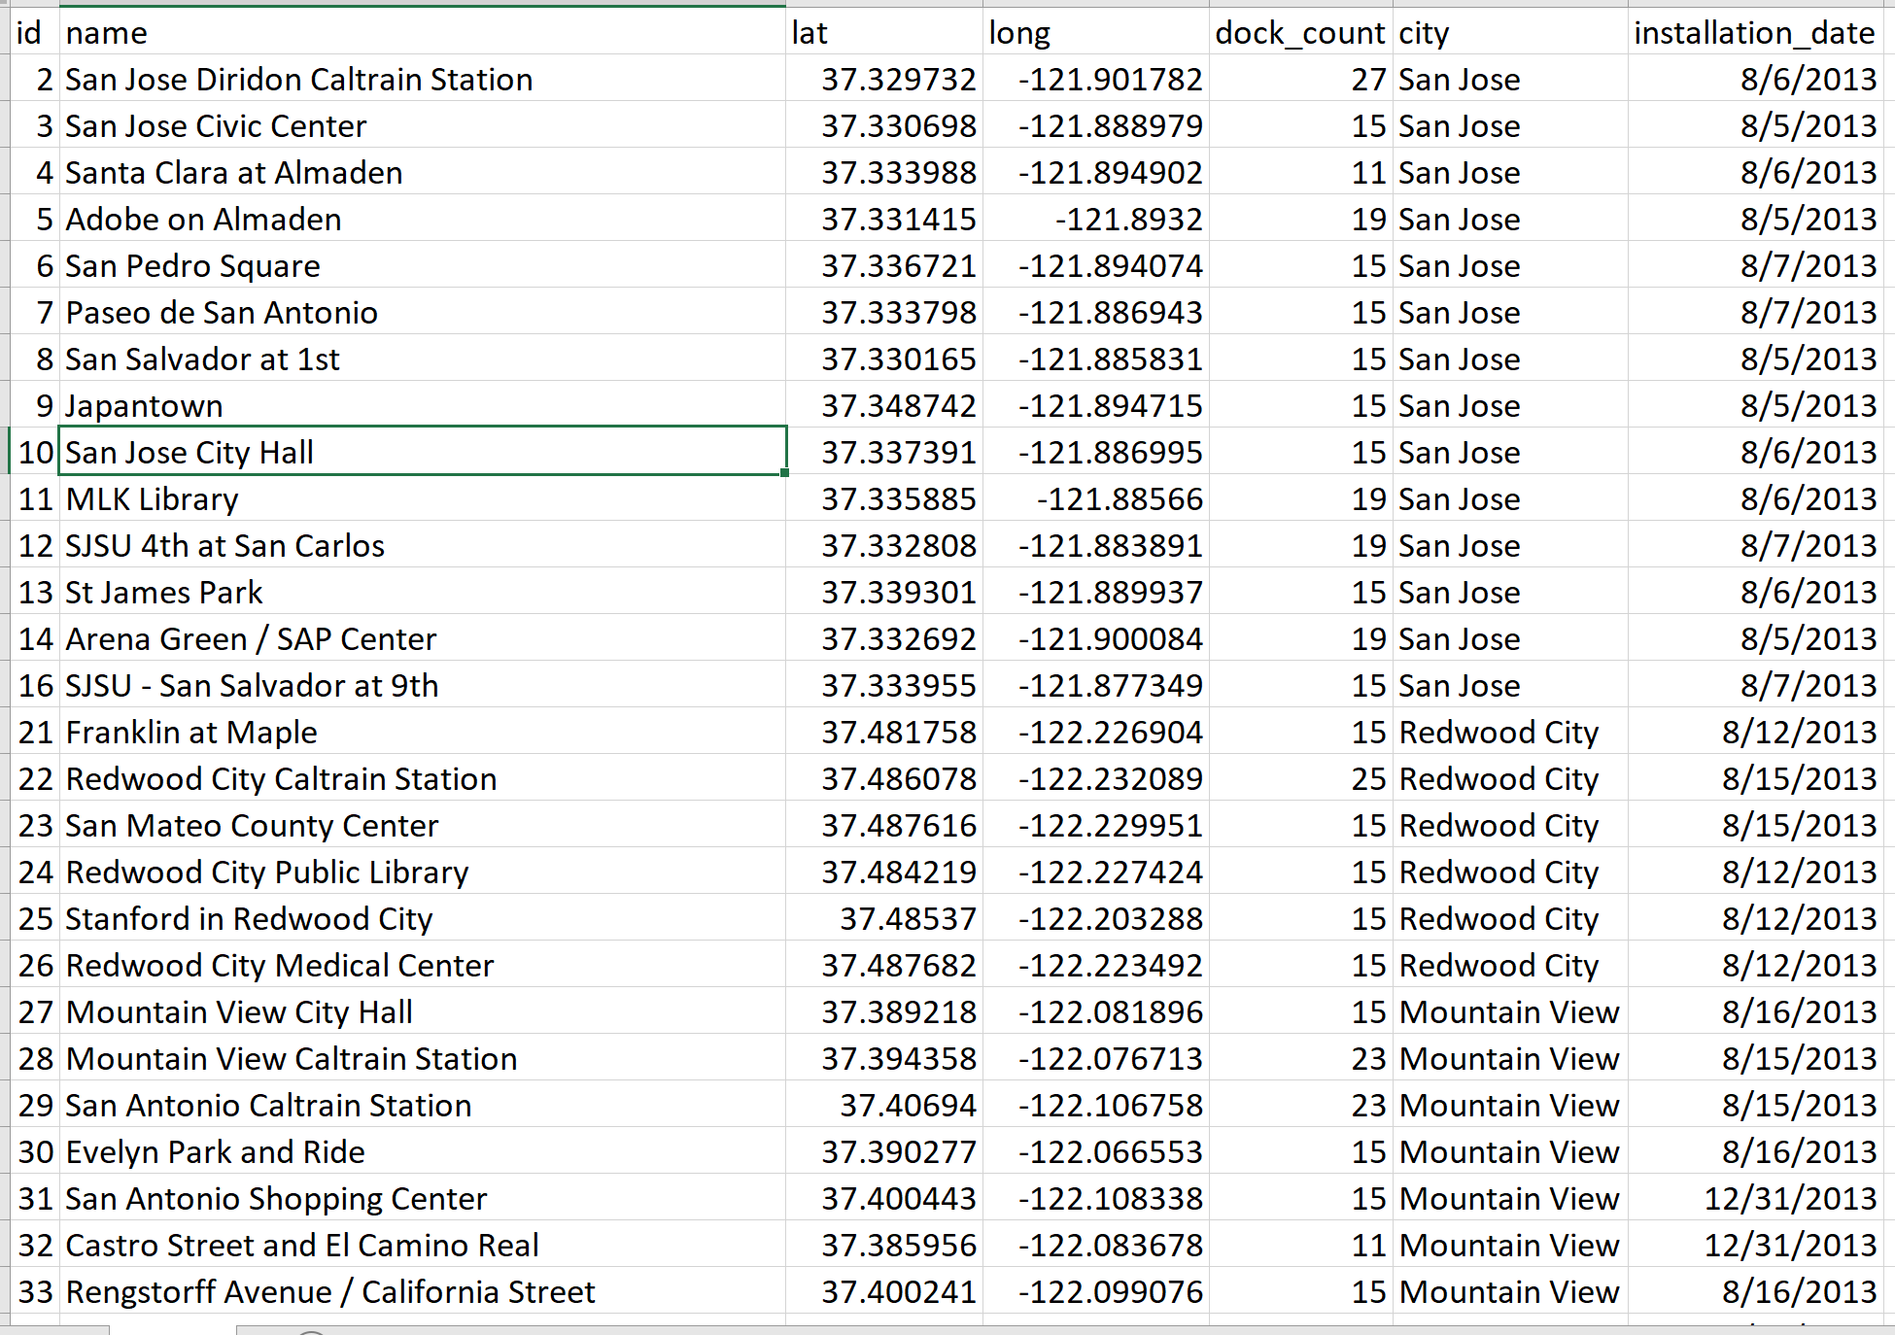

**Status Table:**

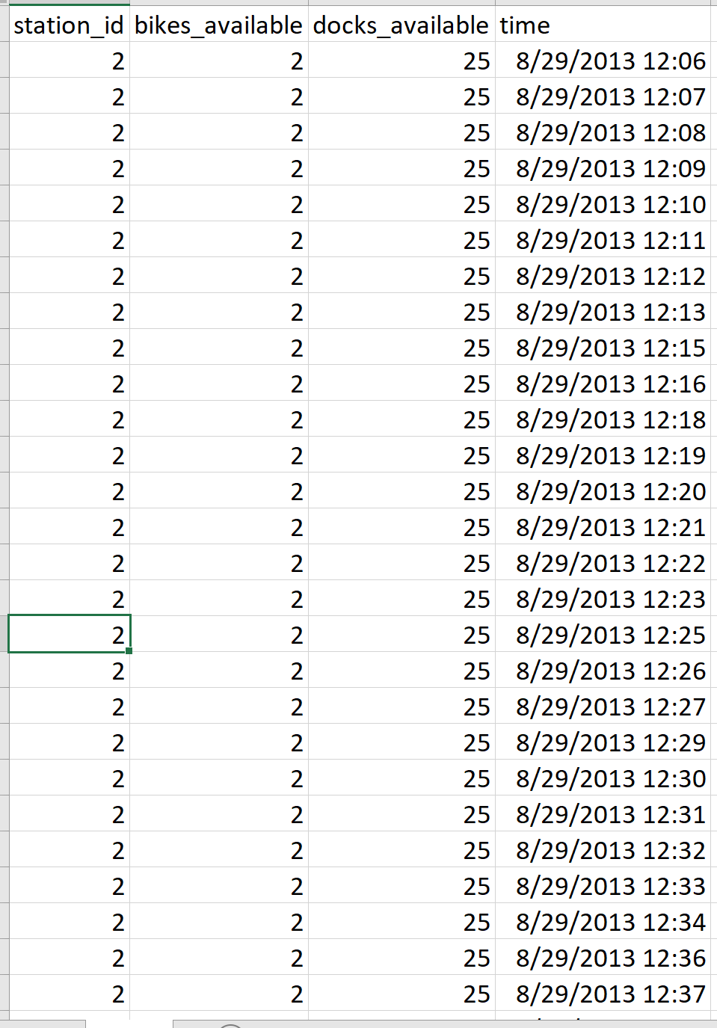

**Trip Table:**

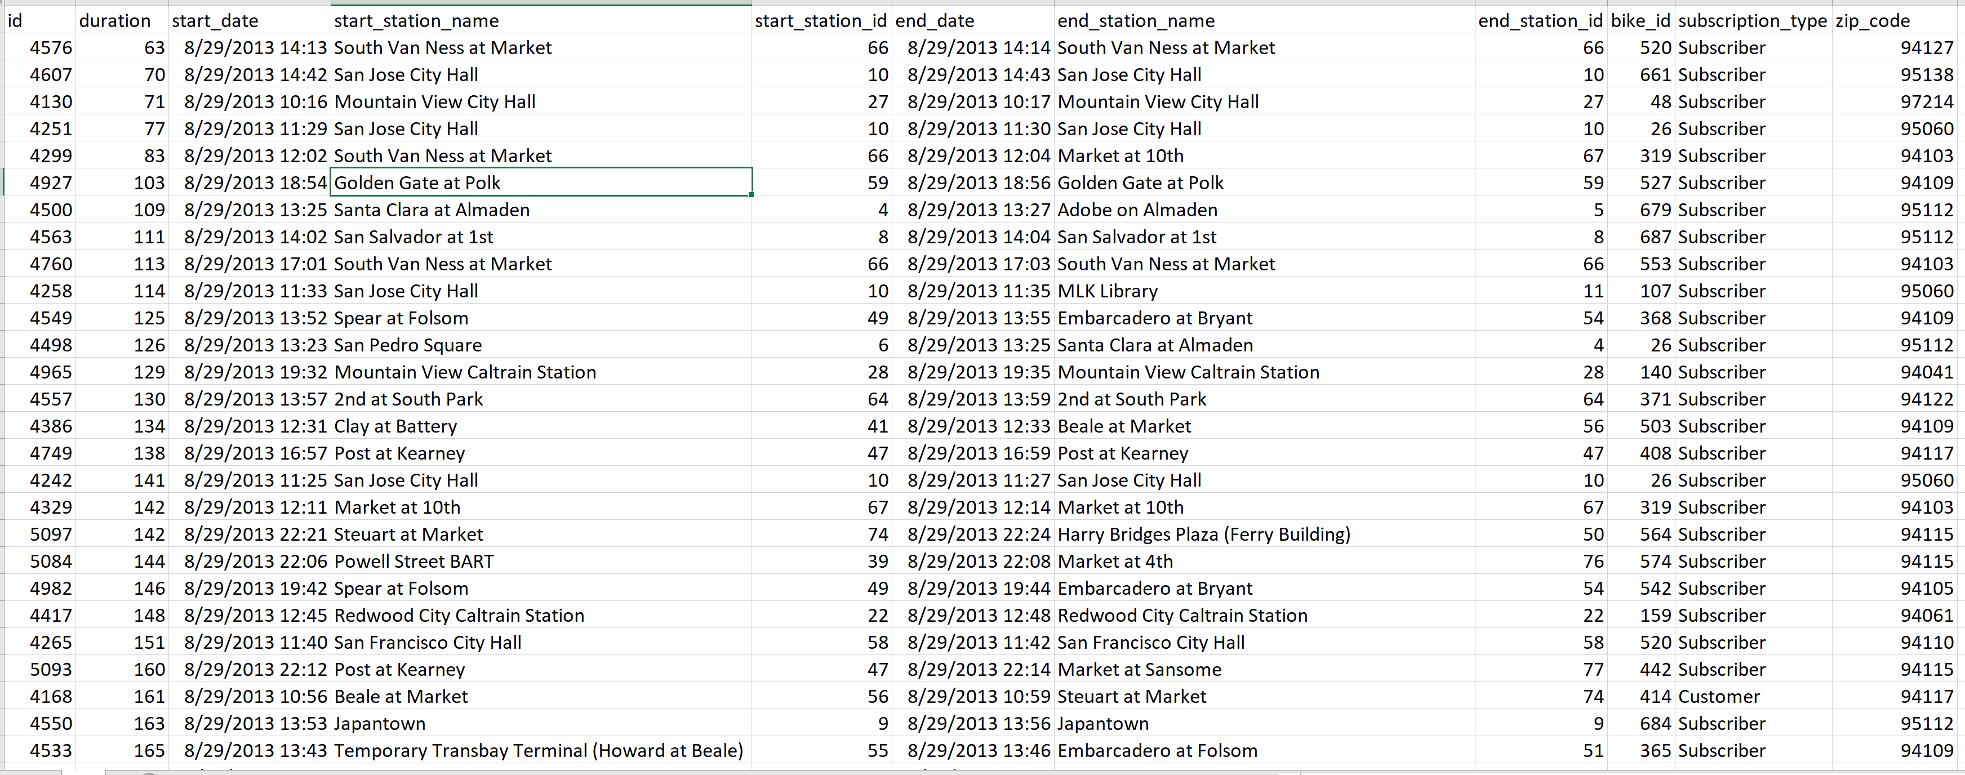

**Weather Table:**

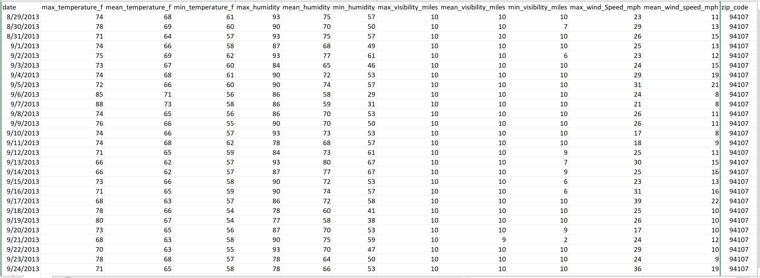

**Dataset2 – Questions from Cross Validated Stack Exchange Database.**

Stack Exchange is a network of question-and-answer (Q&A) websites on topics in diverse fields, each site covering a specific topic. As of August 2019, the 3 most actively viewed sites in the network are Stack Overflow, Super User and Ask Ubuntu.

This database is a sample database of the network and contains 3 related tables:

1. Table “Questions” contains the Id, title, body, creation date, score, and owner ID for each question.

2. Table “Answers” contains the Id, body, creation date, score, and owner ID for each of the answers to these questions. The ParentId column links back to the Questions table.

3. Table Tags contains the tags on each question.

**Motivation for selecting the database:**

This database is chosen to perform exploratory data analysis on Questions and Answers in stack overflow and understand the relationship between them. It helps in understanding the relevance of topics and identify interesting patterns in them.

**Tables and Relationships:**

1. Table “Questions” has primary key: Id (used to uniquely identify each question).

2. Table “Answers” has Primary Key: “Id”. It uses “ParentId” as Foreign Key to refer to table “Questions”.

3. Table Tags has Primary Keys: “Id” and “Tags”. It uses “id” to refer to table “Questions”.

Questions Table:

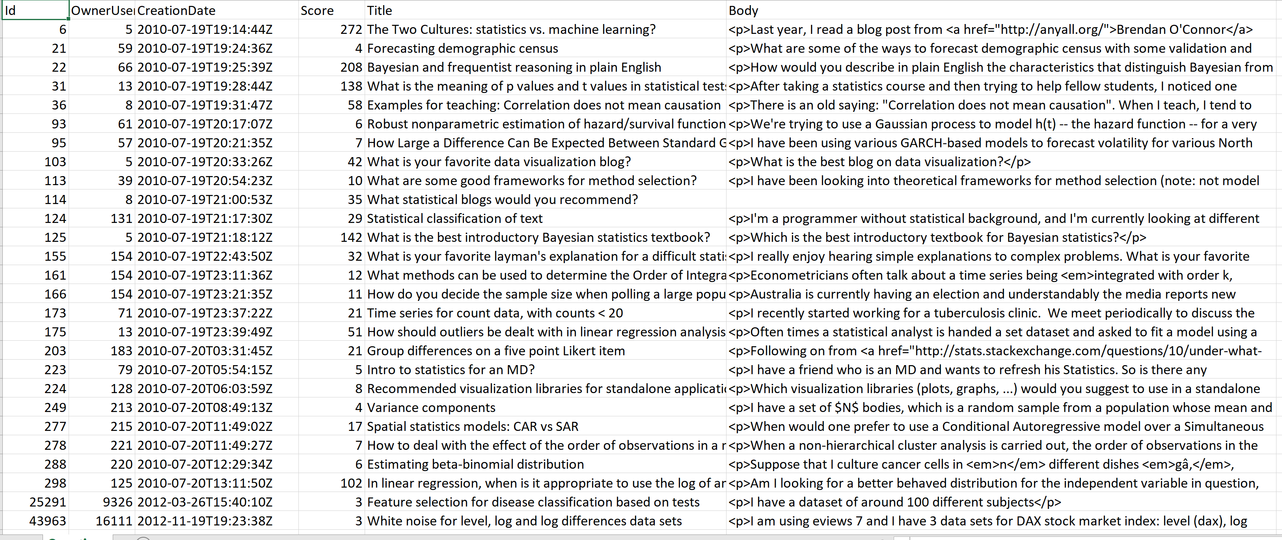

Answers Table:

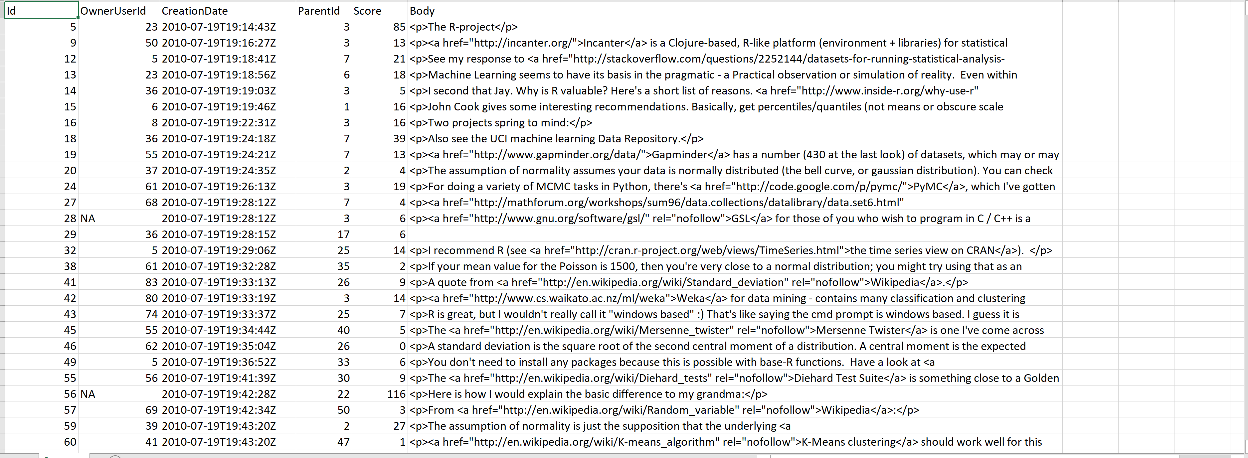

Tags Table:

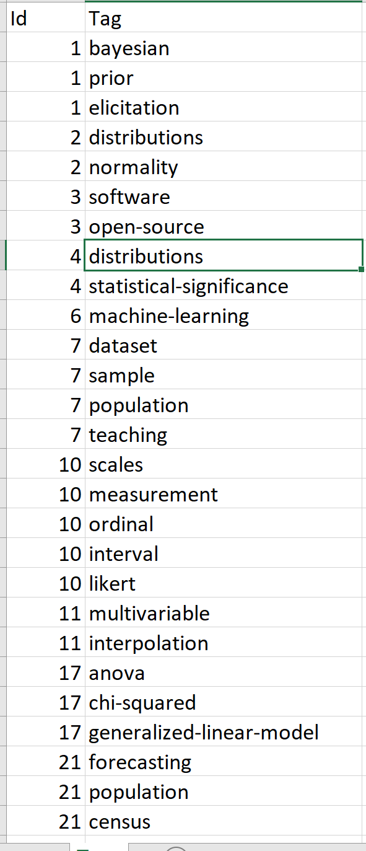

**Dataset3 – Novel Corona Virus.**

On 31 December 2019, WHO was alerted to several cases of pneumonia in Wuhan City, Hubei Province of China. The virus did not match any other known virus. This raised concern because when a virus is new, we do not know how it affects people.

So daily level information on the affected people can give some interesting insights when it is made available to the broader data science community. Data is extracted from the google sheets.

This database is a sample database of the pandemic and contains 4 related tables:

1. Table “covid_19_data” contains the Sno, Observation Date, Province/State, Country/Region, Last Update, Confirmed, Deaths and Recovered attributes.

2. Table “Deaths” contains Country/Region, Provice/State, lat, long and date-wise details about deaths cases due to the pandemic.

3. Table “Recovered” contains Country/Region, Provice/State, lat, long and date-wise details about recovered cases due to the pandemic.

4. Table “Confirmed” contains Country/Region, Provice/State, lat, long and date-wise details about confirmed cases of the pandemic.

**Motivation for selecting the database:**

2019 Novel Coronavirus (2019-nCoV) is a virus (more specifically, a coronavirus) identified as the cause of an outbreak of respiratory illness first detected in Wuhan, China. Early on, many of the patients in the outbreak in Wuhan, China reportedly had some link to a large seafood and animal market, suggesting animal-to-person spread. However, a growing number of patients reportedly have not had exposure to animal markets, indicating person-to-person spread is occurring. At this time, it’s unclear how easily or sustainably this virus is spreading between people - [CDC](https://www.cdc.gov/coronavirus/2019-ncov/about/index.html)

This dataset has daily level information on the number of affected cases, deaths and recovery from 2019 novel coronavirus.

**Tables and Relationships:**

1. Table “covid_19_data” has primary key: Sno (used to uniquely identify each case).

2. Table “Confirmed” has Primary Key: “Country/Region”. It uses “Country/Region” and “State/Province” as Foreign Key to refer to table “covid_19_data”.

3. Table “Deaths” has Primary Key: “Country/Region”. It uses “Country/Region” and “State/Province” as Foreign Key to refer to table “covid_19_data”.

4. Table “Recovered” has Primary Key: “Country/Region”. It uses “Country/Region” and “State/Province” as Foreign Key to refer to table “covid_19_data”.

COVID_19 Data Table:

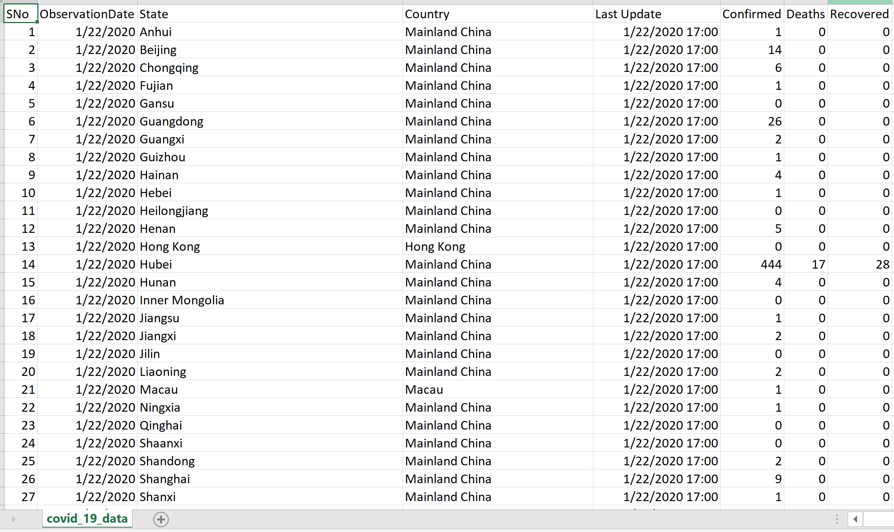

COVID_19 Confirmed Cases Table:

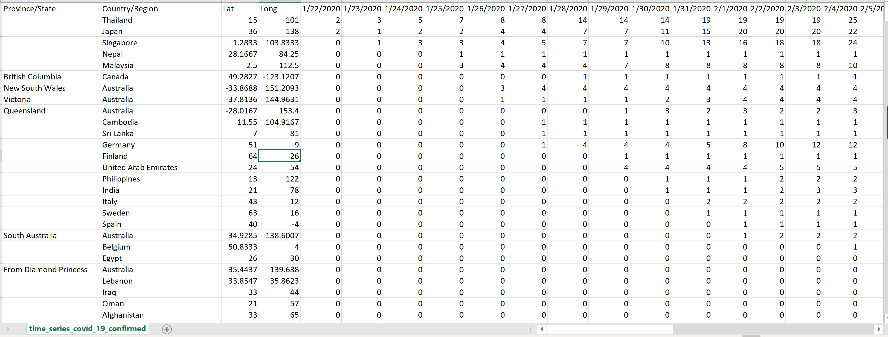

COVID_19 Death Cases Table:

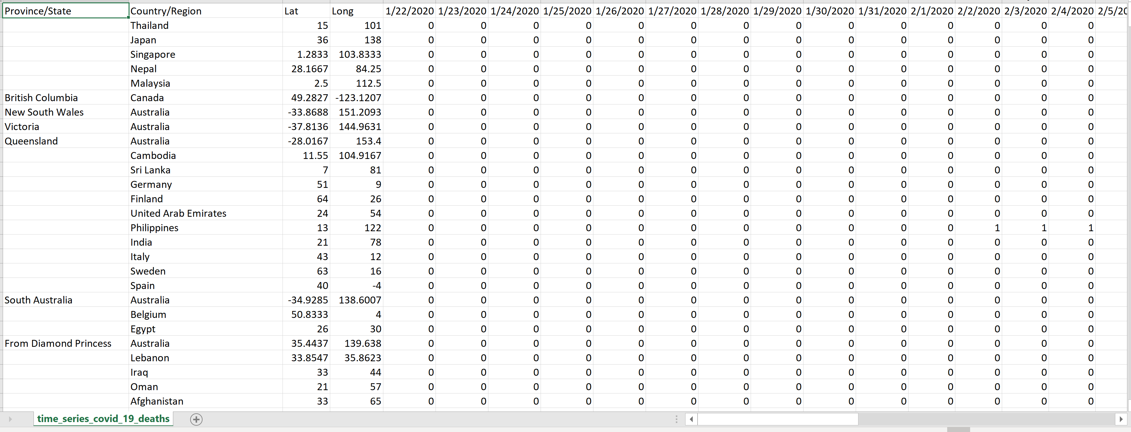

COVID_19 Recovered Cases Table:

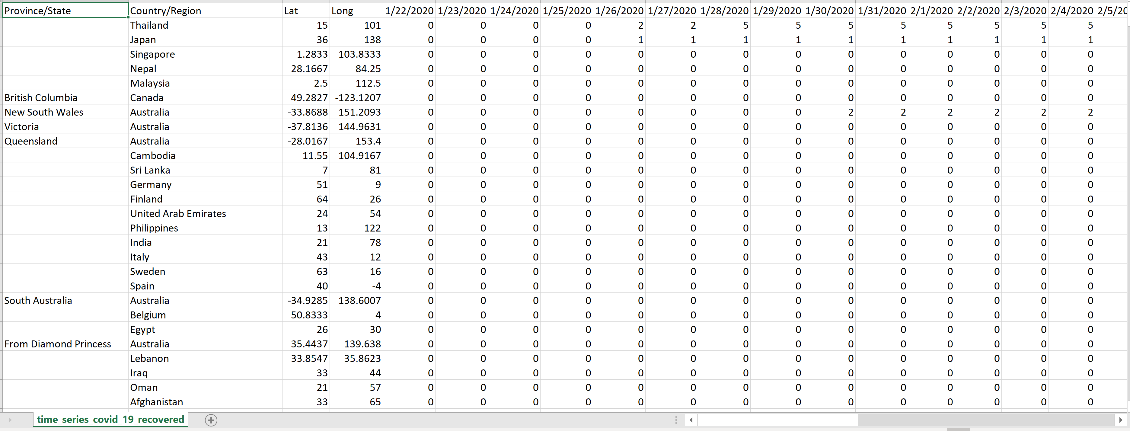

**Dataset4 – World Dataset (provided by the teaching faculty).**

Country Table:

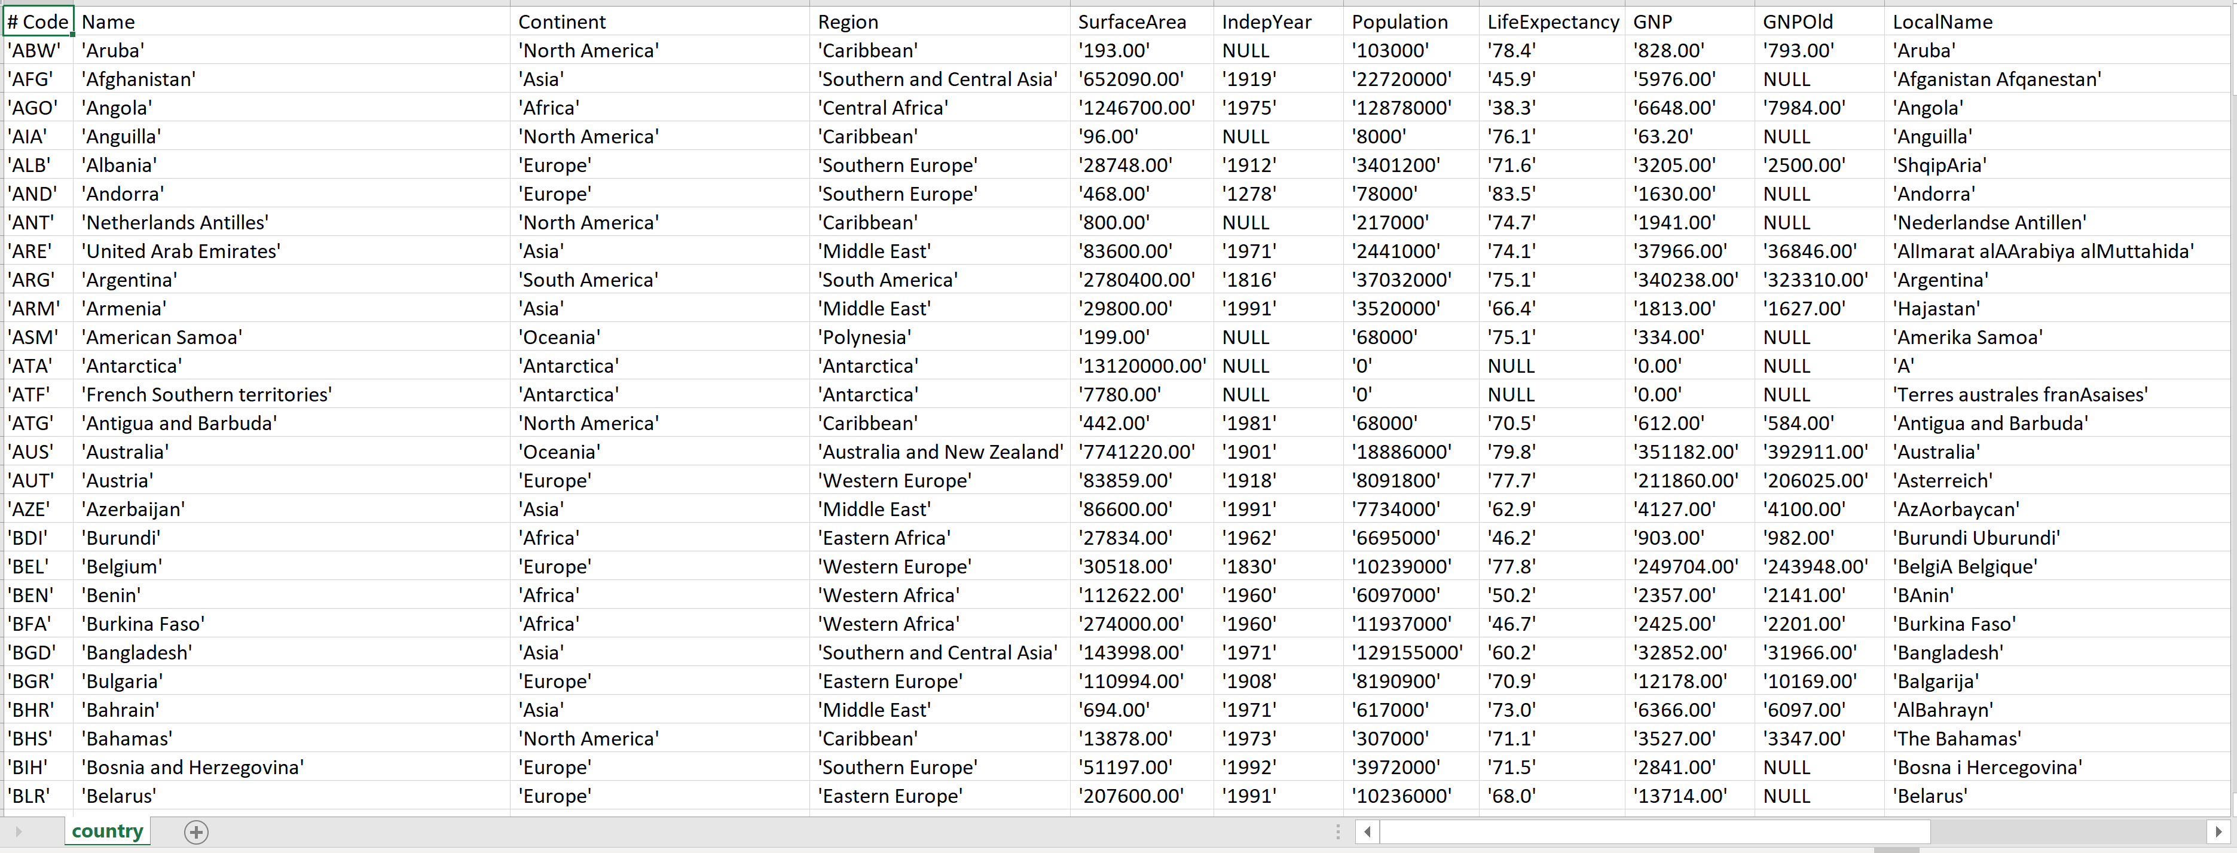

City Table:

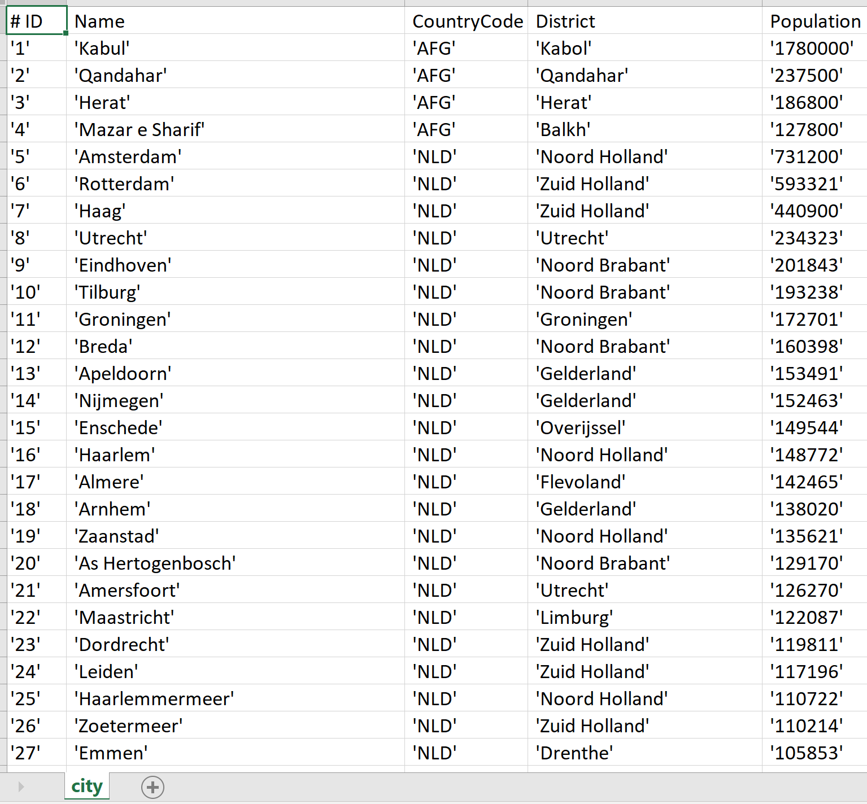

Country Language Table:

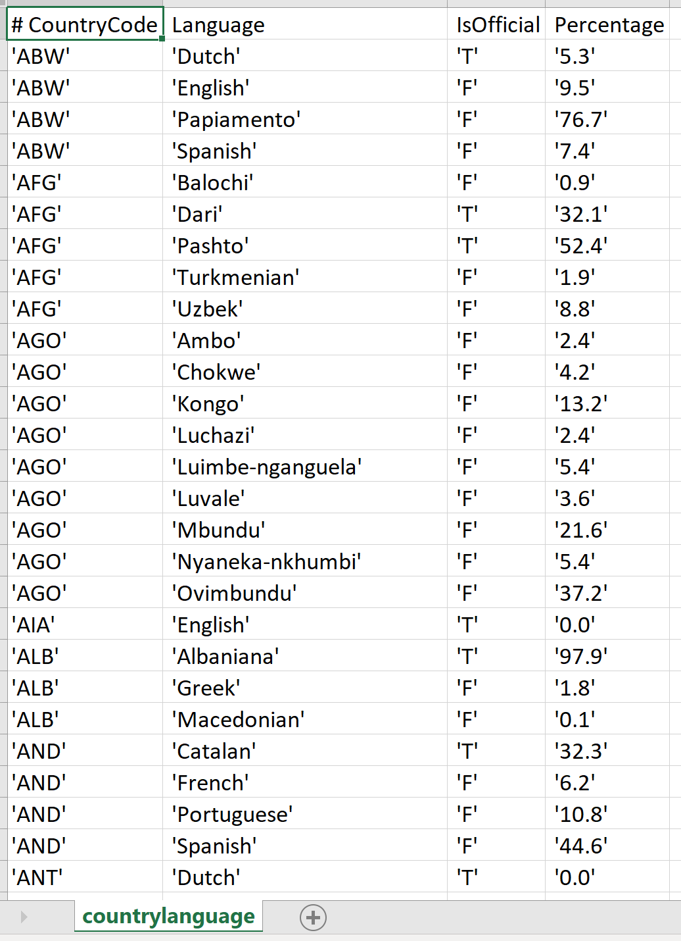

# Technologies Used:

Front End:

<To be filled by Tejaswini>

Back End:

1. Kaggle – for downloading the datasets.
2. Python – to automate the back end process.
3. Amazon EC2 – to create and maintain MySQL DB used to store the CSV files as MySQL databases.
4. MySQL Connector – Used to connect Python Program with MySQL DB.
5. Pymysql – Connector used to load large MySQL databases onto Google Firebase on cloud.
6. Google Firebase – Real-Time database used for keyword exploration of the data present in the tables.

# UI Interface:

<To be filled by Tejaswini>.

# Project Implementation Roadmap:

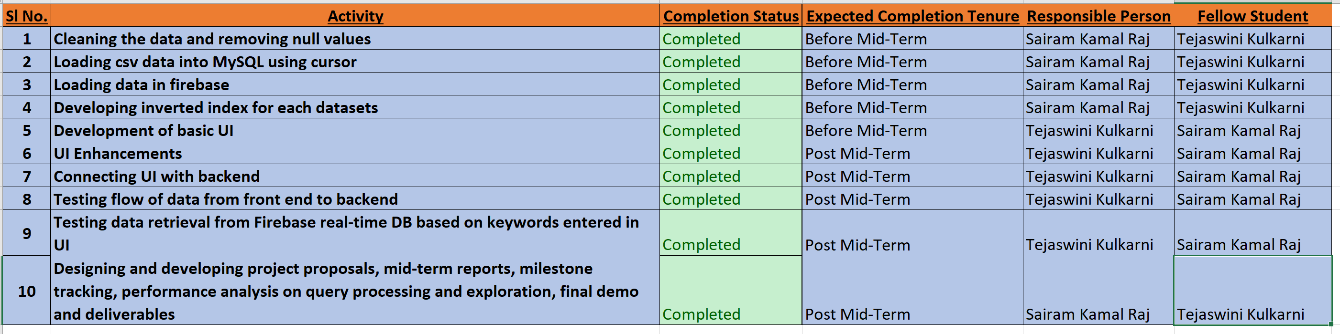

As it can be observed, we completed the entire project on-time and as per schedule.

# Completed Components:

Back End – Real-Time Database (Firebase):

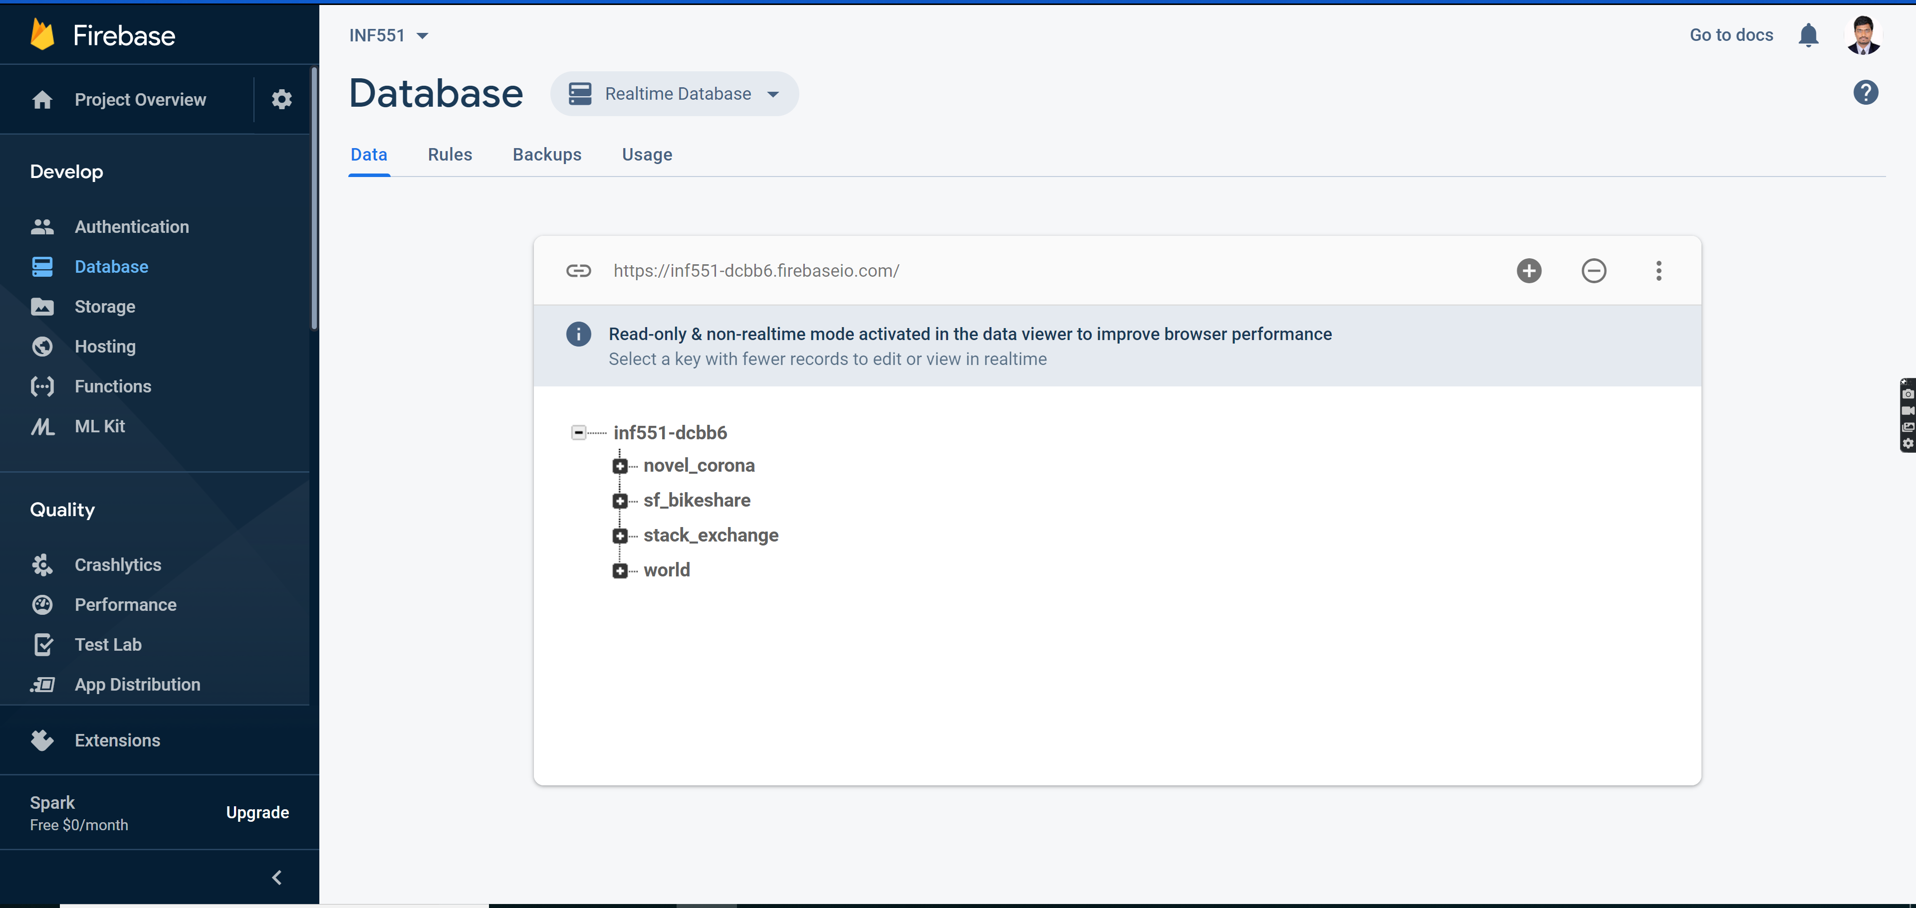

As per the instructions provided in the course, we created a real-time database using firebase and followed the below process to load our required datasets:

1. Loaded the data from kaggle onto a dataframe and cleaned the data.
2. Data cleansing process involved the following steps:
   * 1. Ensuring that the correct file format was used to read the files in order to overcome errors like file not been able to decode utf-8 and avoiding special characters which hinders loading data onto Firebase.
     2. Formatting all the column names and renaming them incase if they are dirty: lowercase and removing of special characters (except underscore and white space).
     3. Obtaining column datatypes for all the features and ensuring that the data follows the domain constraints.
     4. Converting the format of date columns to YYYY-MM-DD, a format that is in compliant with MySQL database.
     5. Removing html specific tags such as <p>, </p> etc… that were present in stack overflow data.
     6. Dropped duplicate rows in the data.
     7. Cleansing of null values by replacing with 0’s or “Unavailable” based on the datatype of the column.
     8. Testing of removal of data that hinders loading onto firebase.
3. Setting up of MySQL database in EC2 with root credentials and created the required tables and provided all privileges to user INF551.
4. Automated the process of loading the values in MySQL from the datasets using Python code.
5. Automated the process of extracting data from MySQL database using python using input parameters as database name and the name of the database to be written in firebase.
6. Created JSON data from the data which is present on MySQL using Python scripts.
7. Utilized the created JSON data to load on to the firebase.
8. Created inverted index for each dataset which included the following steps:
   * 1. Reading the text data from each of the datasets individually.
     2. Cleansing the text data by converting to lowercase, removing the special characters and splitting the data based on space.
     3. Indexing each file based on the primary keys.
9. Loading of data onto firebase, included the following tasks:

Ensure that there is no pre-existing data. Deletion of data if it is already present on the firebase and loading data fresh.

Loading of clean data on firebase real-time database.

Python script to load MySQL DB:

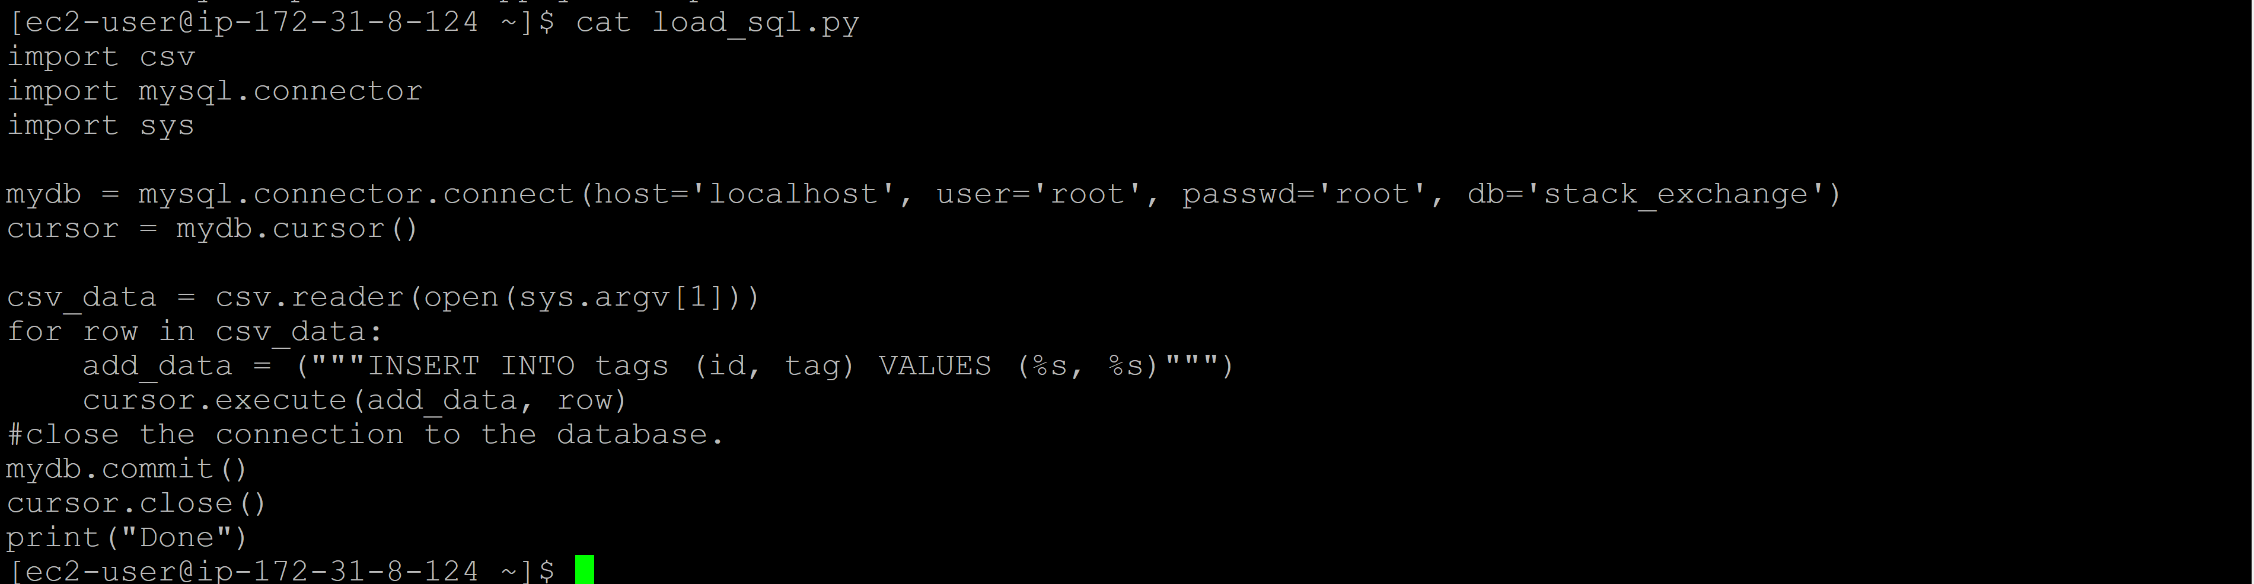

MySQL DB Data:

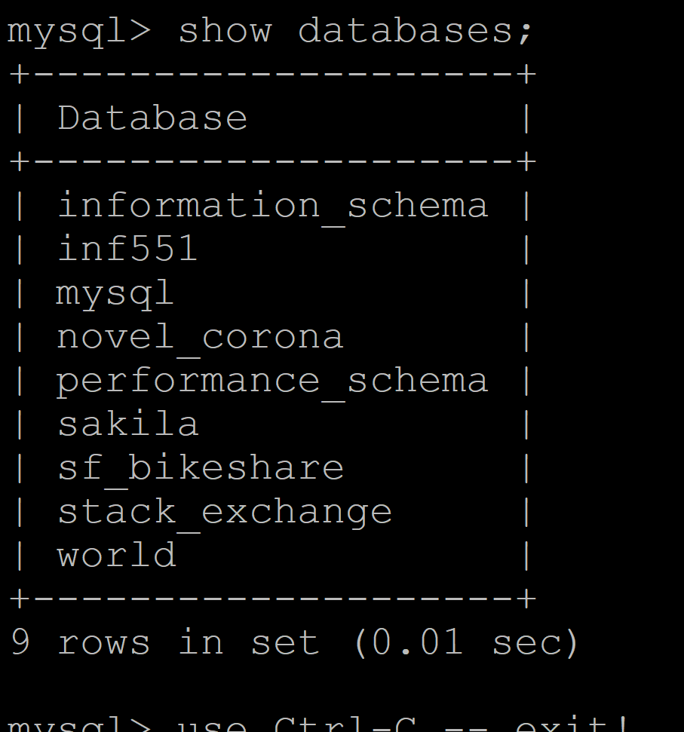

Tables in sf_bikeshare DB

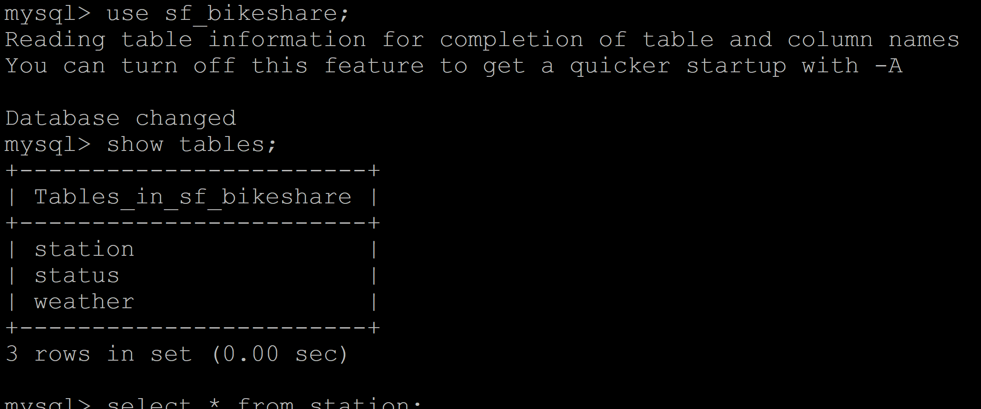

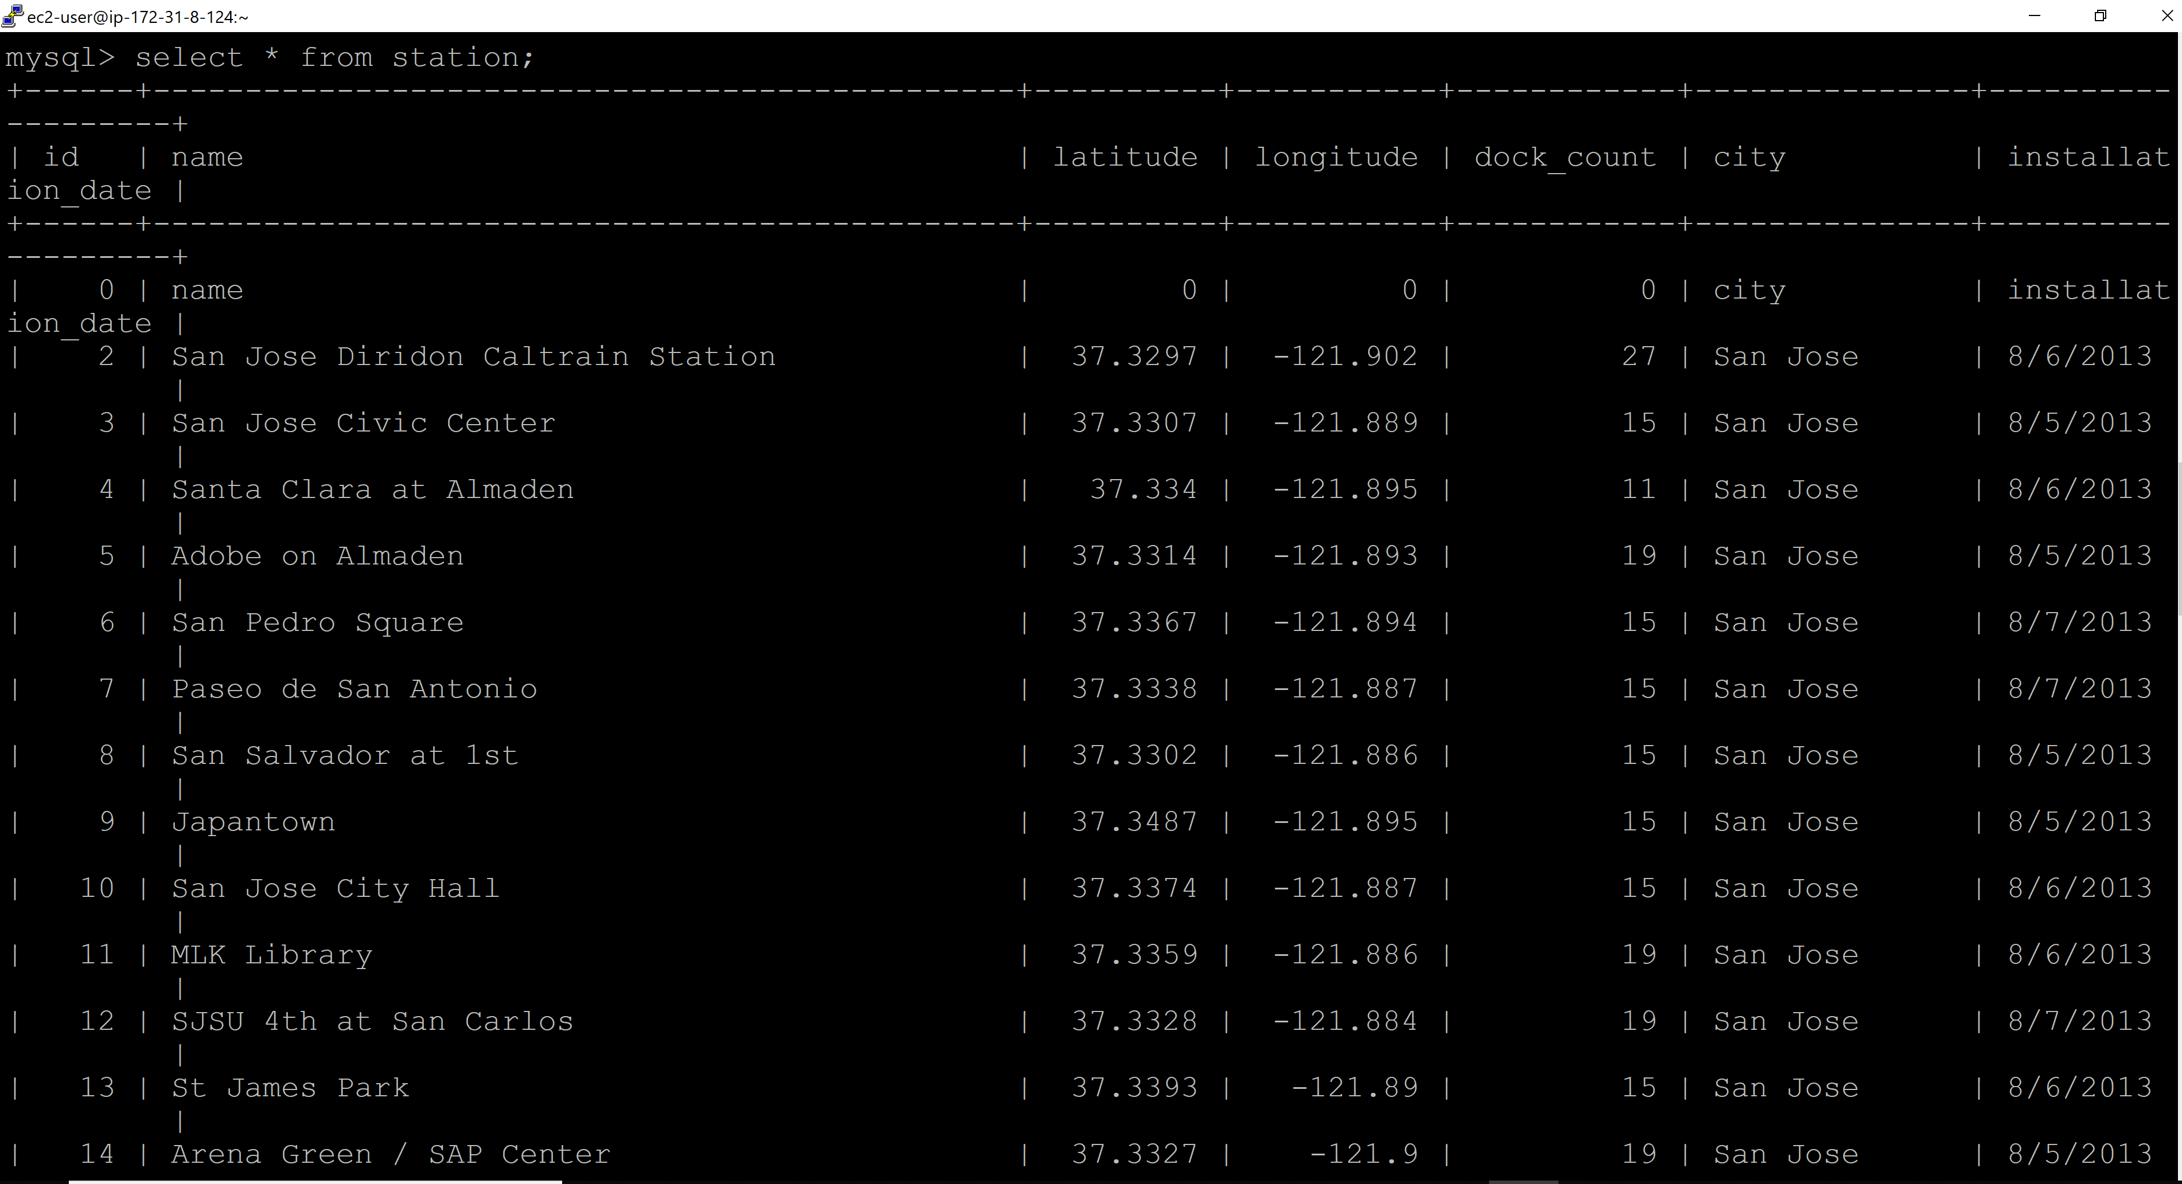

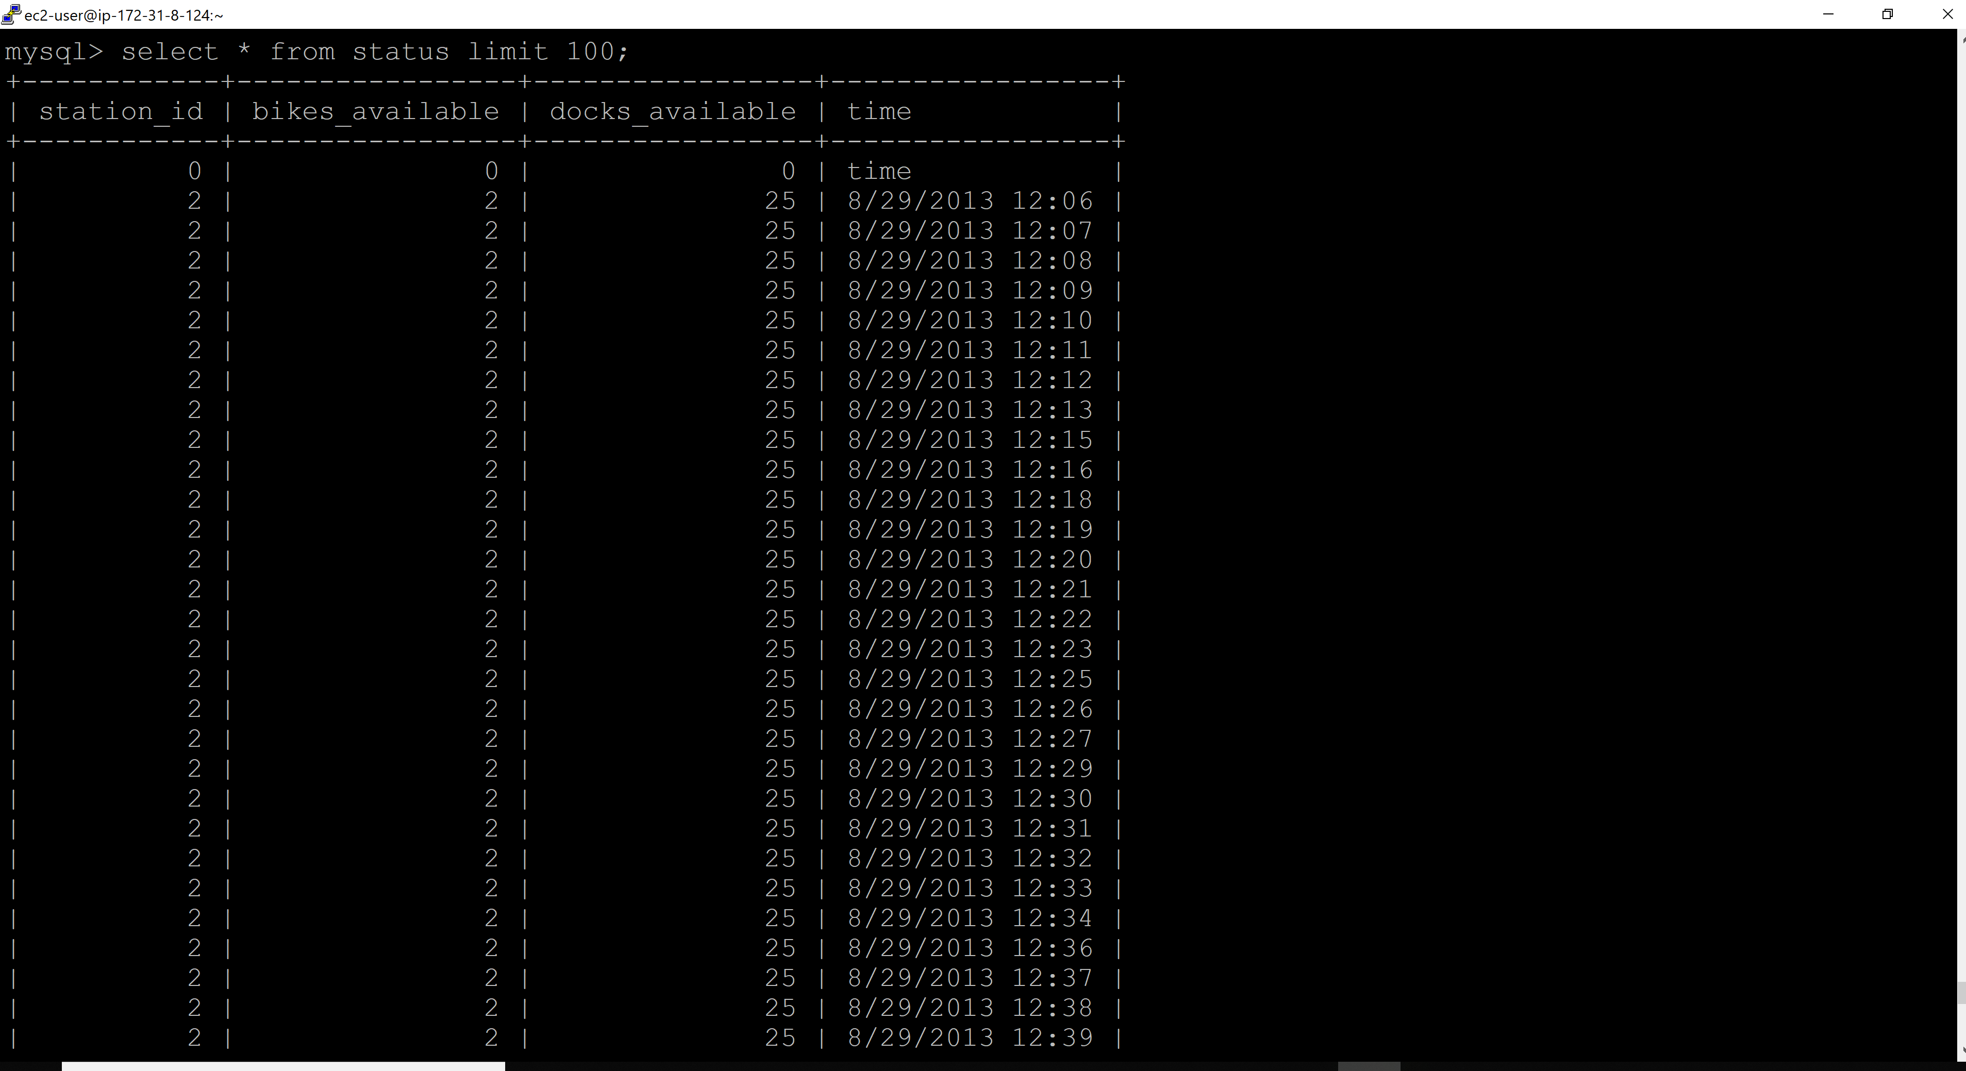

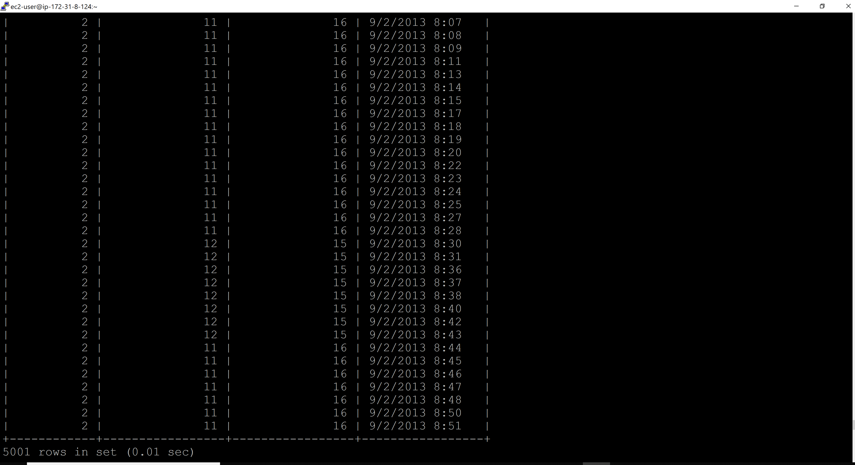

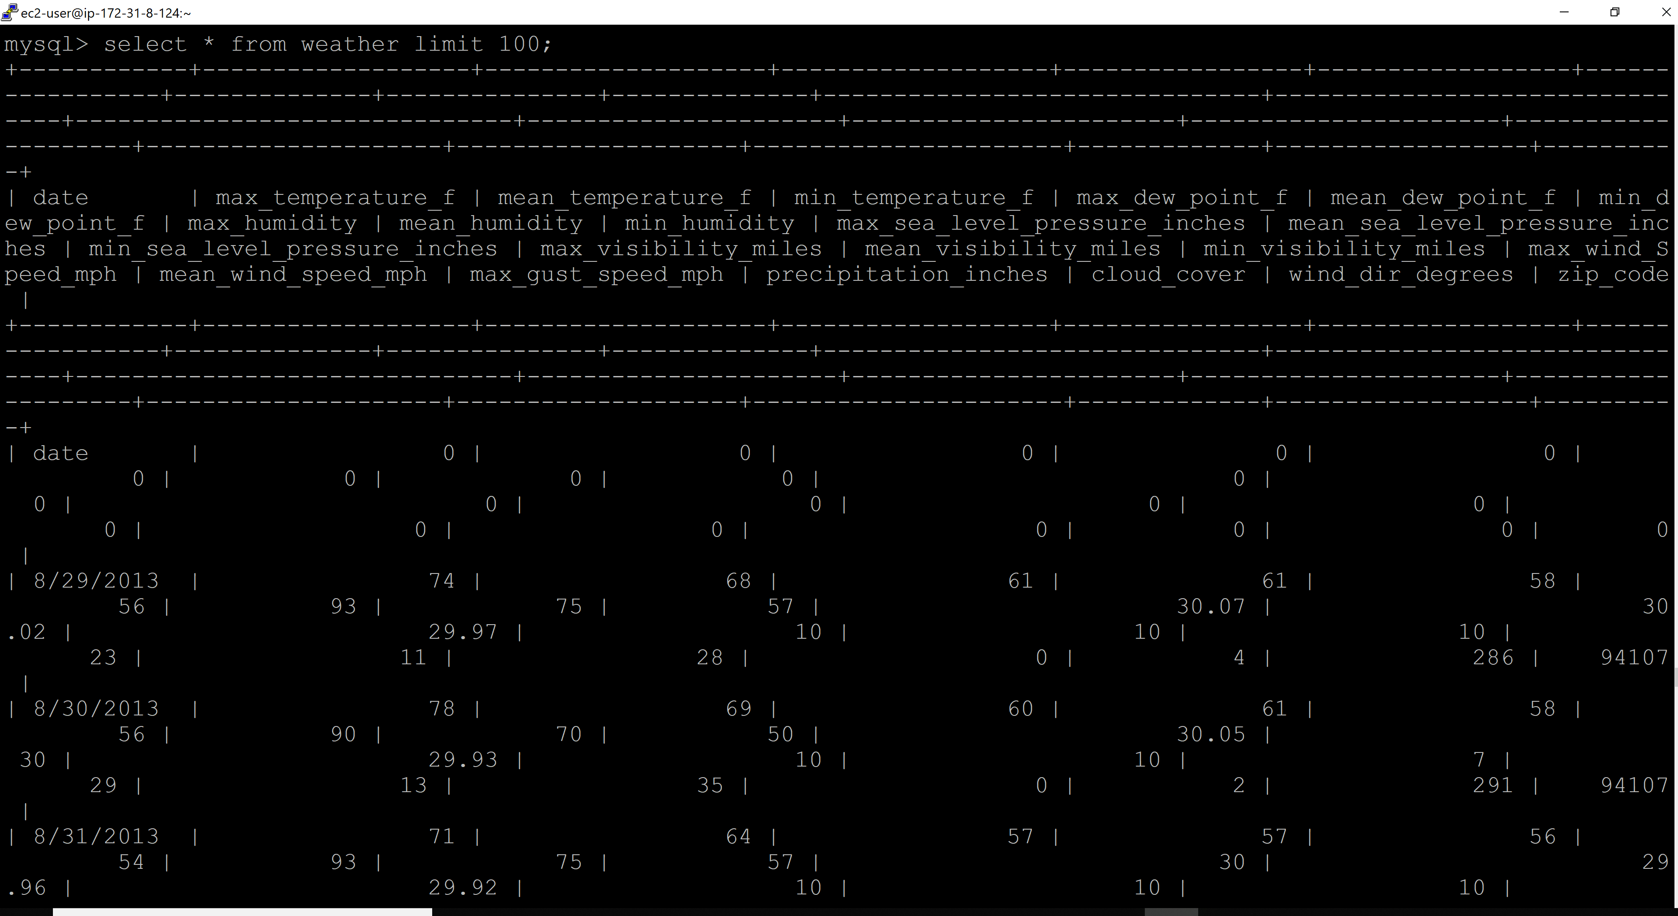

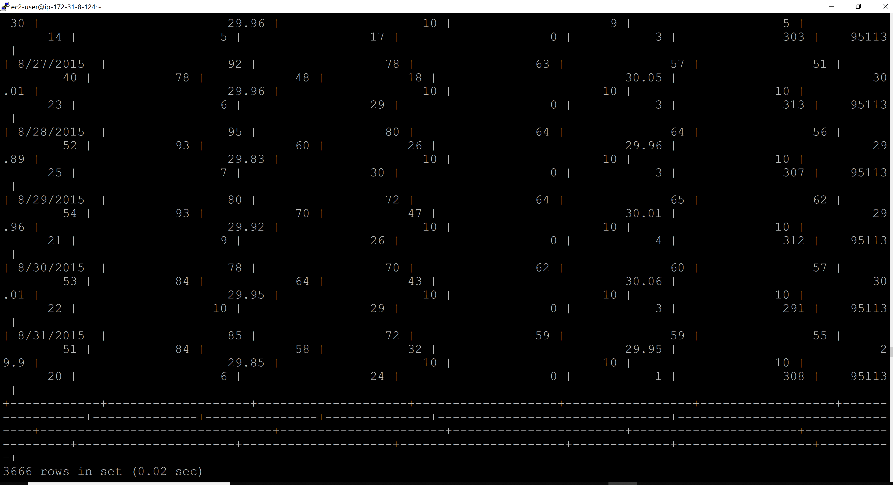

Tables in stack_exchange DB:

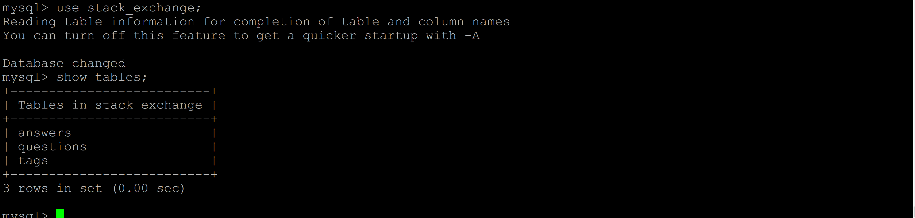

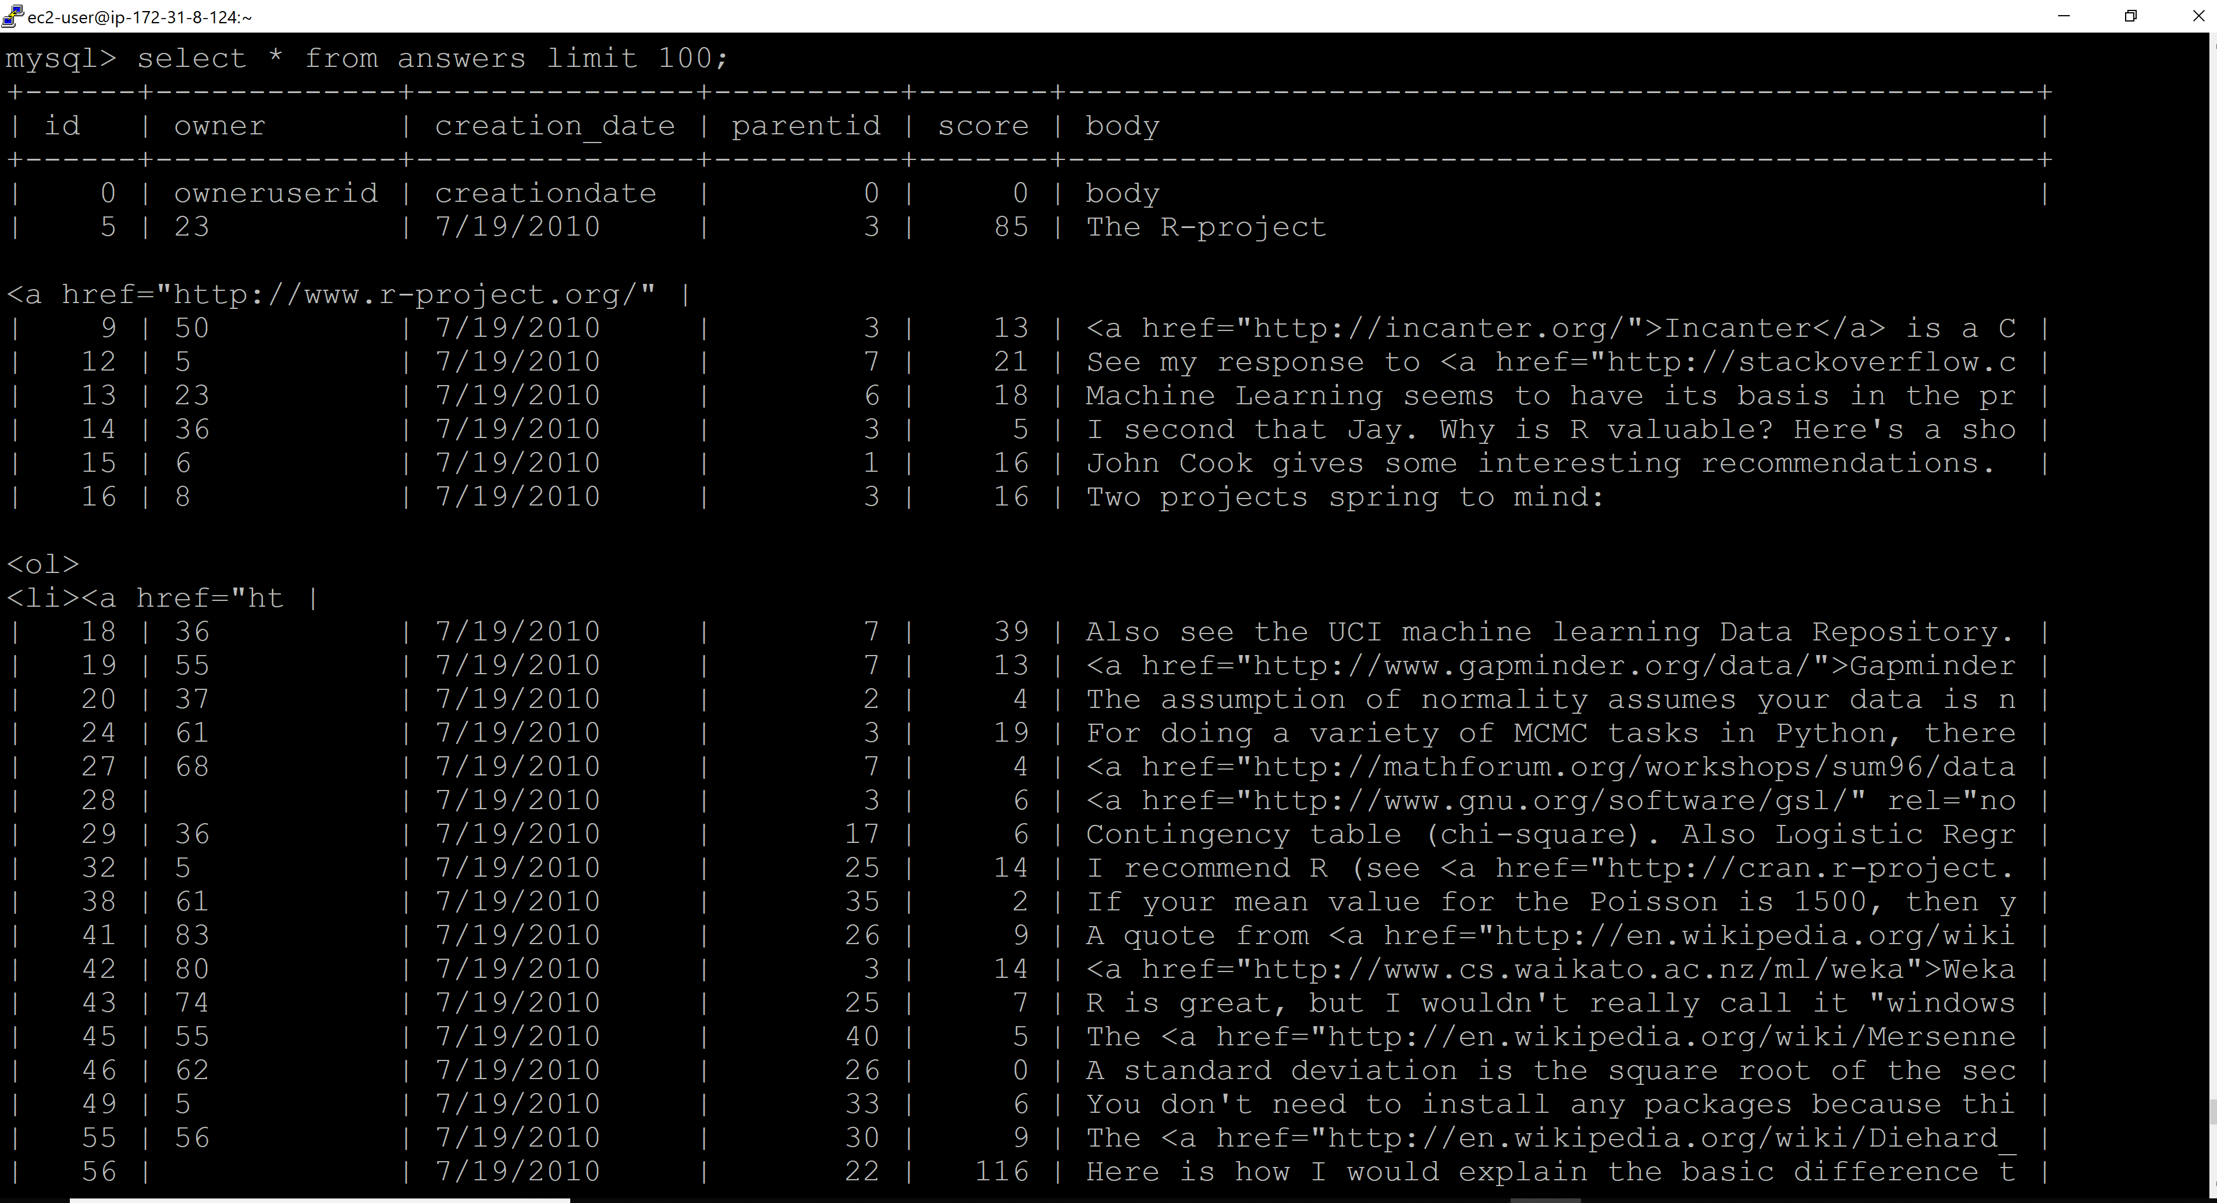

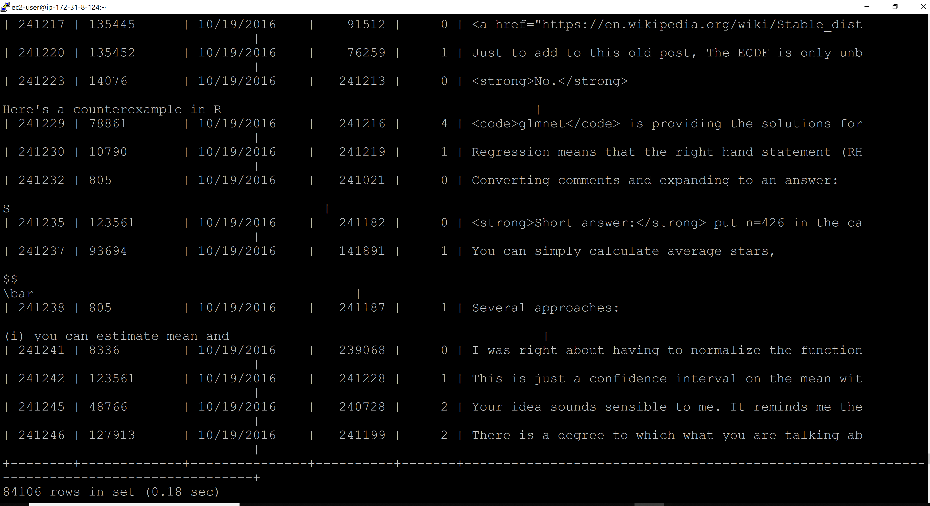

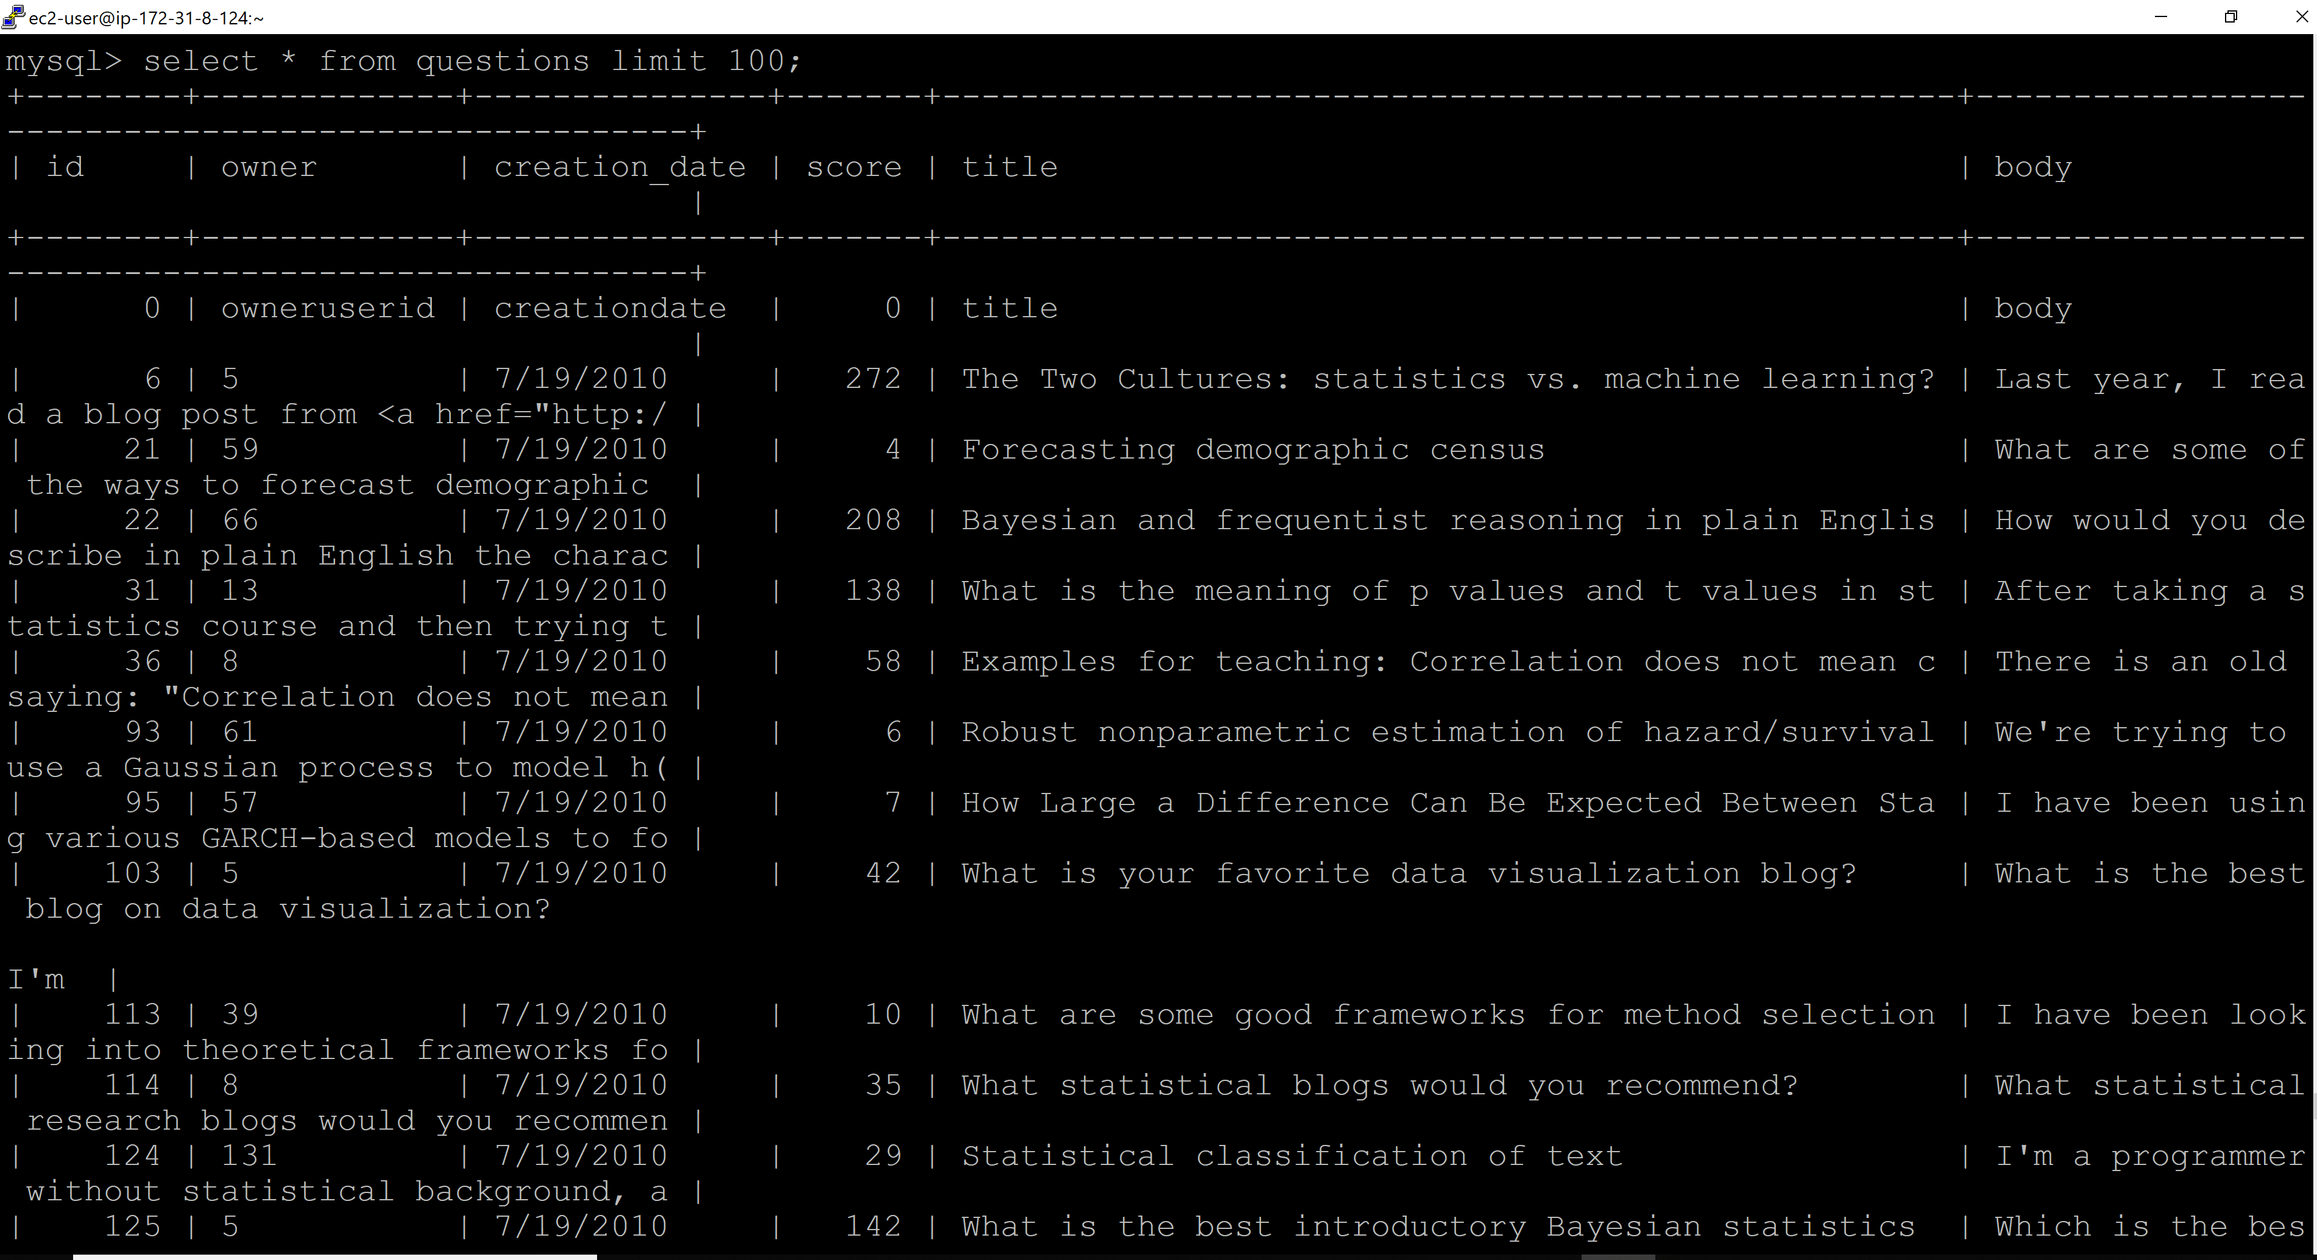

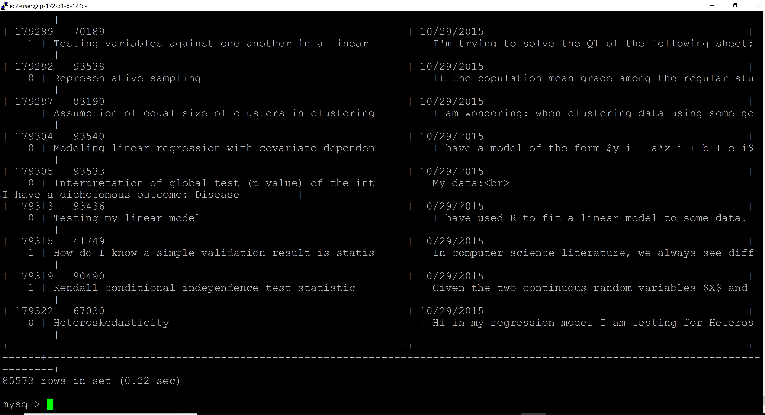

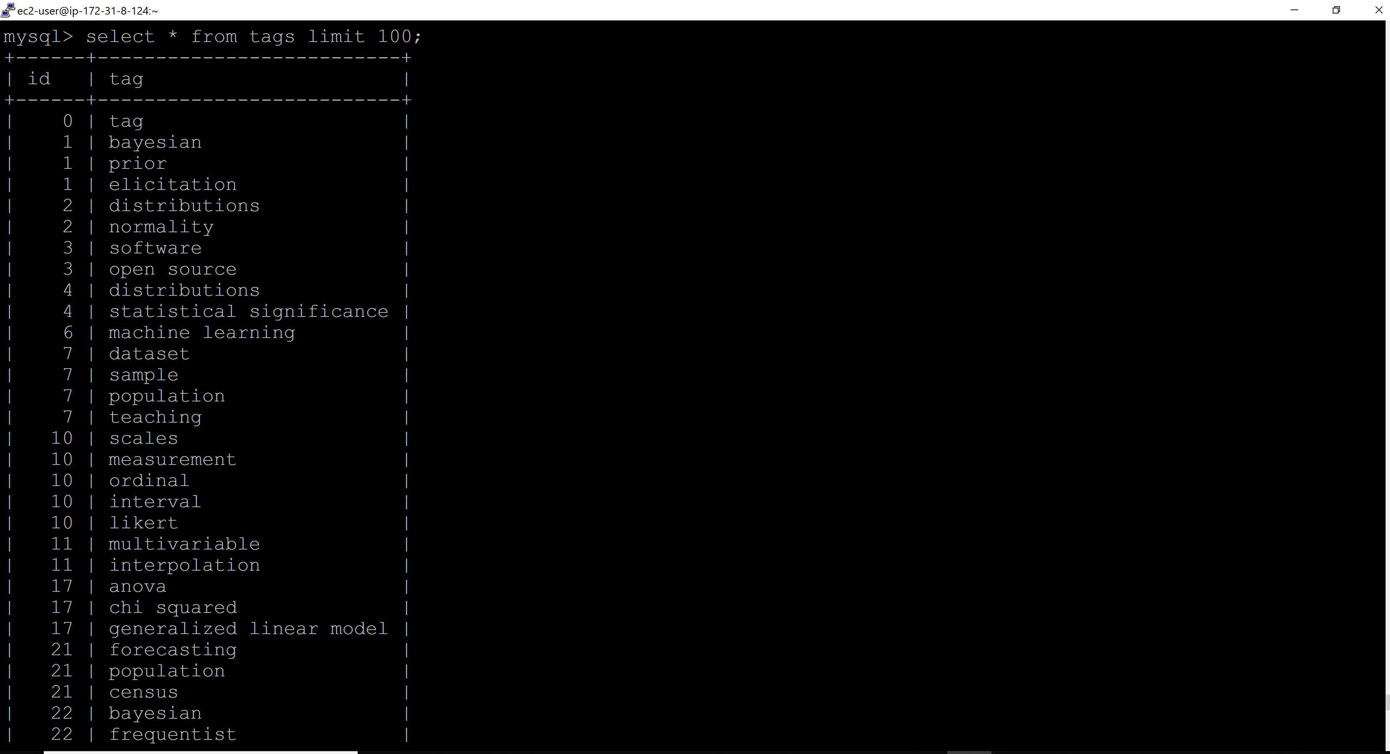

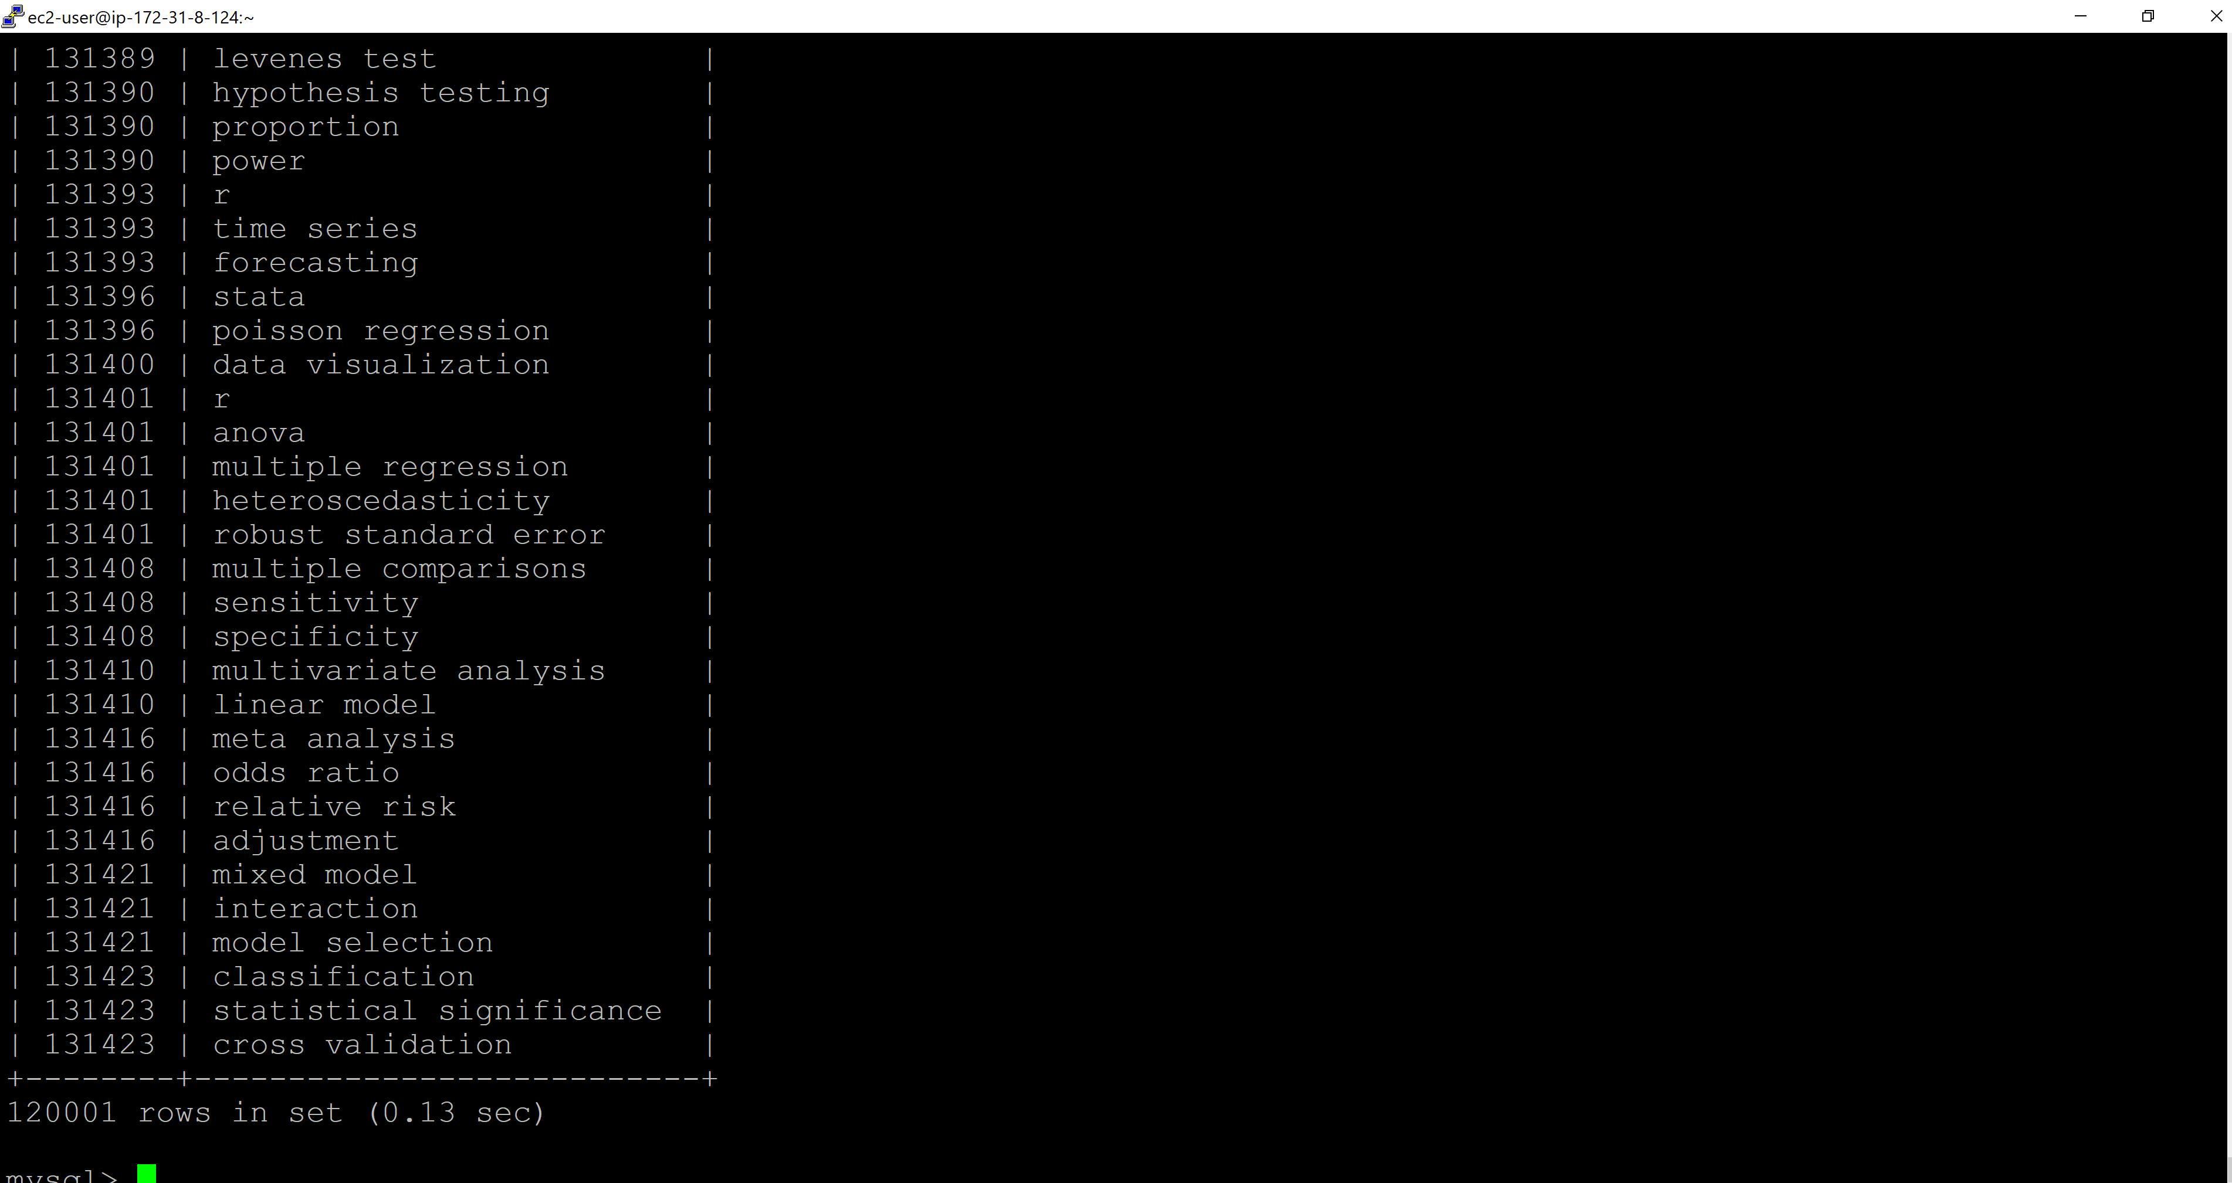

Tables in novel_corona DB:

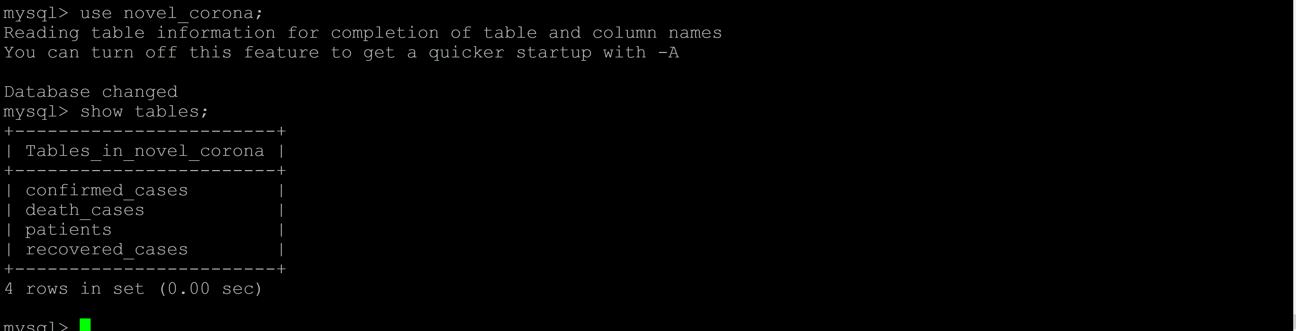

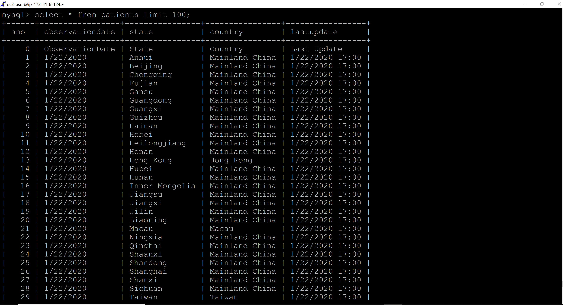

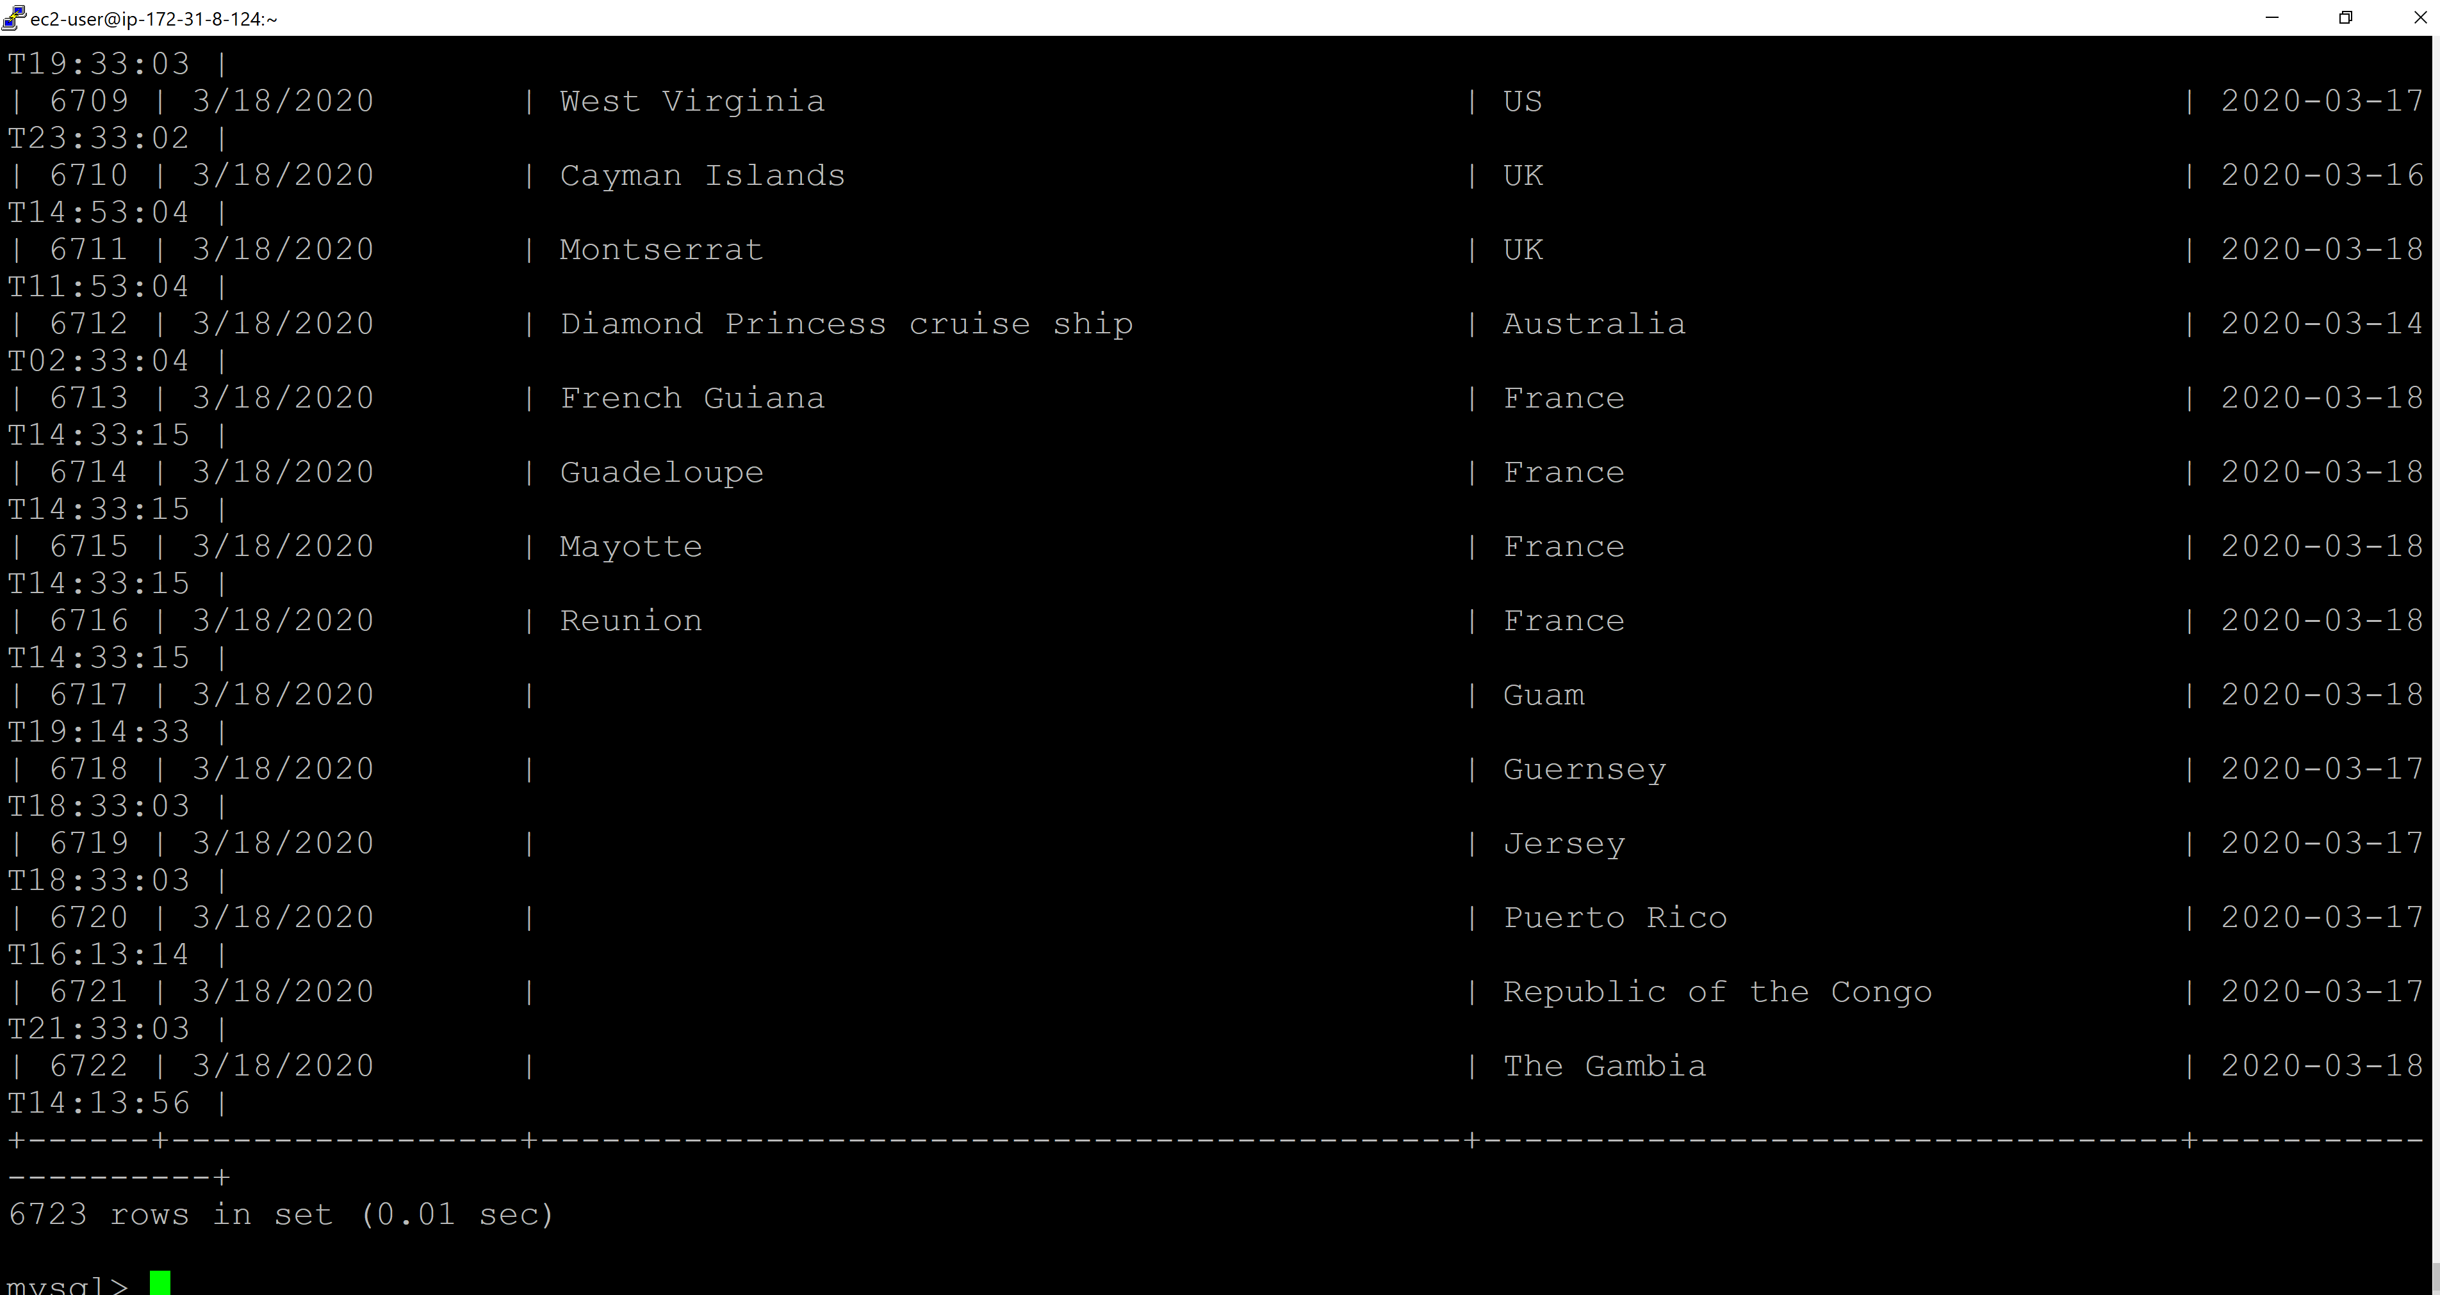

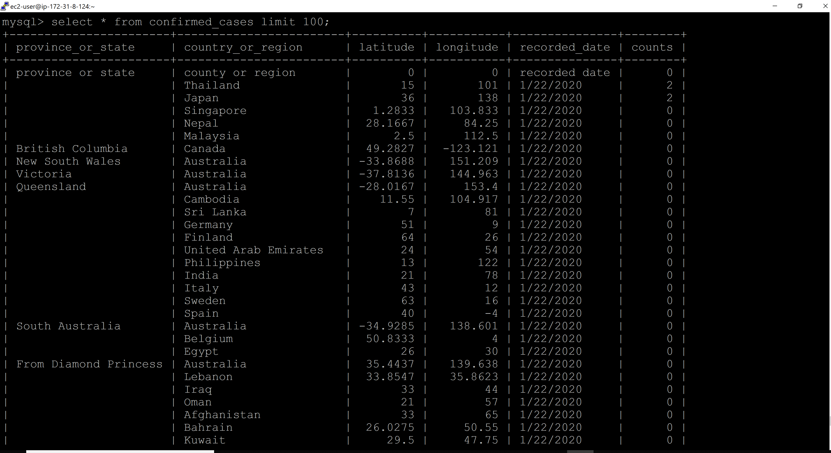

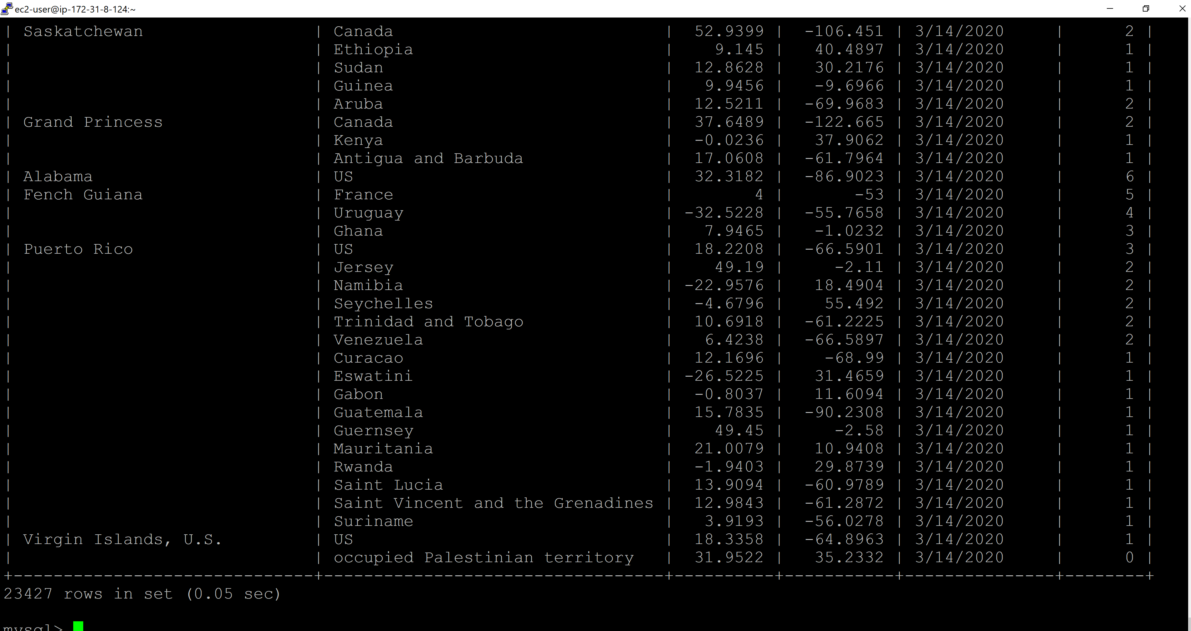

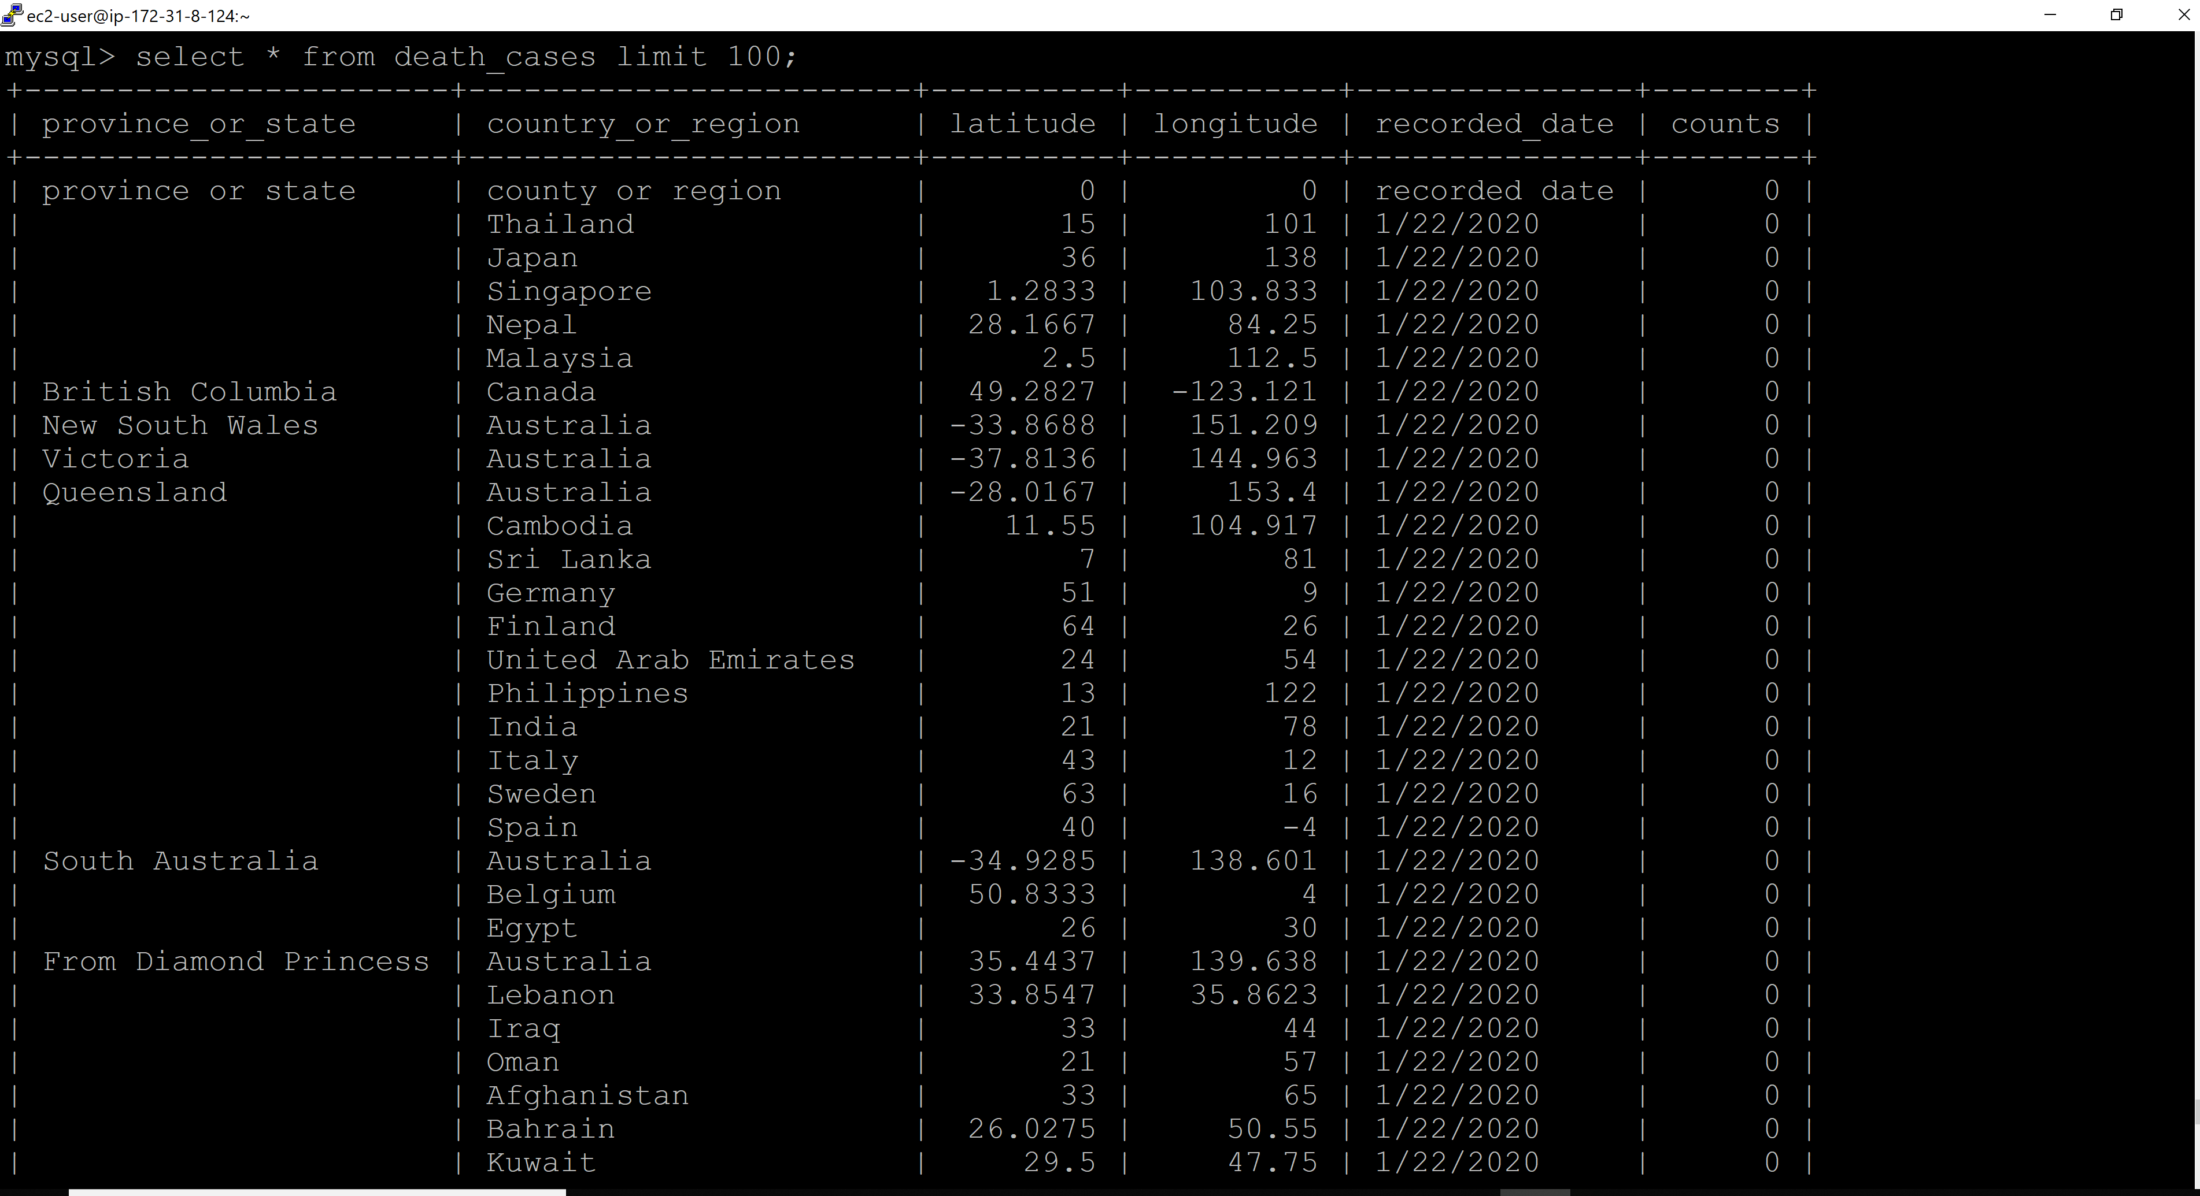

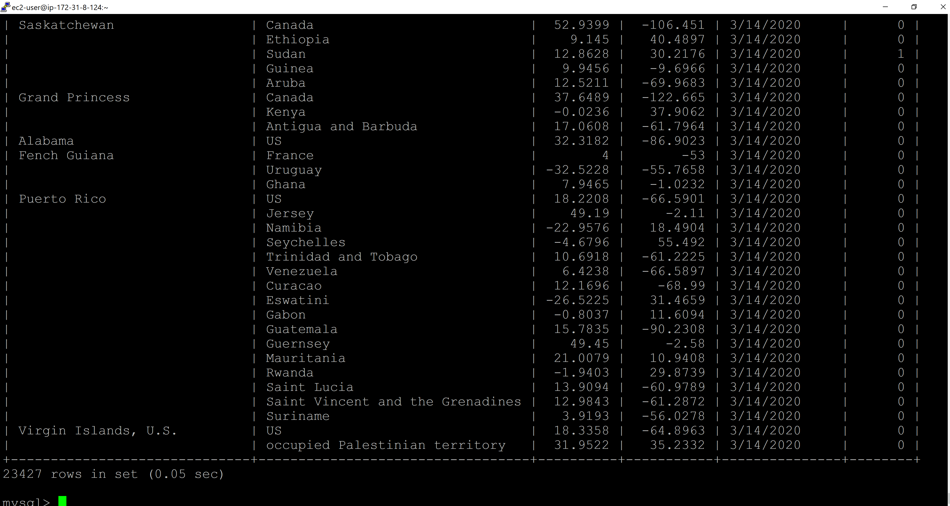

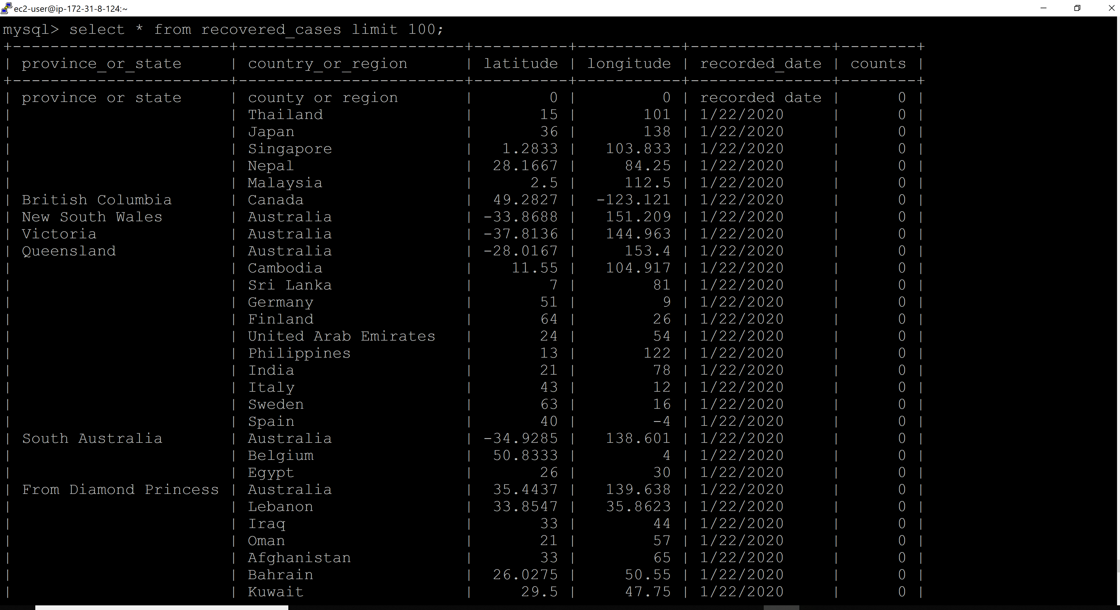

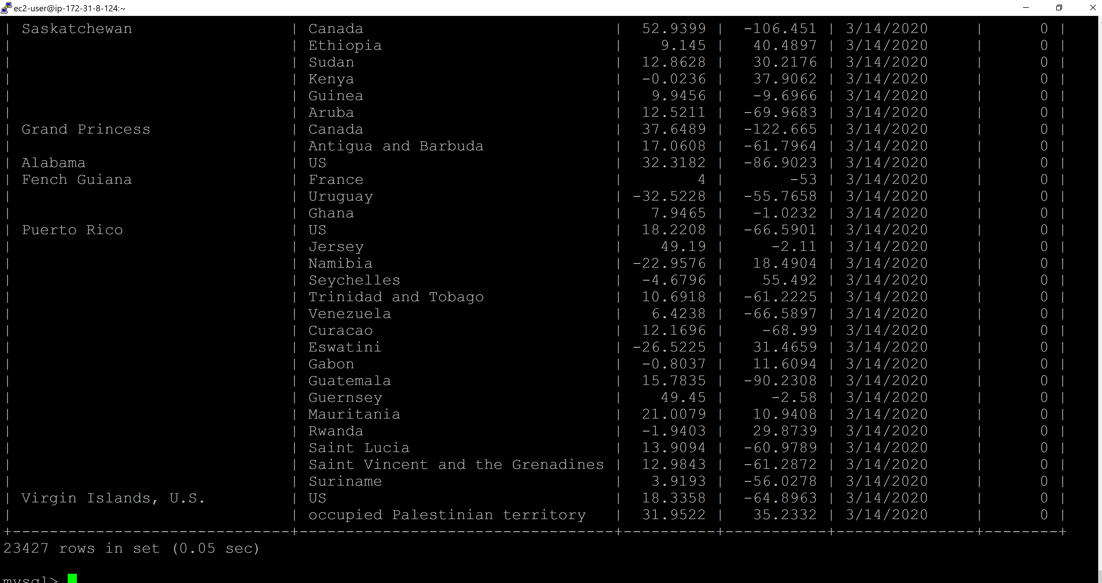

Python Script to load Firebase:

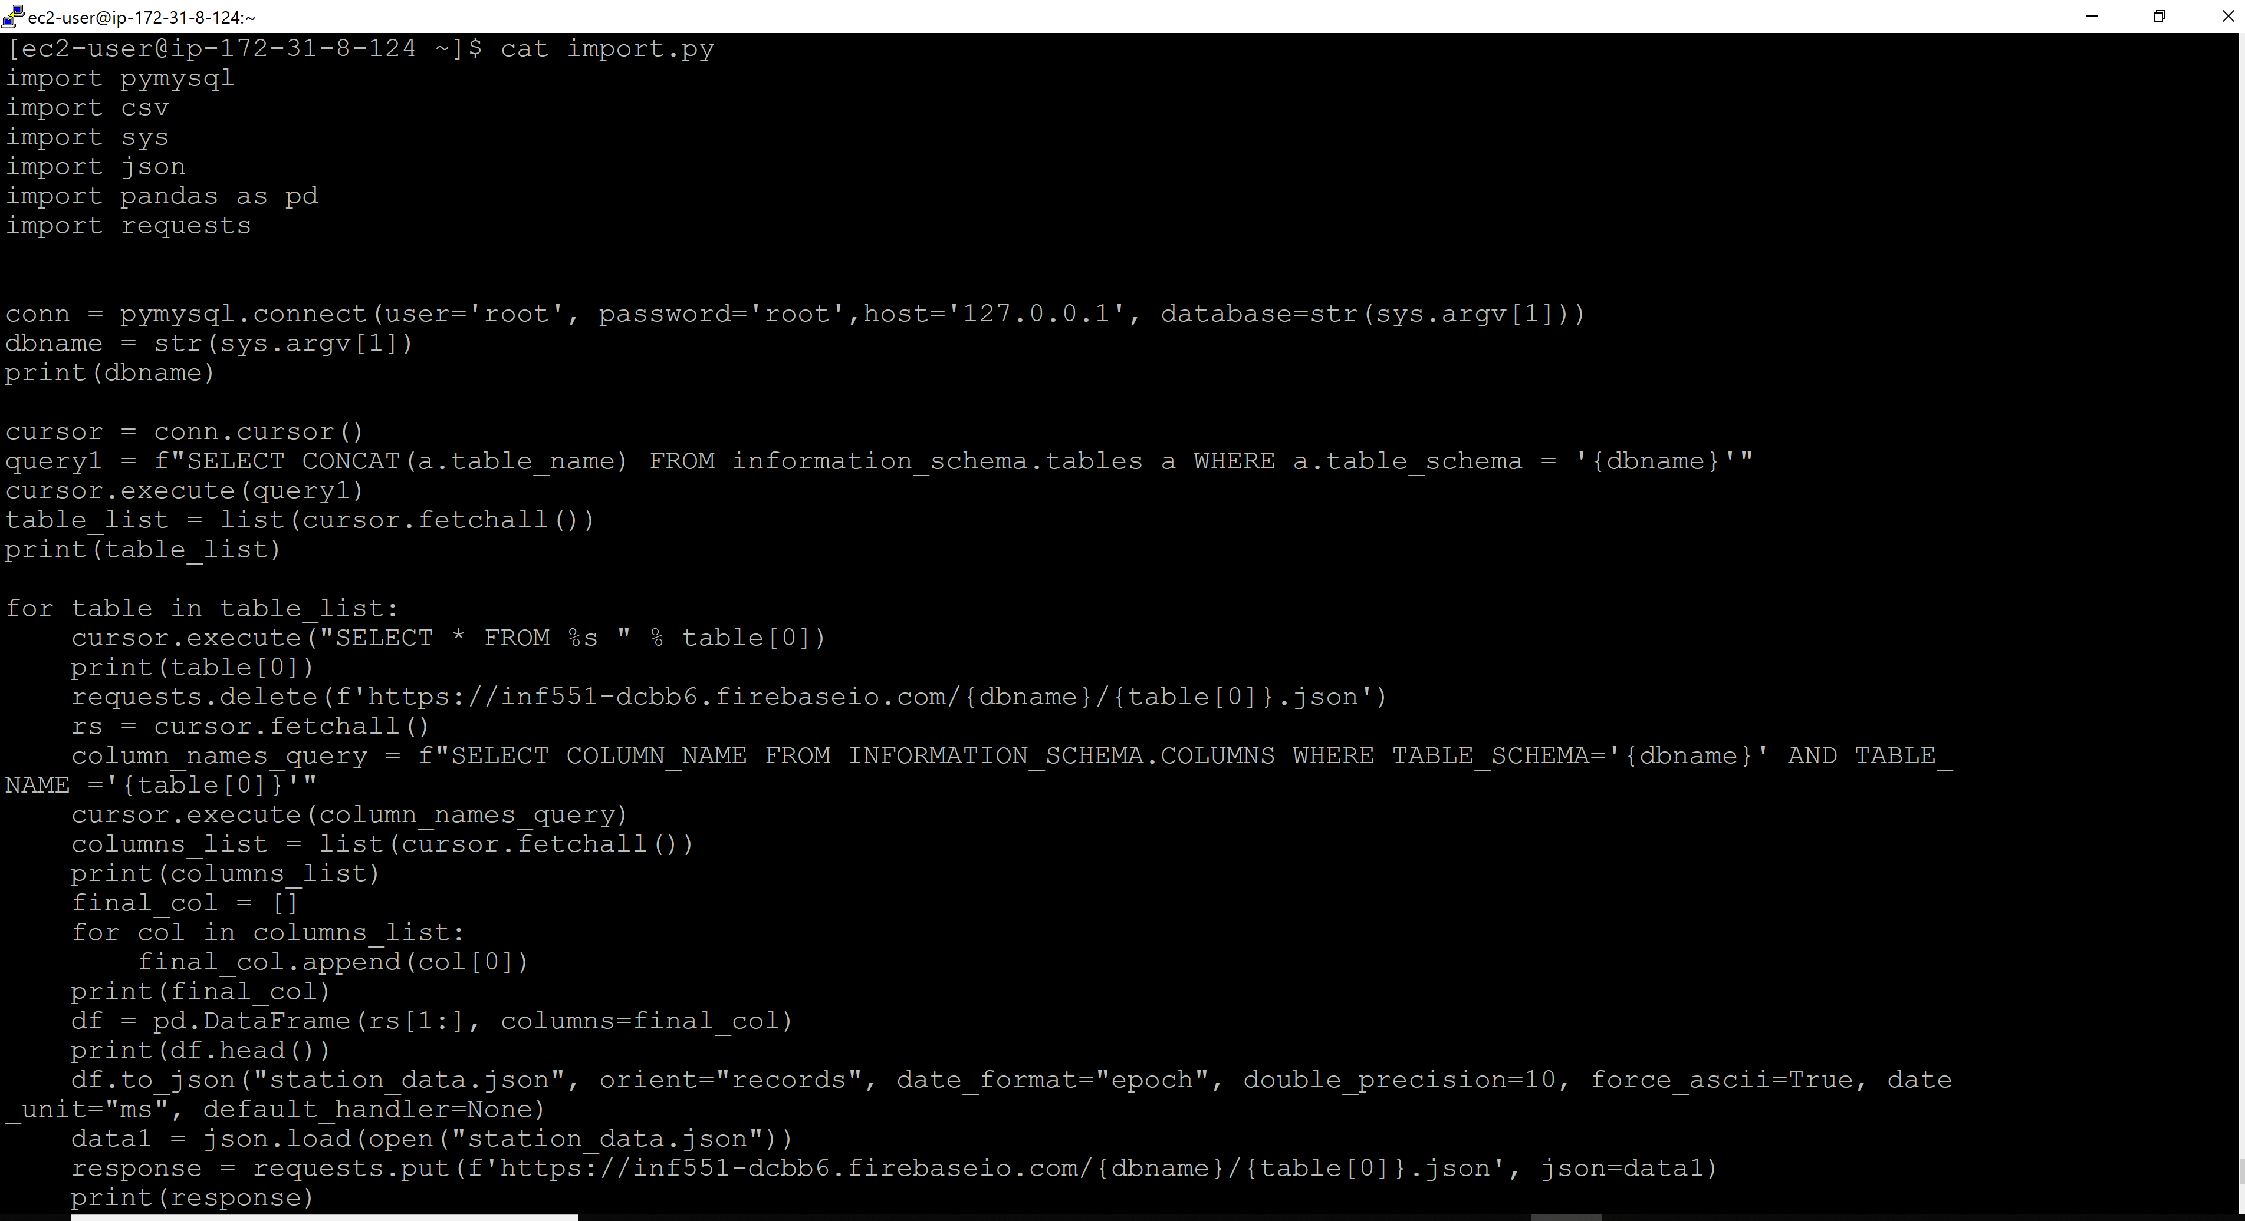

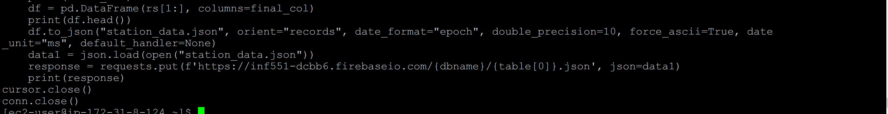

Data loaded in Firebase:

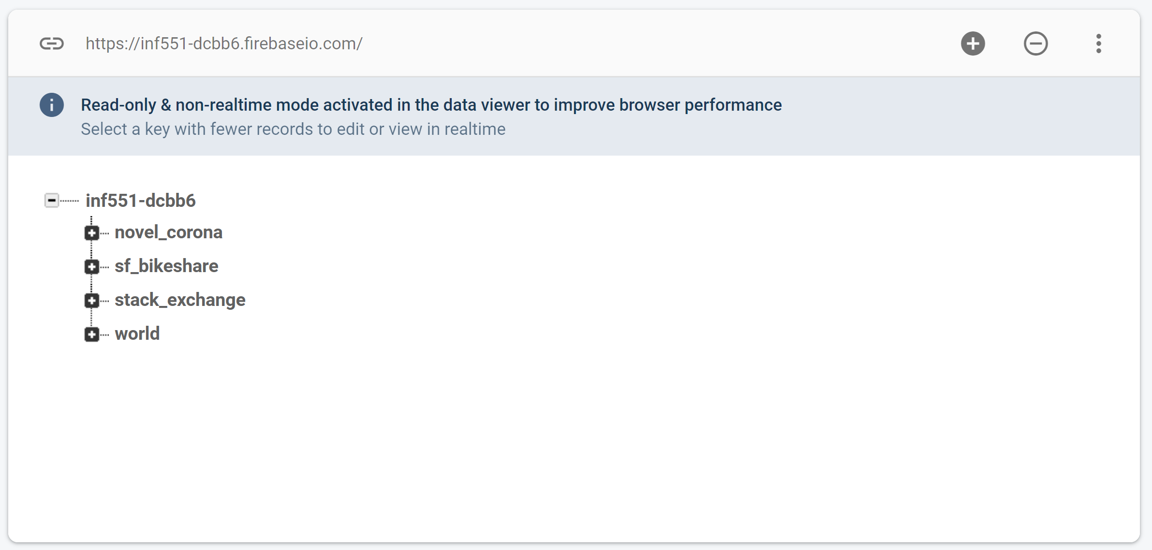

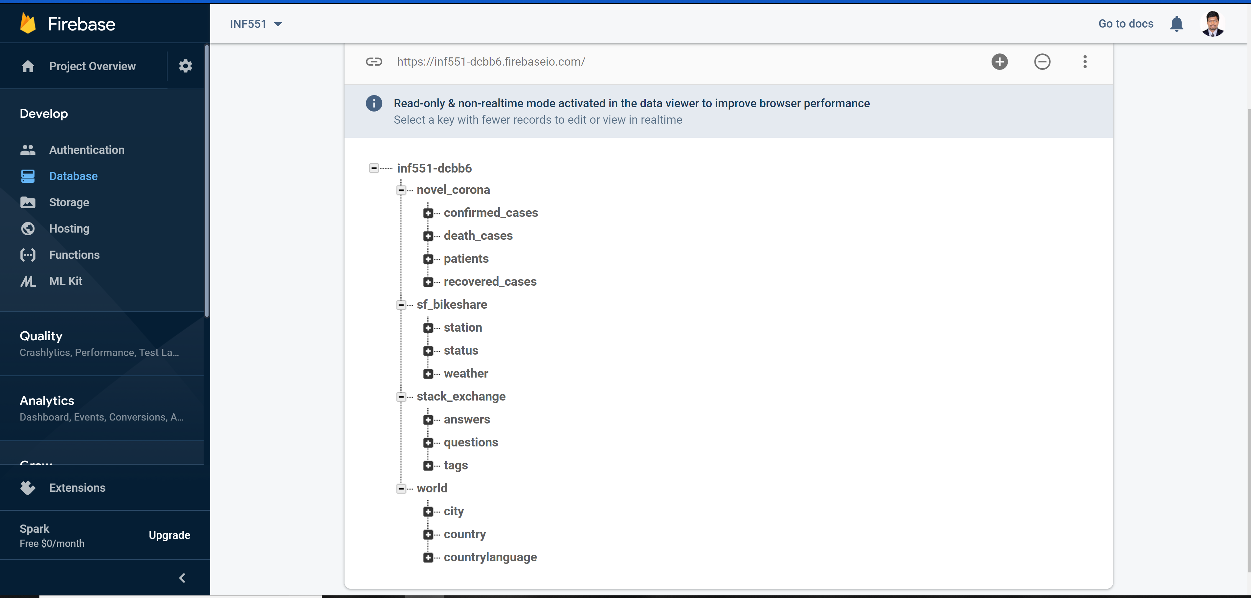

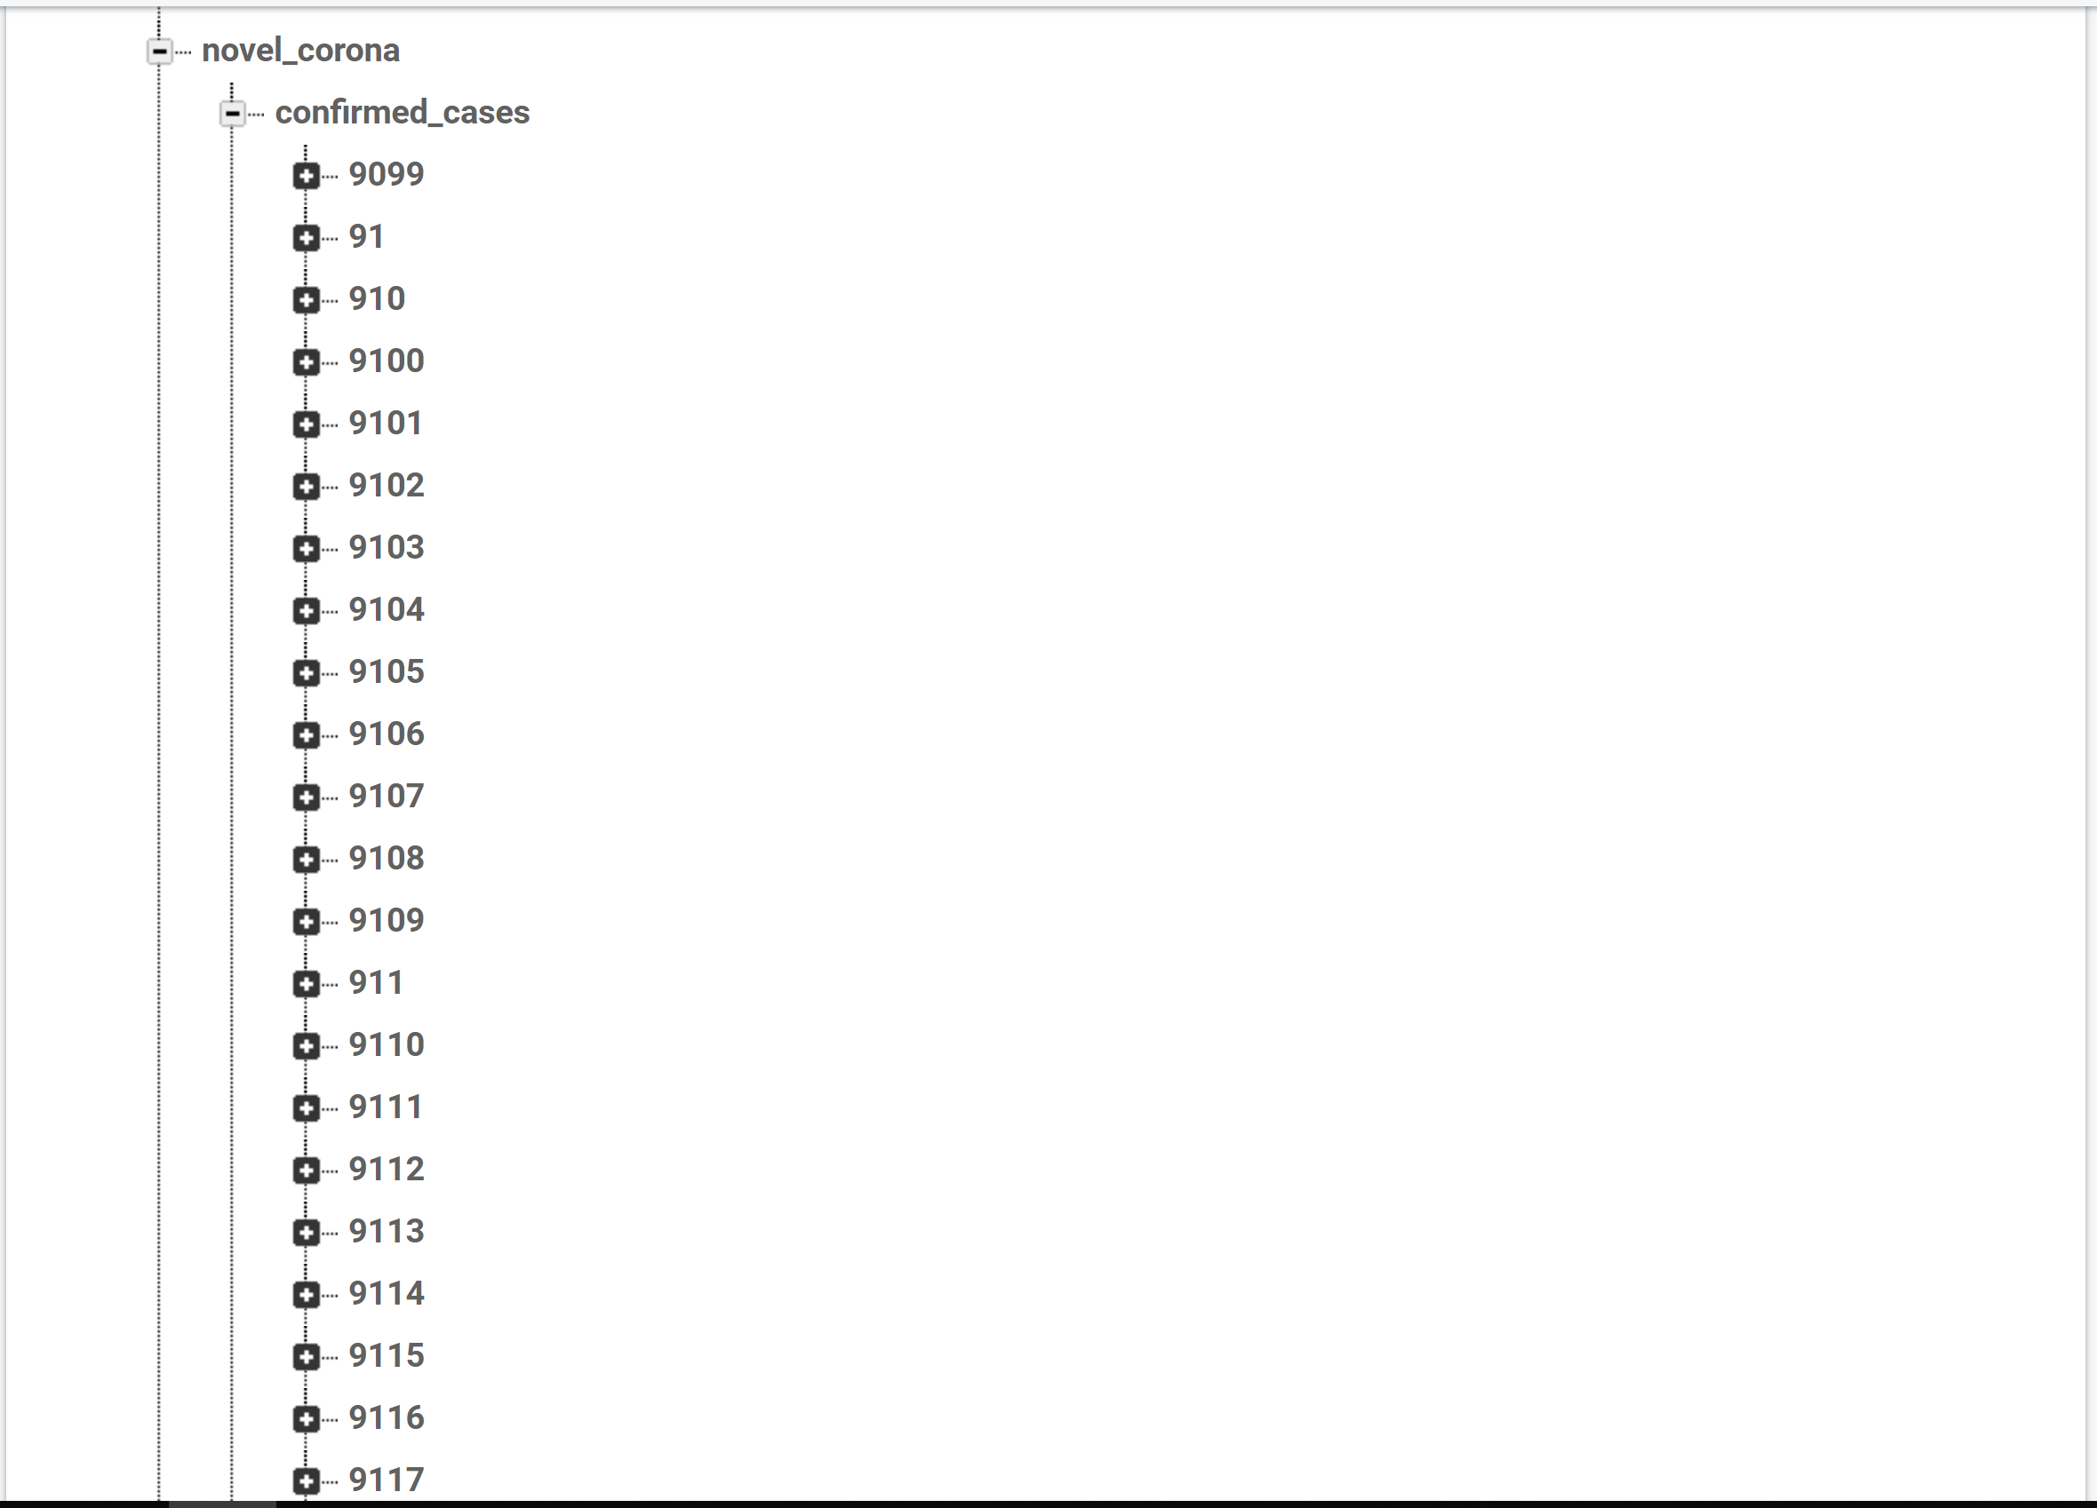

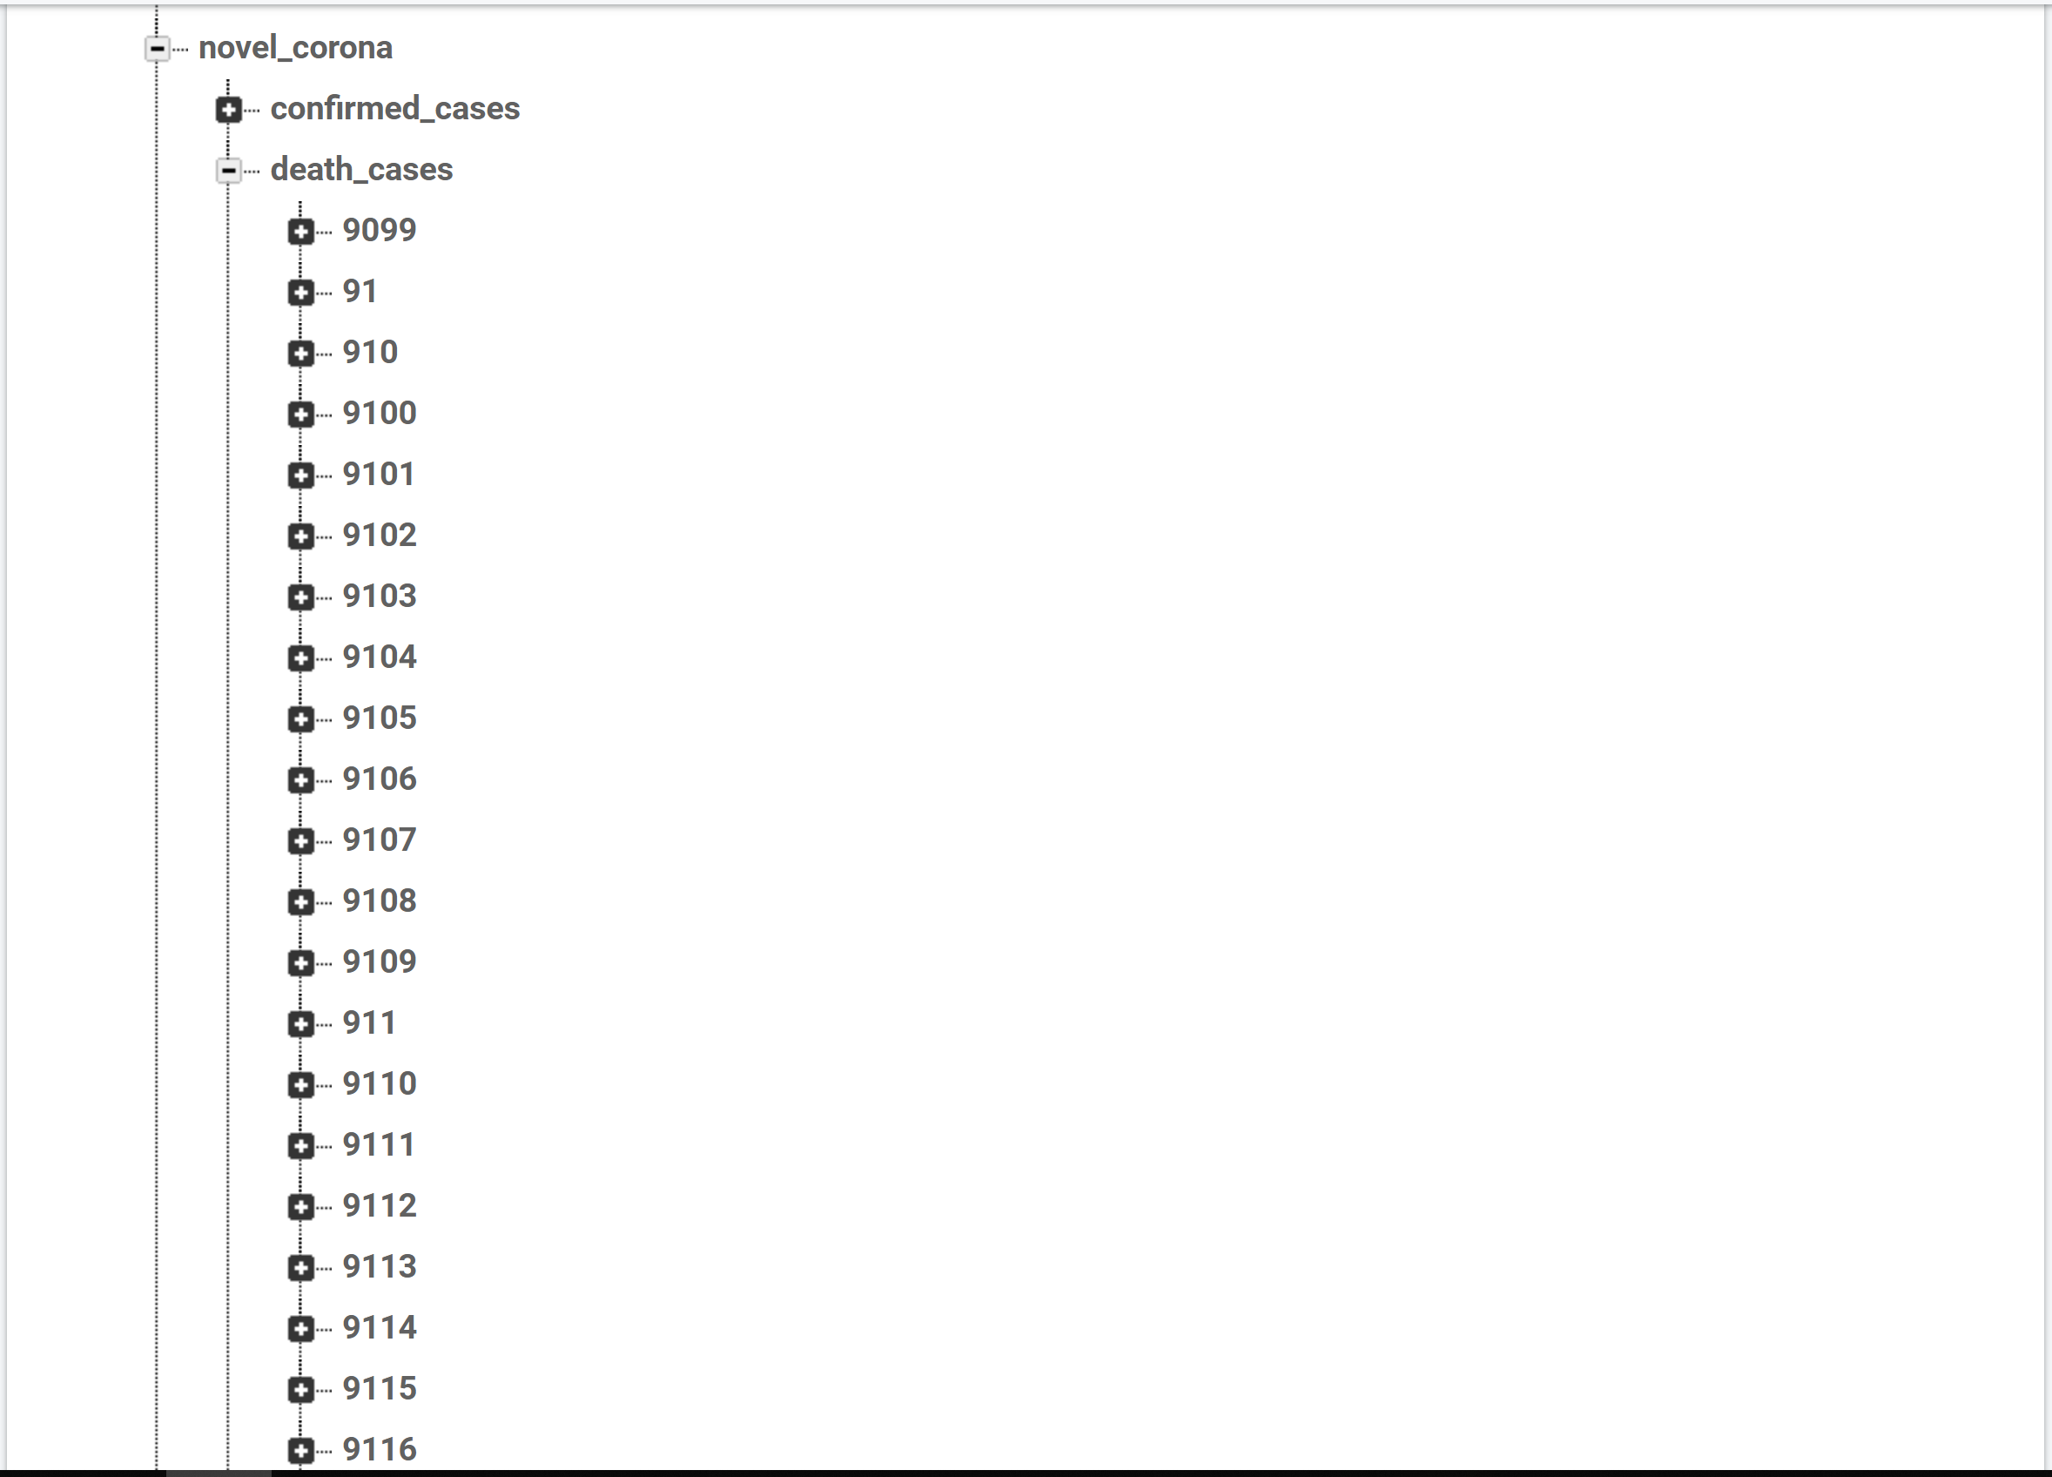

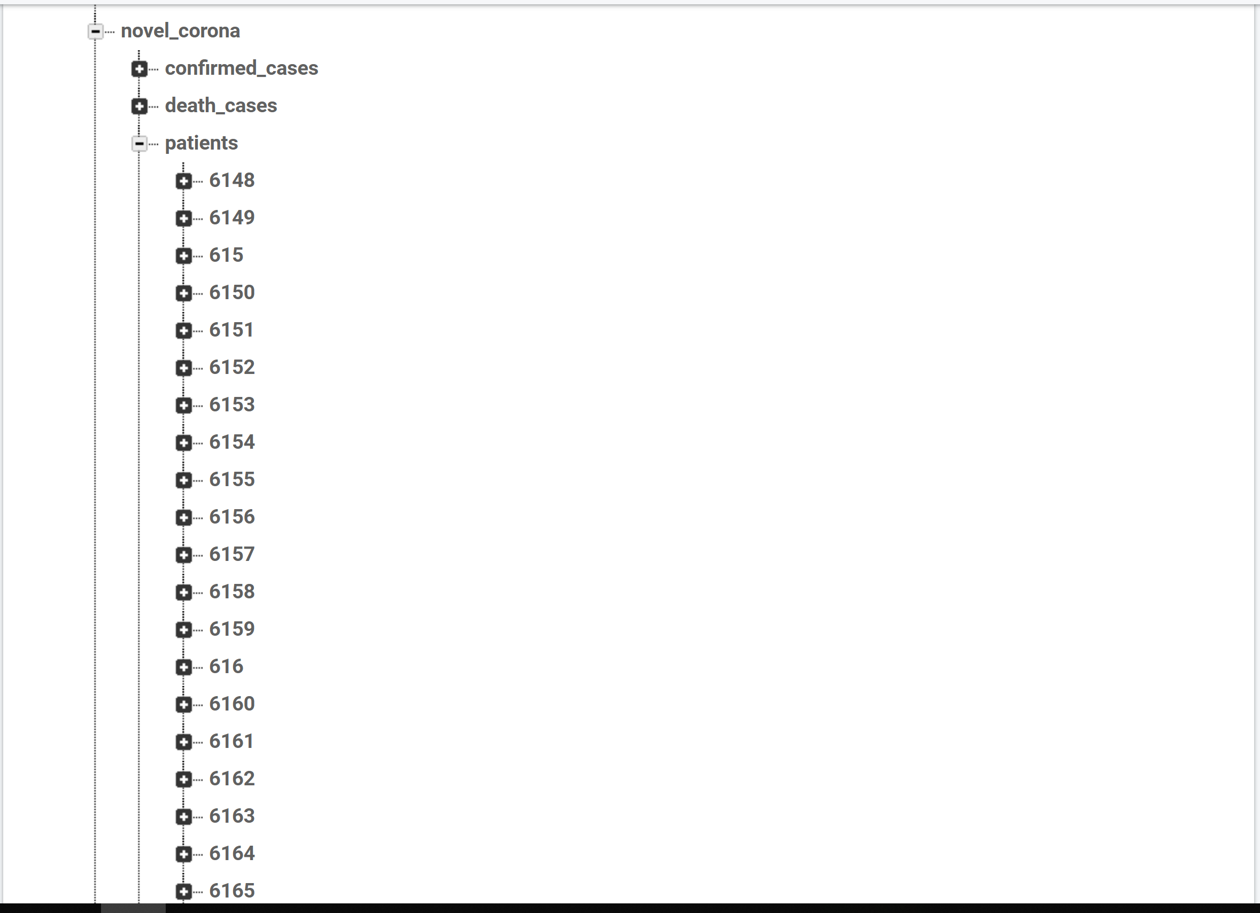

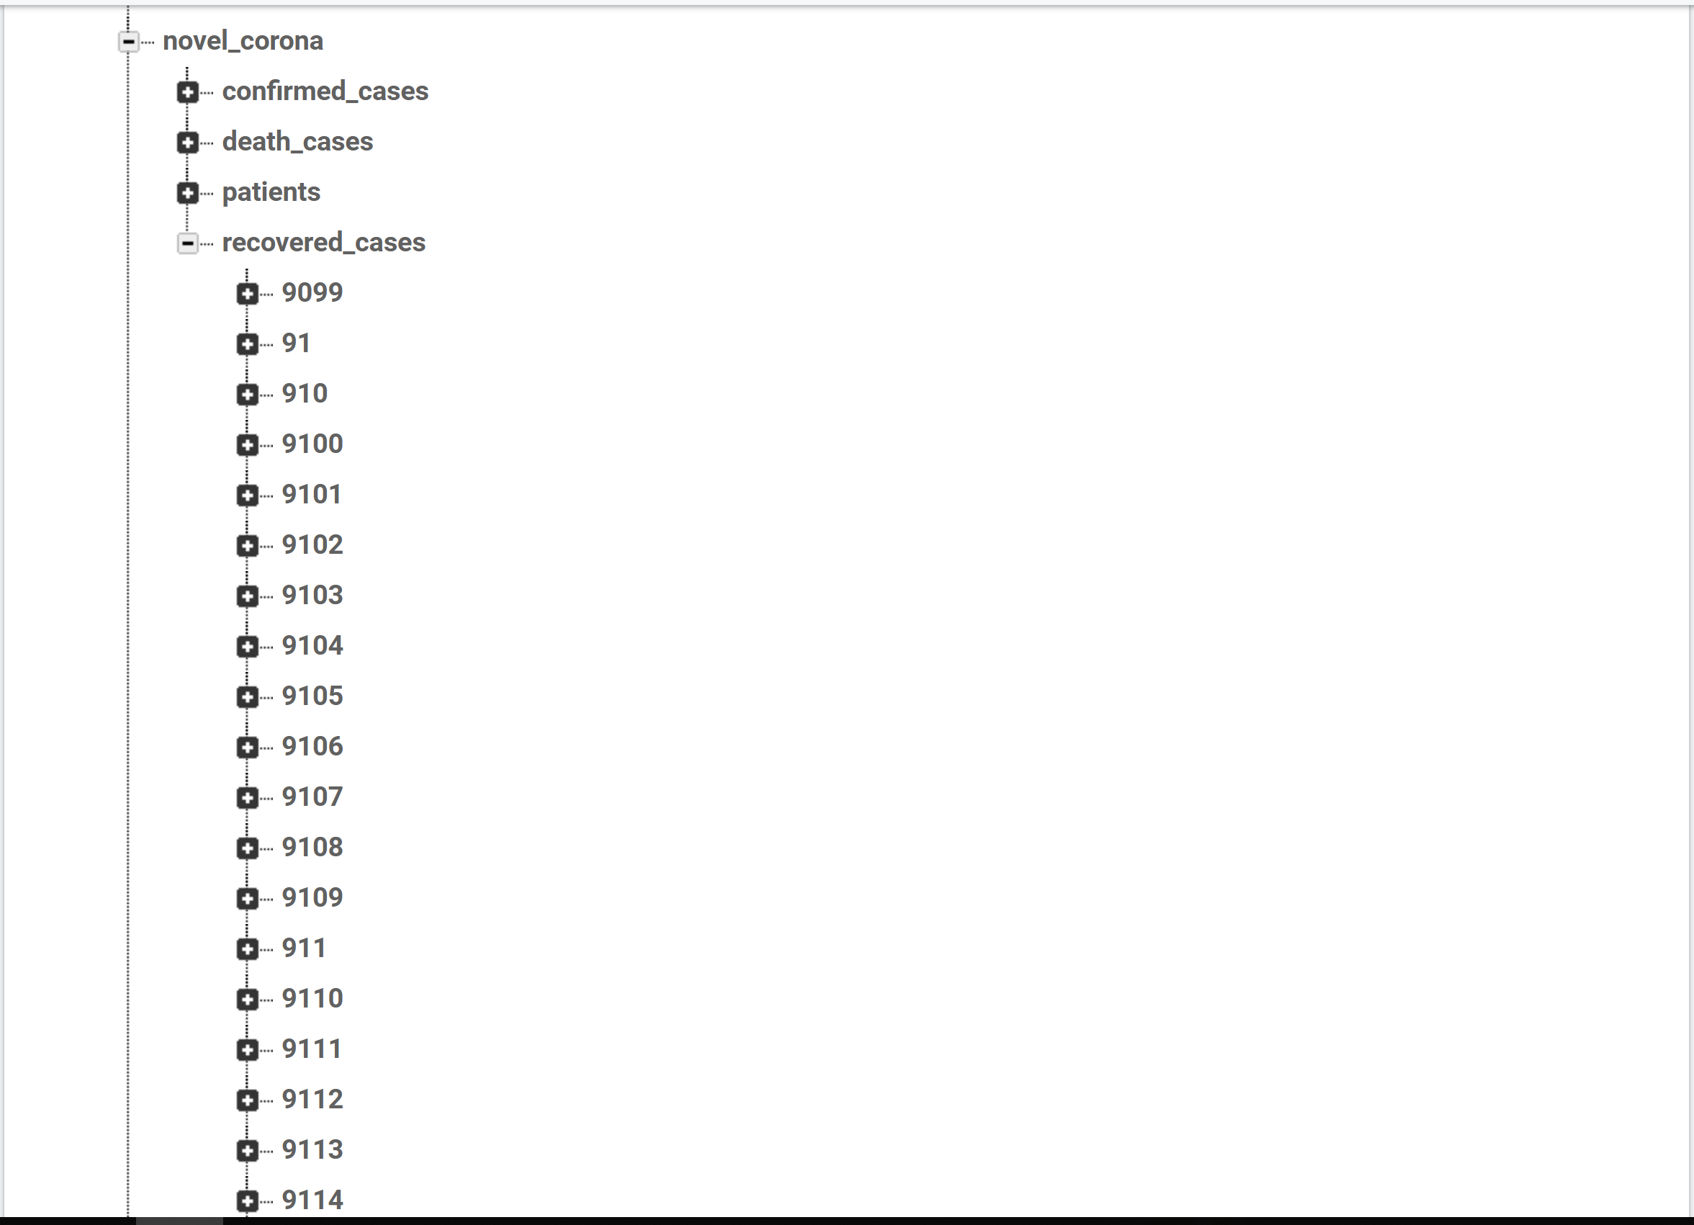

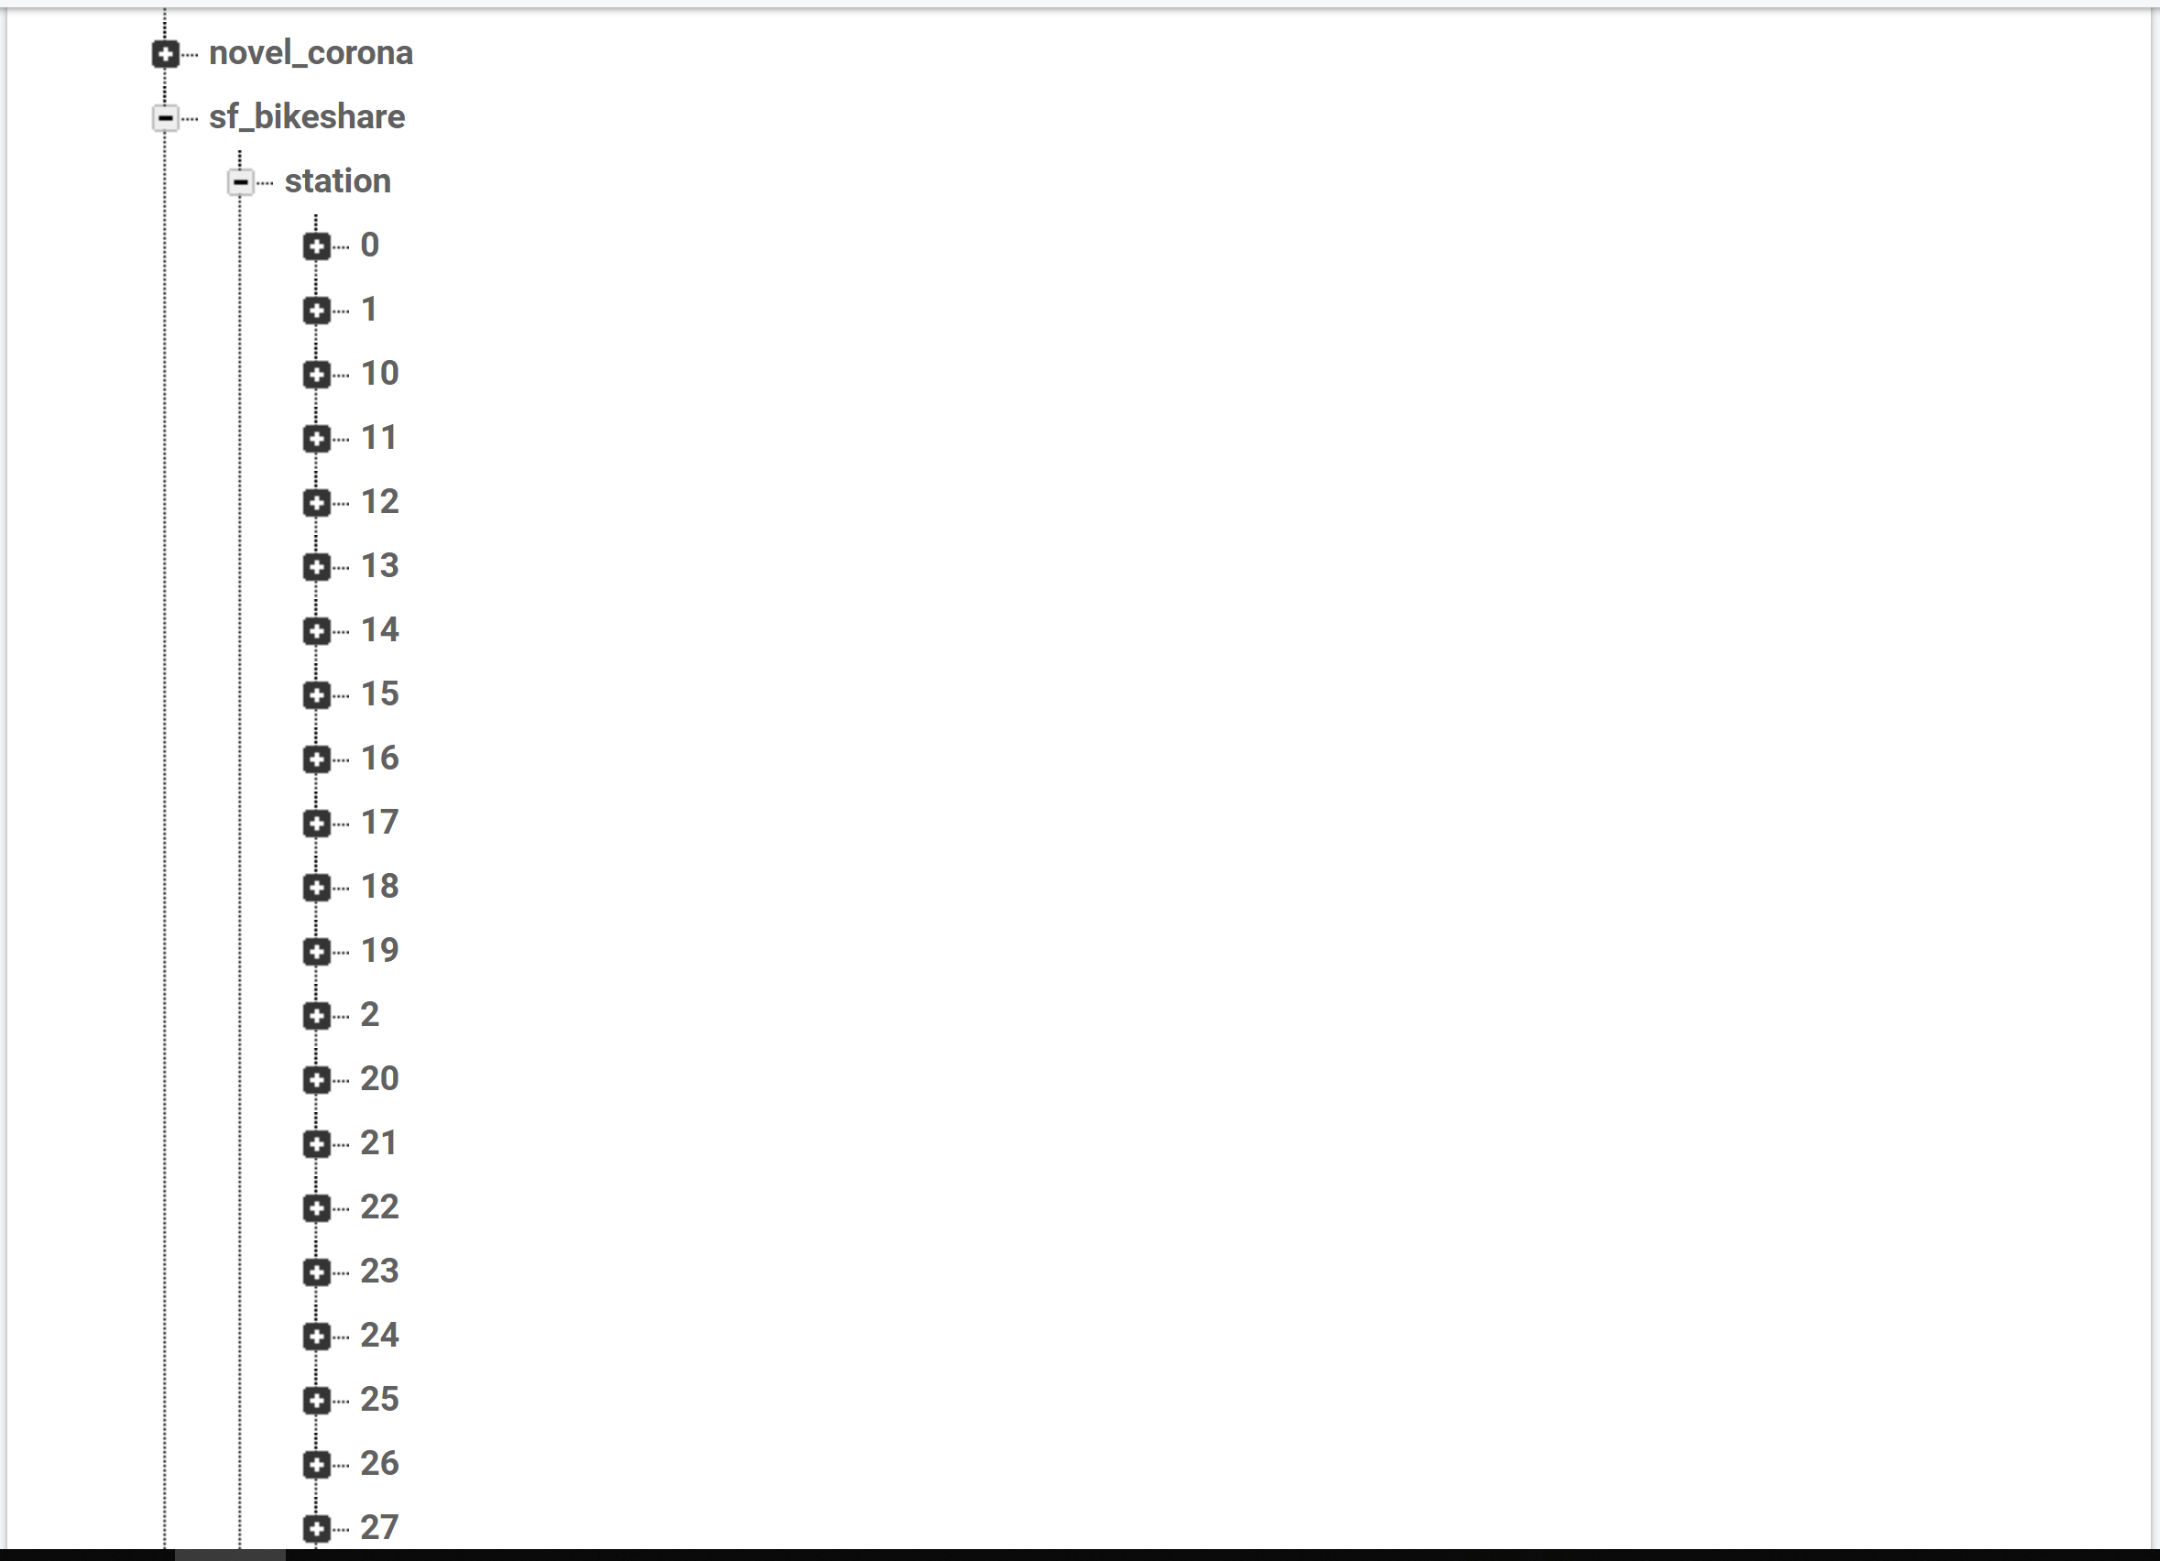

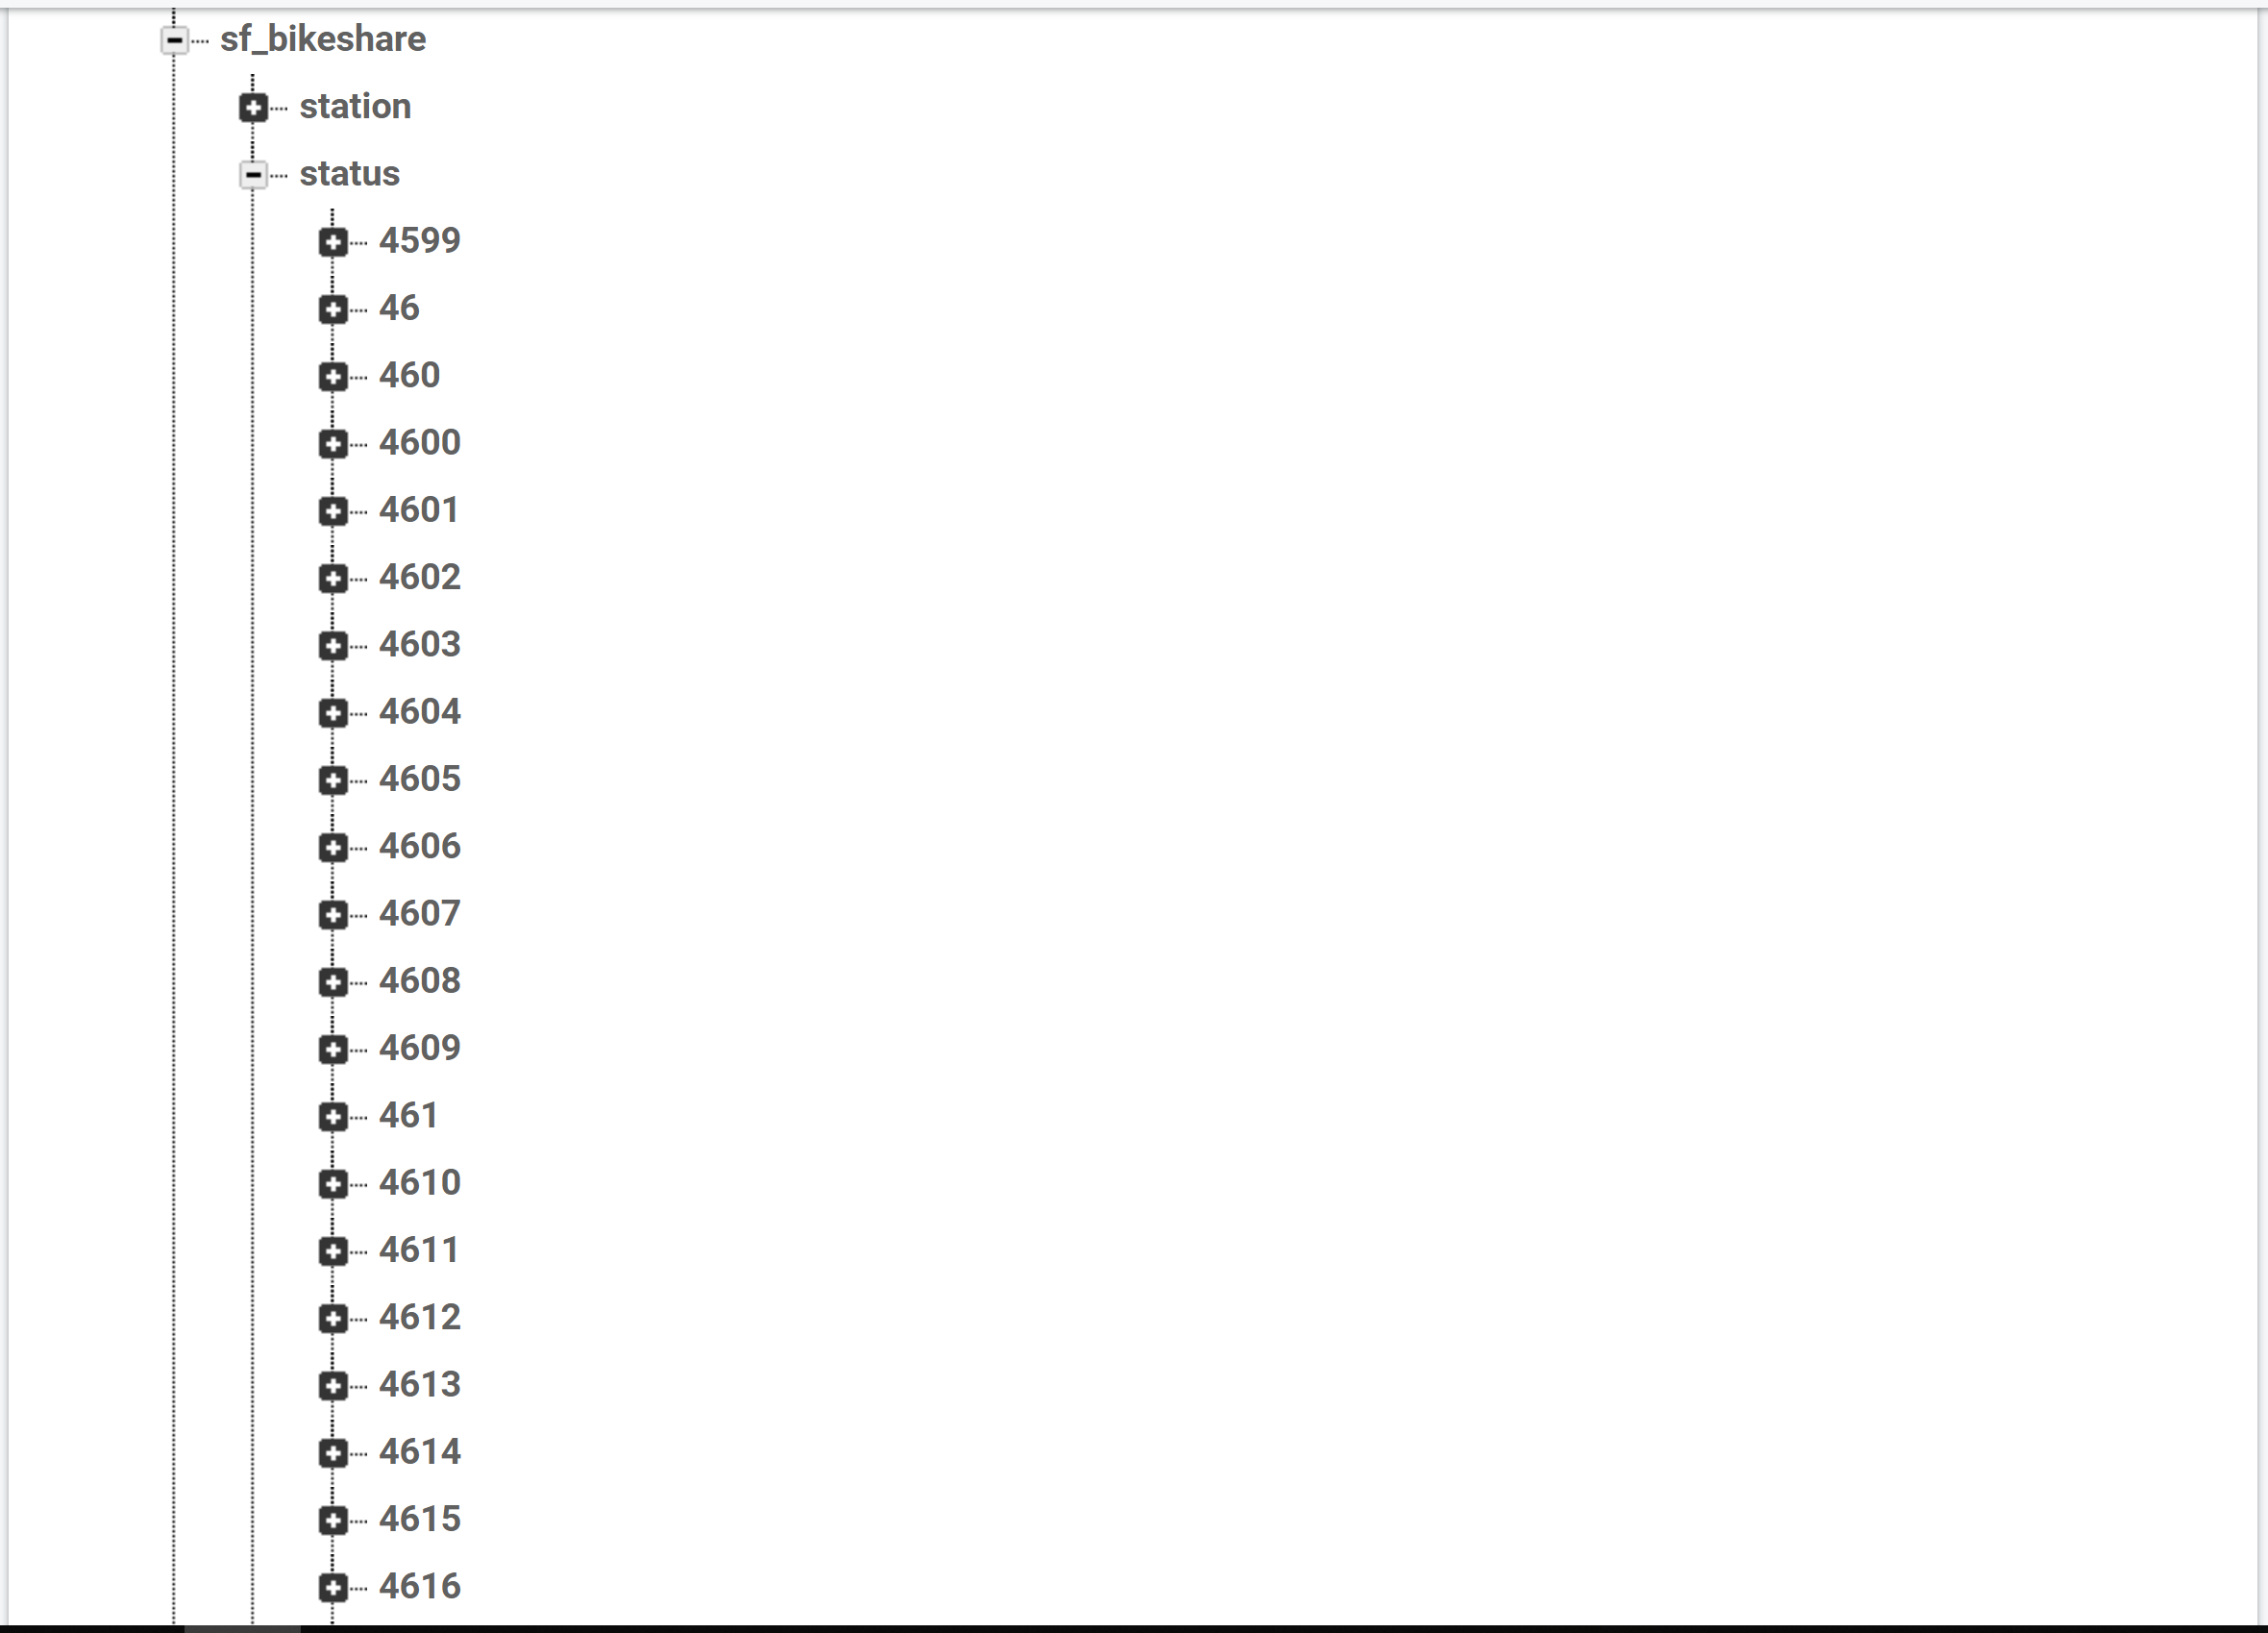

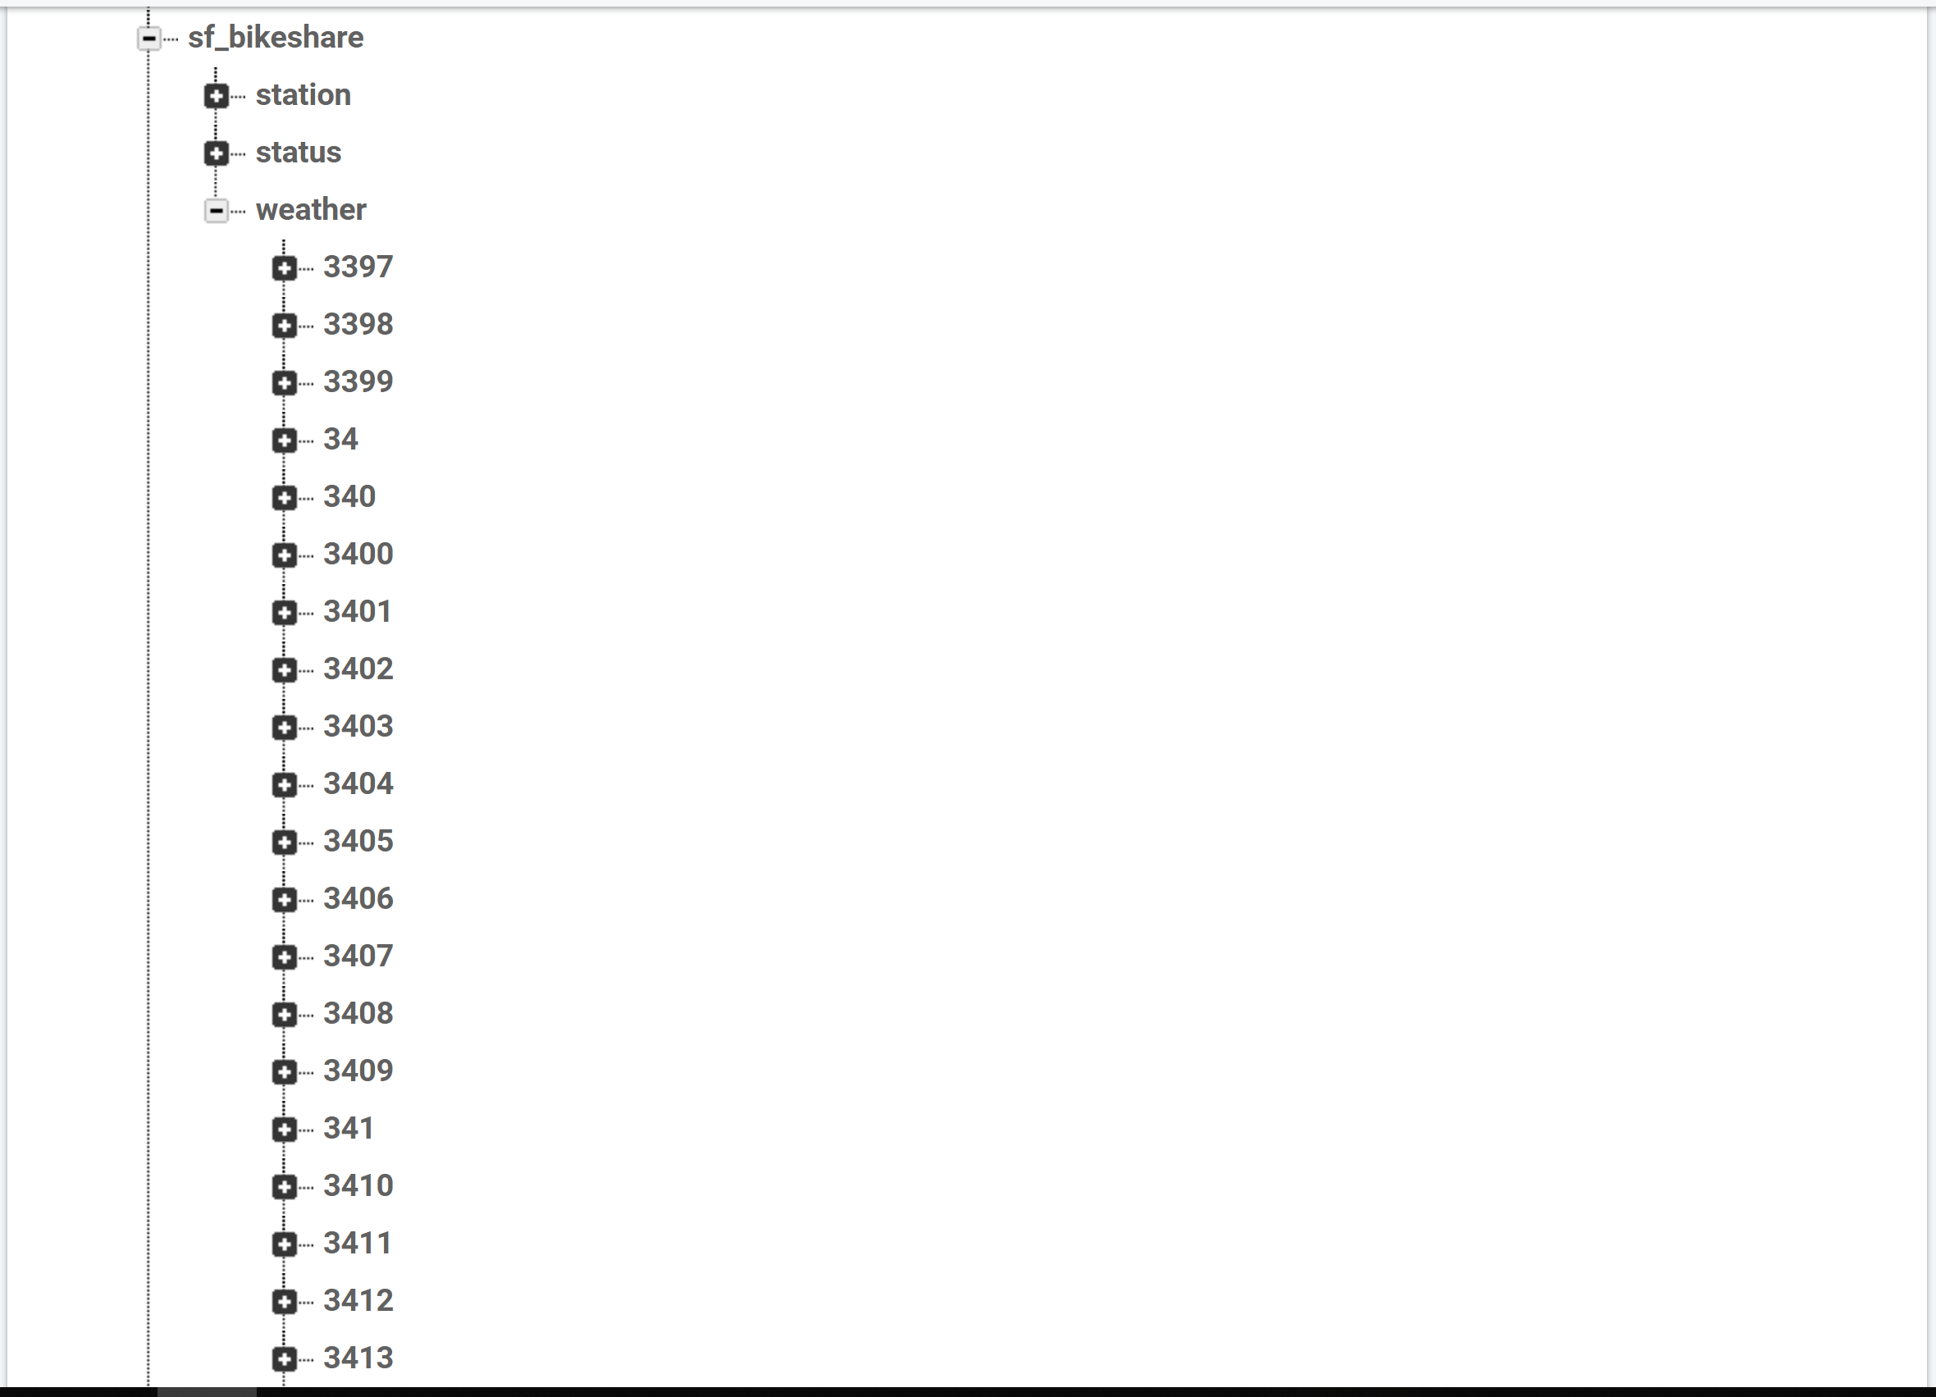

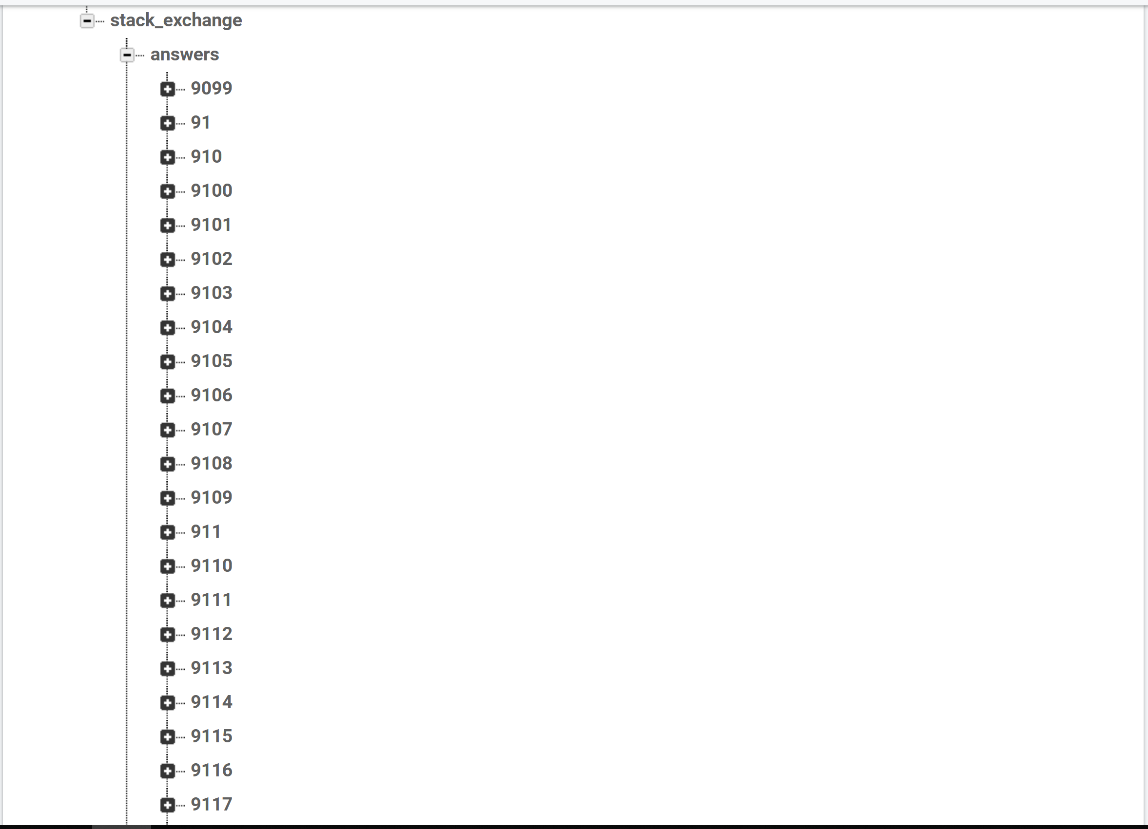

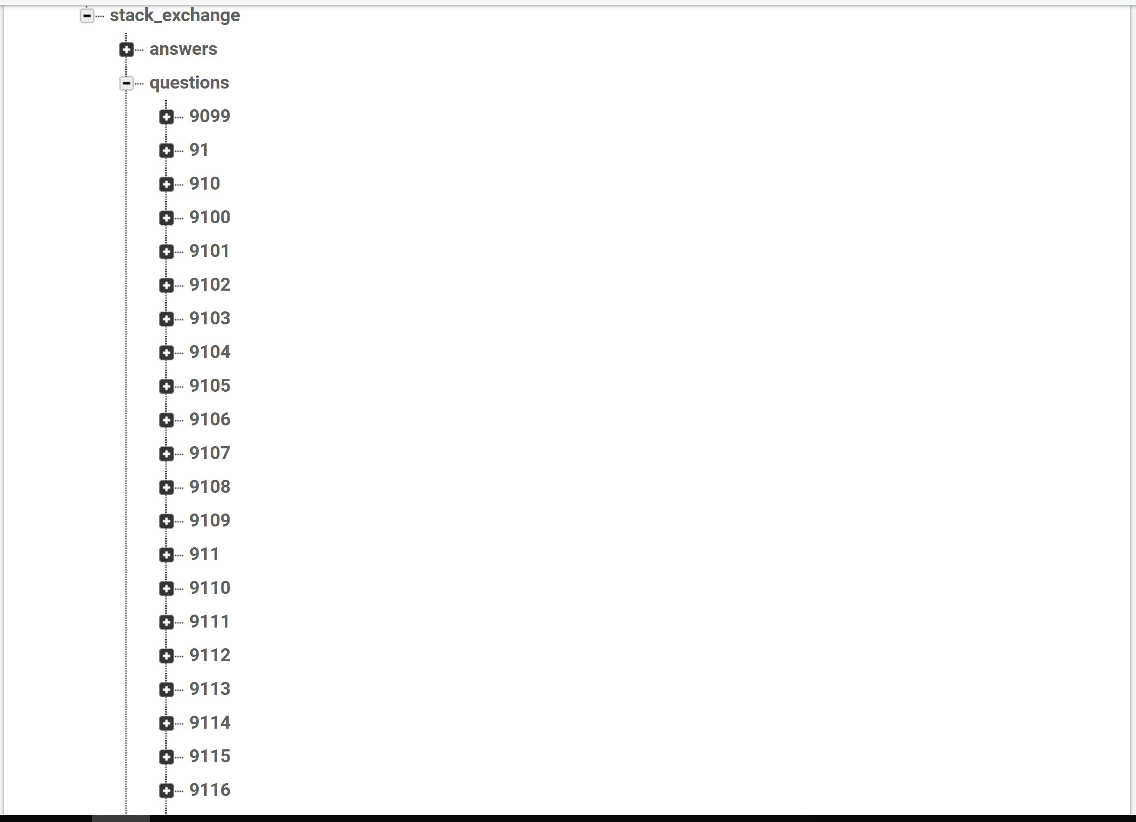

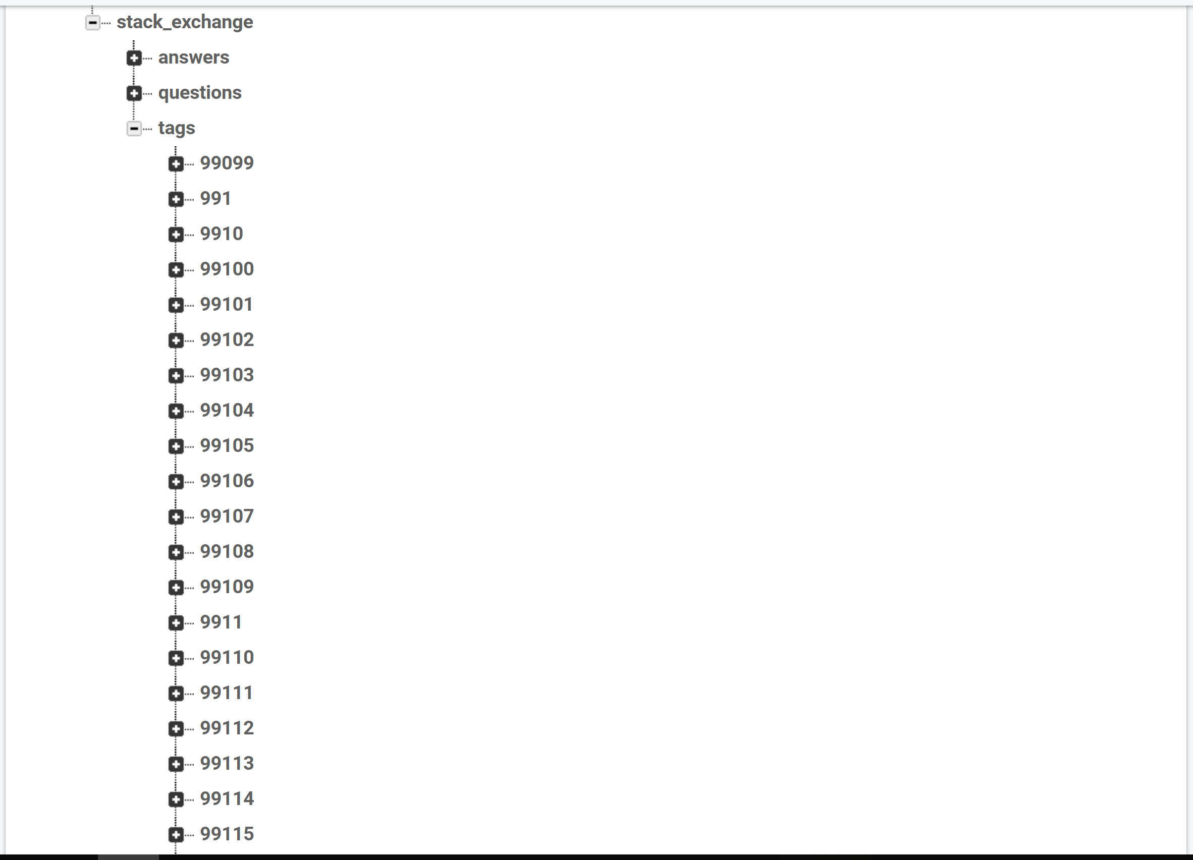

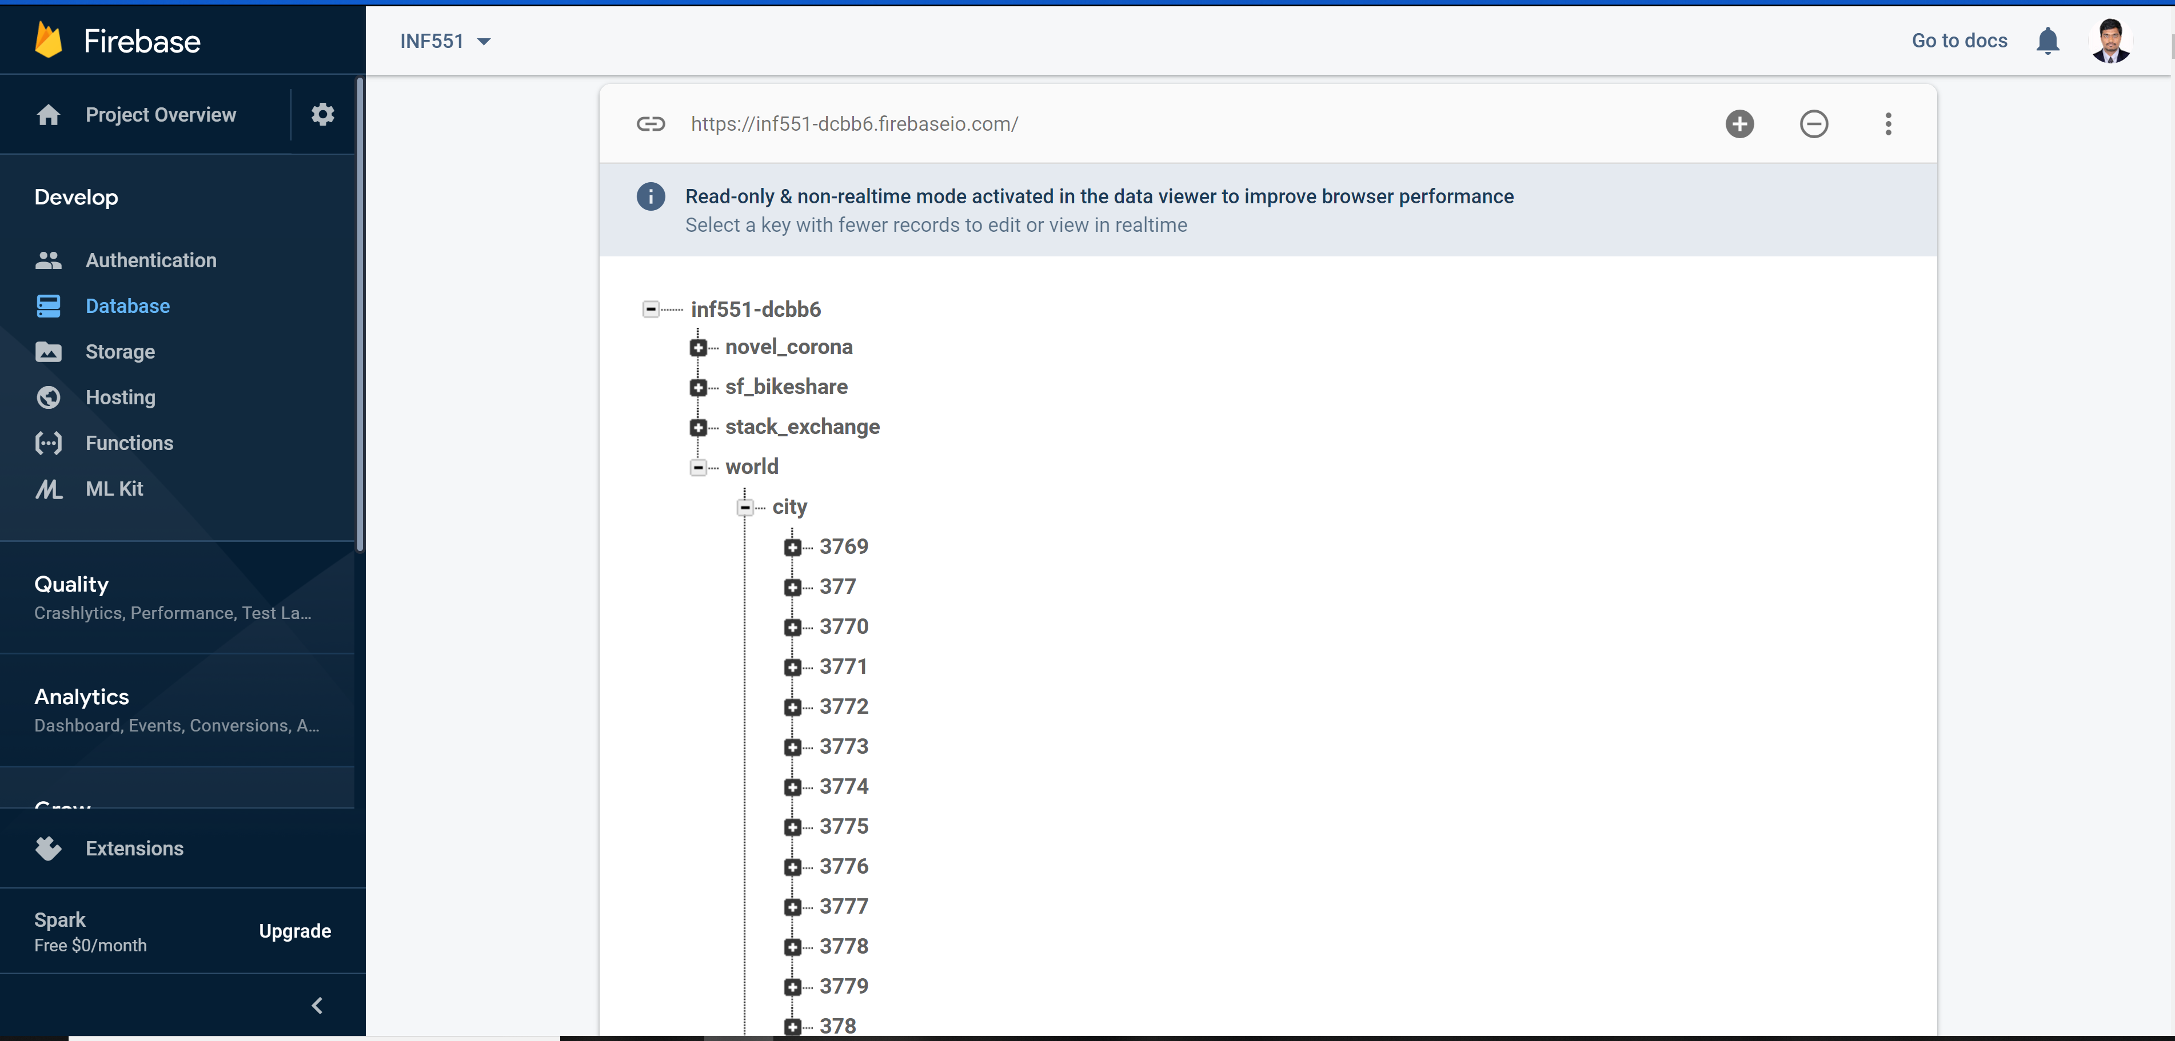

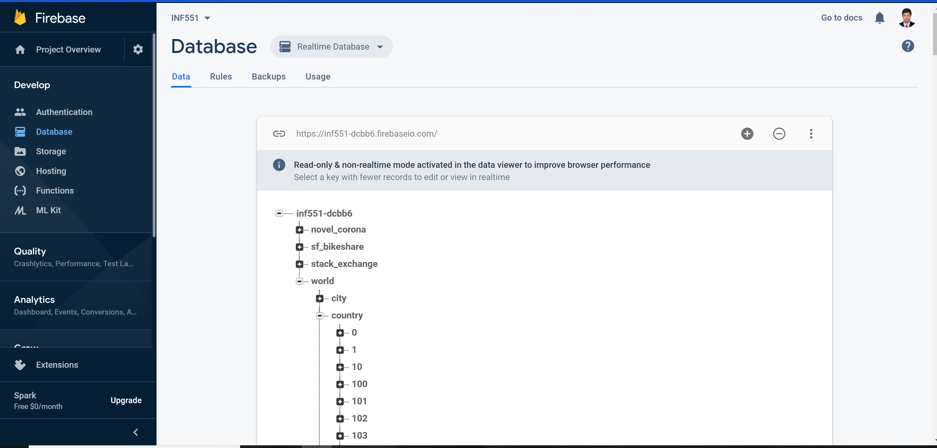

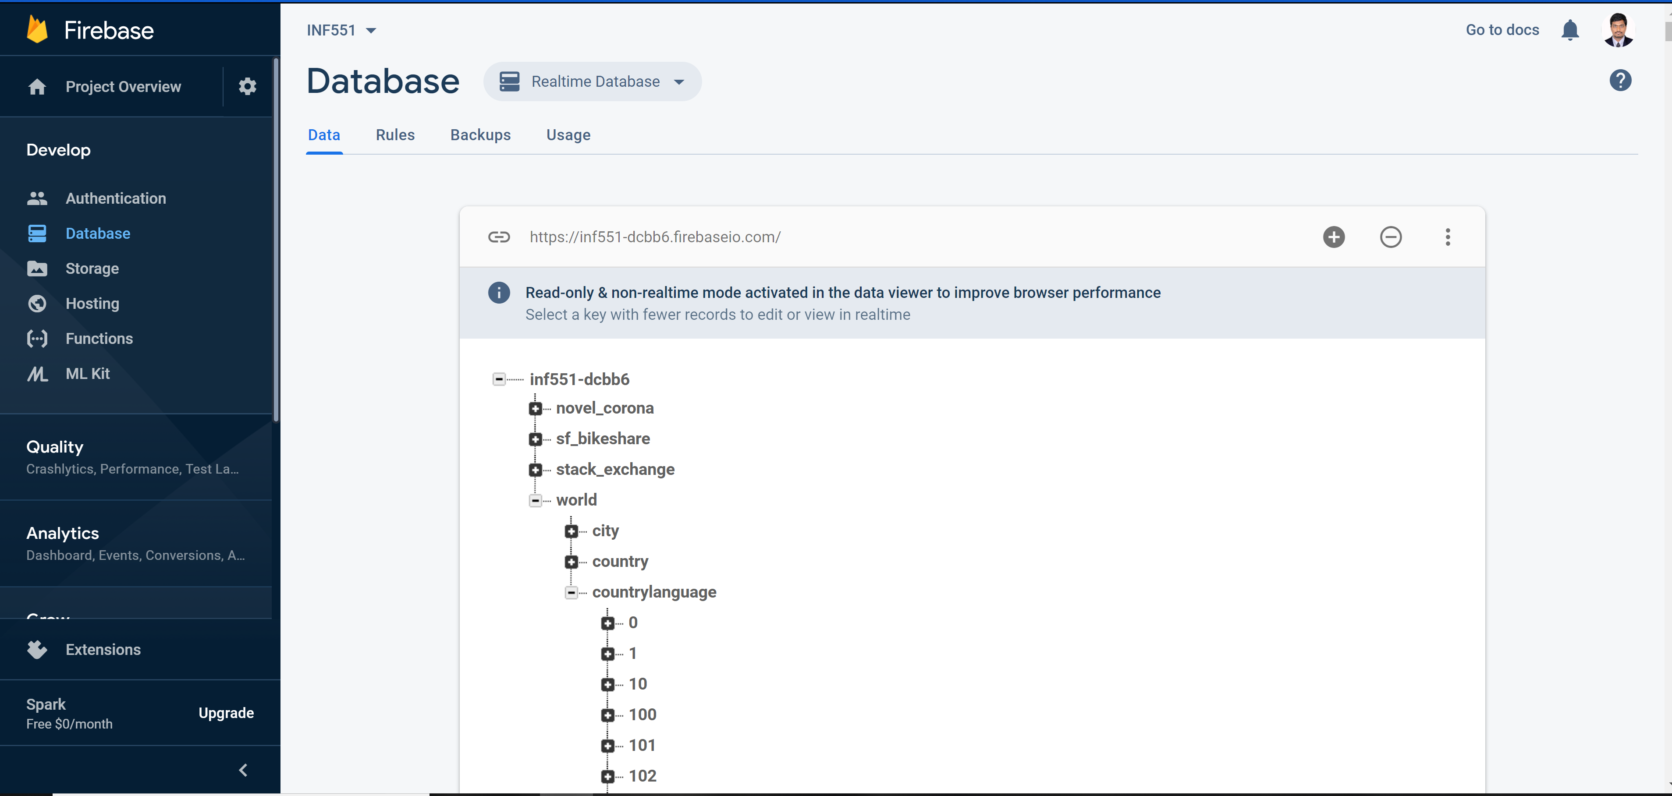

Front End – UI Interface:

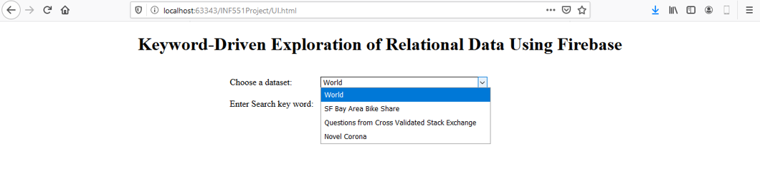

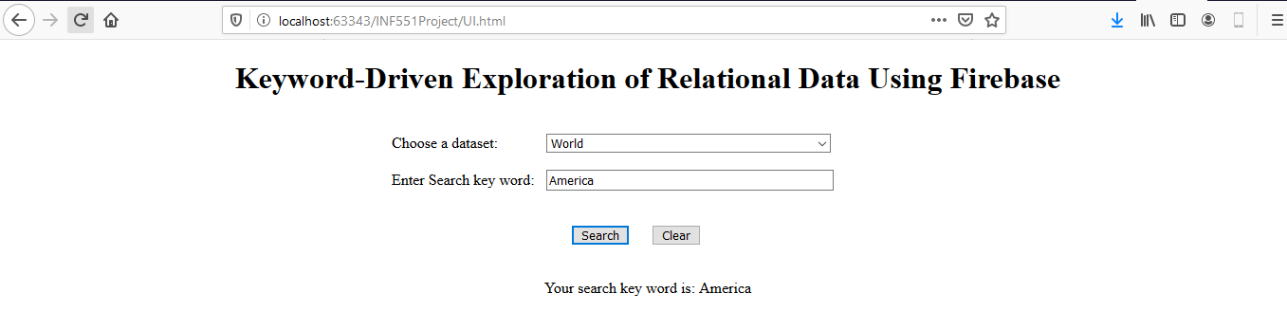

# Project Programming Codes:

Import.py:





# Exploration and Search Phase:

# Performance Analysis:

# Current Phase:

# Challenges Encountered:

Back End Challenges:

1. Issue: Data in Stack Exchange csv files failed to load due to file incompatibility error.

Solution: Used chardet and obtained the correct format for decoding the file and used the format “ISO-8859-1” to decode the file and load data for cleaning.

1. Issue: Handling large datasets was an issue due to file size being large to open on local file systems.

Solution: Loaded a subset of data i.e; around 120000 records using nrows parameters of pandas read_csv method and successfully loaded 120000 records (meeting the projects guidelines of 10000 records) instead of loading the entire data.

1. Issue: Cleansing of large data sets was time consuming.

Solution: Automated cleaning of dataset using python scripts and pandas functionality.

1. Issue: Lots of Null Values in the real-world data.

Solution: For attributes with less than 60% null values, the empty values were filled with 0 or mean, min and max values respectively and as appropriate. For attributes with more than 60% null values, dropped them from the dataset.

1. Issue: Deciding on to a single format to store and access data especially for Date Columns.

Solution: Converted Date columns (if required) to YYYY-MM-DD format to store it in compatible format of SQL. In scenarios where the Date columns are not significant they were stored as strings.

# Summary Report:

1. Are you on track to achieve your milestone?

**Answer:** Yes, As mentioned in the project status tracking section. We are on track with achieving the milestone and extremely confident that based on the excellent knowledge taught in the class and our domain knowledge and experience we will be able to complete the project on time.

1. Any challenges you have encountered? Any help you will need?

**Answer:** Challenges encountered till now are mentioned in the above section. Yes, We might need some guidance and help in terms of methods to retrieve data from the Firebase and displaying it to user. We are working on the same now and might need TA’s expertise and experience knowledge sharing in guiding us in the right direction.

1. Any other things you need to report?

**Answer:** No. We have reported everything as per the project requirements in this document and the already submitted project proposal document.

1. Are group members equipped to implement the application by end of the semester?

**Answer:** The group members combine skills like Software Development, System integration, Design document experts and are also good in presentations.

In addition, we strongly believe that topics and skills taught in this course by the expert faculty and TA’s will enable us to achieve this project by end of the semester.

# Important Reference Links:

1. Kaggle Dataset – SF Bay Area Bike Share: <https://www.kaggle.com/benhamner/sf-bay-area-bike-share>.
2. Kaggle Dataset – Questions from Cross Validated Stack Exchange: <https://www.kaggle.com/stackoverflow/statsquestions>.
3. [Kaggle Dataset – Novel Corona Virus 2019 Dataset](https://www.kaggle.com/sudalairajkumar/novel-corona-virus-2019-dataset): <https://www.kaggle.com/sudalairajkumar/novel-corona-virus-2019-dataset>.
4. [Google Firebase and Web Integration Documentation](https://firebase.google.com/docs/database/web/start) - <https://firebase.google.com/docs/database/web/start>
5. [Google Drive – Source Code and Reports:](https://drive.google.com/drive/u/0/folders/1XlLKcDBxi1ofmAKJ-mp5NKHrrSYHCzip) <https://drive.google.com/drive/u/0/folders/1XlLKcDBxi1ofmAKJ-mp5NKHrrSYHCzip>.
6. [ITP 449 relevant Lecture Documents:](https://drive.google.com/drive/u/0/folders/1Il1Eyrr31GFcvzpEVjWrAopm9ujo5r3_) <https://drive.google.com/drive/u/0/folders/1Il1Eyrr31GFcvzpEVjWrAopm9ujo5r3_>
7. Project Introduction Video (Trailer):
8. Demo Recording:
9. GitHub Link: <https://github.com/SairamKRaj/Data-Engineering/tree/master/Keyword%20Search%20in%20Real-Time%20Database>